LAMPIRAN

Lampiran 1. Data Berat Badan Rata-Rata dan Keseragaman

BB RATA-RATA
WAKTU | Tier 1 | Tier 3
Minggu 6 | 622,50 | 611,00
Minggu 7 | 637,88 | 626,88
Minggu 8 | 721,00 | 730,44
Minggu 9 | 848,06 | 832,81
Minggu 10 | 961,63 | 945,50
Total | 3791,07 gr | 3746,63 gr
BB Rata-Rata
  792,14 gr
  792,14 gr

KESERAGAMAN
WAKTU | Tier 1 | Tier 3
Minggu 7 | 92,15 | 96,08
Minggu 8 | 95,10 | 92,16
Minggu 9 | 91,18 | 88,24
Minggu 10 | 93,14 | 91,18
Total | 339,13 gr | 334,50 gr
Keseragaman Rata-Rata | 107,92 gr | 106,21 gr

Lampiran 2. Hasil Uji-T Pertumbuhan Berat Badan (equal)
 | Tier 1 | Tier 3
Mean | 107,91 | 106,20
Variance | 506,65 | 31,87
Observations | 3 | 3
Pooled Variance | 269,26
Hypothesized Mean Difference | 0
Df | 4
t Stat | 0,12
P(T<=t) one-tail | 0,45
t Critical one-tail | 2,13
P(T<=t) two-tail | 0,90
t Critical two-tail | 2,77

Lampiran 3. Hasil Uji-T Keseragaman (equal)

 | Tier 1 | Tier 3
Mean | 92,89 | 91,91
Variance | 2,80 | 10,48
Observations | 4 | 4
Pooled Variance | 6,64
Hypothesized Mean Difference | 0
Df | 6
t Stat | 0,53
P(T<=t) one-tail | 0,30
t Critical one-tail | 1,94
P(T<=t) two-tail | 0,61
t Critical two-tail | 2,44

Lampiran 4. Suhu dan Kelembapan per Minggu
- Suhu
Suhu (°C)
Minggu | Tier 1 | Tier 3
1 | 28,17 | 27,96
2 | 28,63 | 28,39
3 | 27,25 | 27,25
4 | 29,18 | 29,10

Kelembapan

Kelembapan
Minggu | Tier 1 | Tier 3
1 | 86,35 | 86,30
2 | 85,86 | 85,70
3 | 90,91 | 90,85

Lampiran 5. Data mentah suhu, kelembapan, dan kecepatan angin

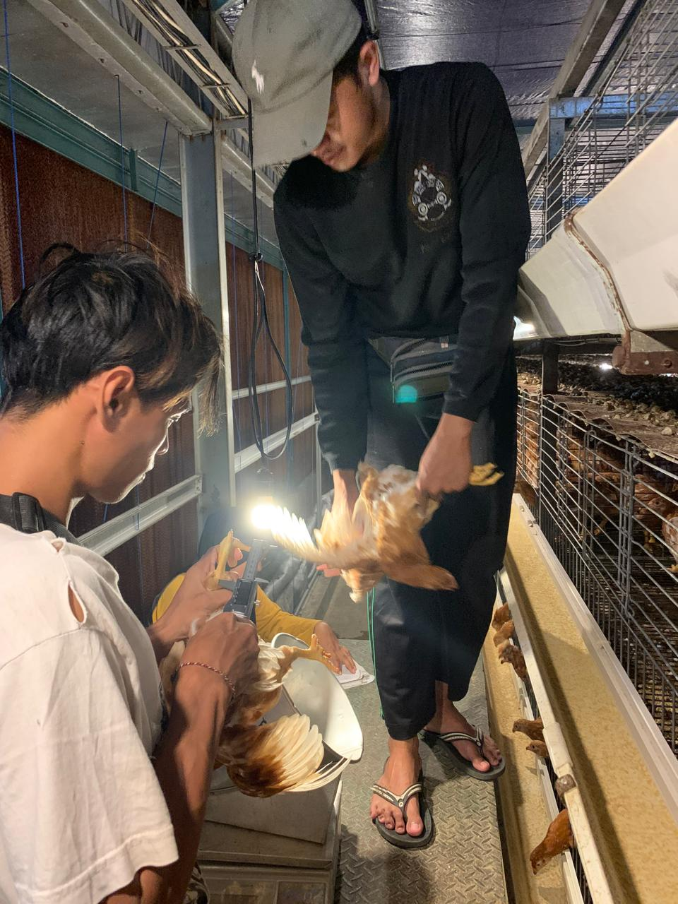
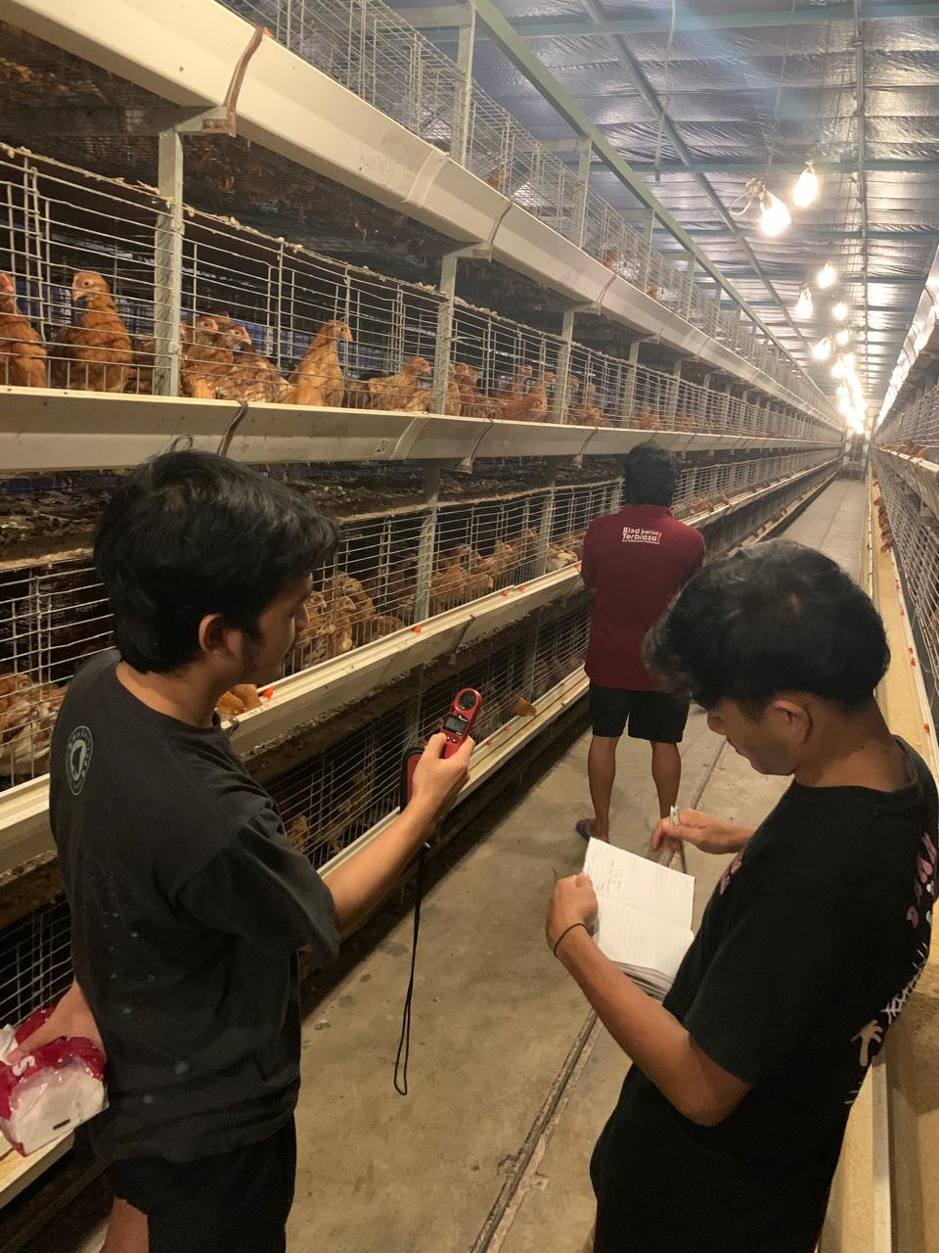
Lampiran 6. Dokumentasi Penelitian
sampling berat badan mingguan
mendata hasil cek suhu kelembapan kecepatan angin
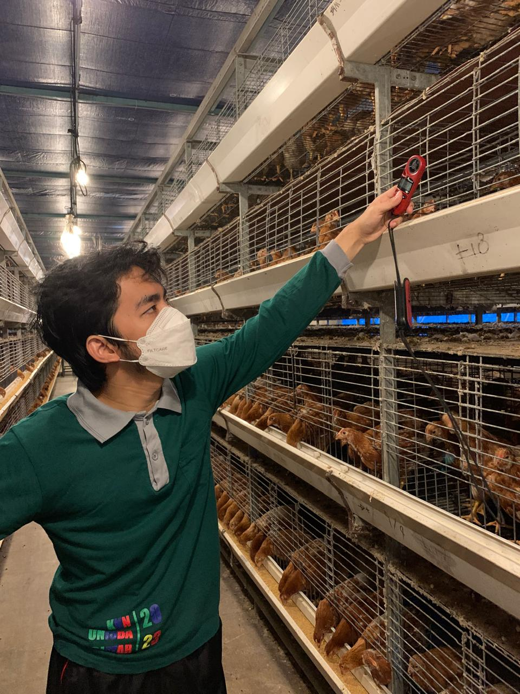
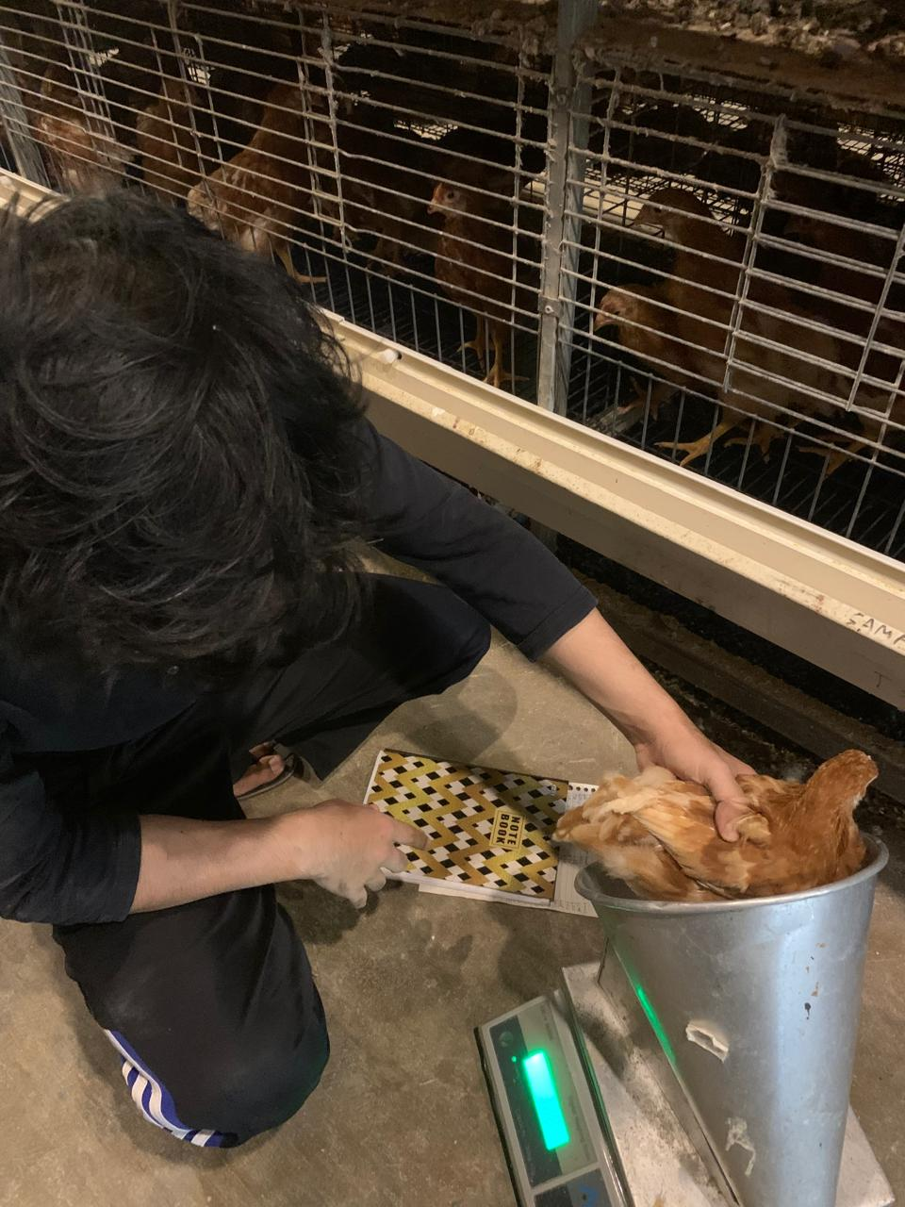

cek suhu kelembapan kecepatan angin
sampling bb mingguan

