Lampiran I
KUESIONER PENELITIAN
Petunjuk Pengisian:
Jawablah pertanyaan berikut dengan memberi tanda centang (√) pada kolom jawaban
Identitas Responden
- Nama :
- Umur : ….. Tahun
- Jenis Kelamin : Laki-Laki/Perempuan
- Pendidikan :
  - SD
  - SMP
  - SMA
  - Sarjana
- Pekerjaan :
- Swasta
- Wiraswasta
- PNS/Guru
- TNI/POLRI
- Petani
- Peternak
- Tidak/Belum bekerja

Persepsi Negatif
No | Petanyaan | 3 | 2 | 1
 | Apakah bapak/ibu merasa tergangu dengan udara bau yang berasal dari peternakan sapi perah di daerah ini ?
 | Apakah bapak/ibu merasa tergangu dengan lalat yang berasal dari peternakan sapi perah di daerah ini ?
3. | Apakah bapak/ibu merasa tergangu dengan adanya pencemaran air yang berasal dari peternakan sapi perah di daerah sini ?
Keterangan :
3 Sangat terganggu
2 Cukup Terganggu
- Tidak terganggu
Persepsi Positif
No | Petanyaan | 3 | 2 | 1
 | Apakah bapak/ibu ada keluarga yang bekerja di peternakan sapi perah?
2. | Apakah bapak/ibu merasa terbantu dengan tersedianya pupuk kandang dan susu sapi segar keperluan bapak ibu?
Keterangan :
- Sangat banyak / sangat terbantu
- Cukup ada / cukup terbantu
- Tidak ada / tidak terbantu

Lampiran II
Dokumentasi Wawancara Dengan Responden dan Perangkat Kelurahan
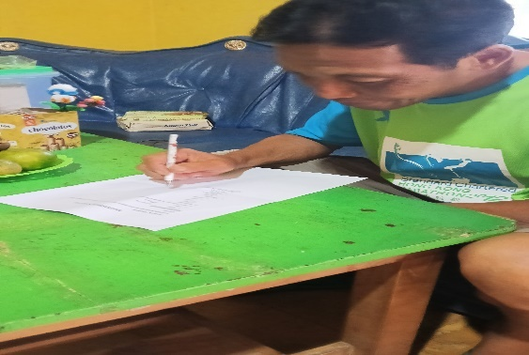
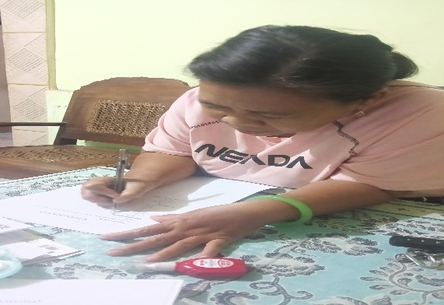
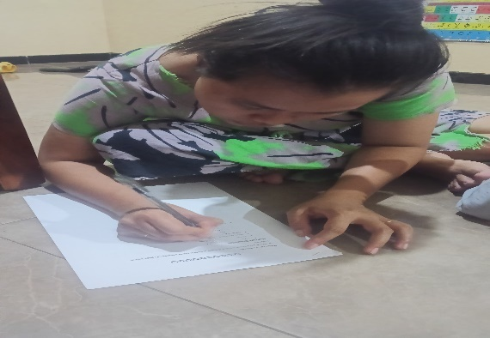
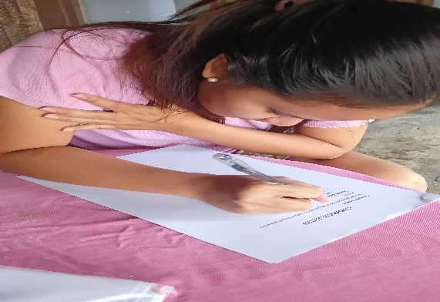
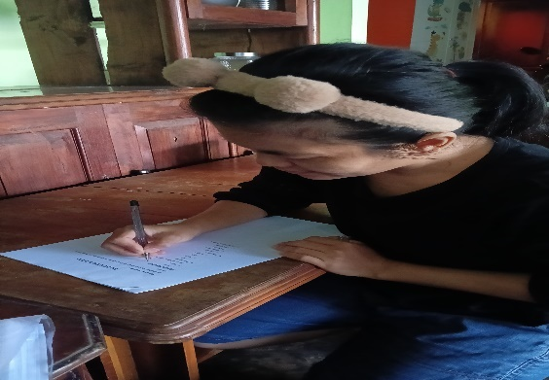
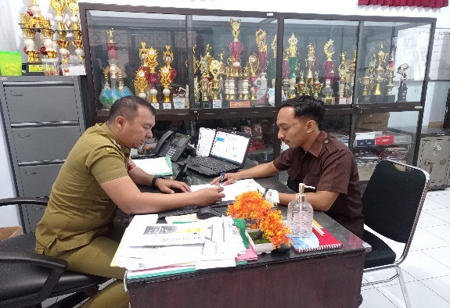

Lampiran III
DATA TABULASI RESPONDEN
Nama | Umur | Jenis Kelamin | Pendidikan | Pekerjaan | Persepsi Negatif |  |  | Total | Persepsi Positif |  | Total
 |  |  |  |  | X1.1 | X1.2 | X1.3 | Total | X2.1 | X2.2 | Total
Sunaryanti | 56 th | P | SMA | Swasta | 1 | 1 | 1 | 3 | 1 | 1 | 2
Linda | 50 th | P | SMA | Swasta | 1 | 1 | 1 | 3 | 1 | 1 | 2
Eli | 57 th | P | SMA | Swasta | 1 | 1 | 1 | 3 | 3 | 1 | 4
Aji Erwanto | 50 th | L | SMA | Swasta | 1 | 1 | 1 | 3 | 3 | 1 | 4
Yuli Riswati | 50 th | P | Sarjana | Wiraswasta | 1 | 1 | 1 | 3 | 1 | 1 | 2
Wahyuni | 43 th | P | SMA | Wiraswasta | 1 | 1 | 1 | 3 | 1 | 1 | 2
Pujo Haryono | 43 th | L | SMA | Wiraswasta | 1 | 1 | 1 | 3 | 1 | 1 | 2
Wiwit Rahayu | 27 th | L | Sarjana | Swasta | 1 | 1 | 1 | 3 | 1 | 1 | 2
Suliono | 54 th | L | SMP | Swasta | 1 | 1 | 1 | 3 | 3 | 1 | 4
Wasiana | 48 th | P | SD | Tidak/Belum Bekerja | 1 | 1 | 1 | 3 | 1 | 1 | 2
Harsono | 41TH | L | SMA | Wiraswasta | 1 | 1 | 2 | 4 | 1 | 1 | 2
RULI SOFYAN | 47TH | L | SMA | Swasta | 1 | 1 | 1 | 3 | 1 | 1 | 2
BAMBANG RIANTO | 42TH | L | SMA | Wiraswasta | 1 | 1 | 1 | 3 | 1 | 1 | 2
SATINI | 61TH | P | SMA | Swasta | 1 | 1 | 1 | 3 | 1 | 1 | 2
ERIANA | 28TH | P | SMA | Tidak/Belum Bekerja | 1 | 2 | 1 | 4 | 1 | 3 | 4
ARI SUMARDI | 40TH | L | SMA | Swasta | 1 | 1 | 1 | 3 | 2 | 1 | 3
REVALIA PUTRI ARIYANTI | 19TH | P | SMA | Tidak/Belum Bekerja | 1 | 1 | 1 | 3 | 1 | 1 | 2
NURMIASIH | 64TH | P | SD | Swasta | 1 | 1 | 2 | 4 | 1 | 1 | 2
HARI NOVIANTO | 28TH | L | SD | Swasta | 2 | 1 | 2 | 5 | 1 | 1 | 2
WAHYU EKO CAHYONO | 30TH | L | SMA | Swasta | 1 | 3 | 1 | 5 | 1 | 2 | 3
ASMARI | 53TH | L | SMA | Wiraswasta | 1 | 2 | 1 | 4 | 1 | 1 | 2
KARINA REZA IRAWAN | 21TH | P | SMP | Swasta | 1 | 2 | 3 | 5 | 2 | 2 | 4
ROHMAD | 59TH | L | SMA | Swasta | 1 | 1 | 1 | 5 | 1 | 1 | 2
FRANDYKA SUSET PUTRA | 38TH | L | SMA | Wiraswasta | 1 | 1 | 2 | 4 | 2 | 2 | 4
SUWARNO | 68TH | L | SMP | Swasta | 1 | 2 | 1 | 4 | 1 | 1 | 2
MUJIONO | 42TH | L | SMA | Swasta | 2 | 1 | 1 | 4 | 1 | 1 | 2
SUNARI | 69TH | L | SMP | PETANI | 1 | 1 | 1 | 3 | 1 | 1 | 2
ANIK RAHAYU | 51TH | P | Sarjana | PNS | 1 | 1 | 2 | 4 | 2 | 1 | 3
HASAN HUSIN | 59TH | L | Sarjana | Tidak/Belum Bekerja | 1 | 1 | 1 | 3 | 1 | 1 | 2
YUDHA AGUS WAHYUDI | 28TH | L | SMA | TNI | 1 | 1 | 1 | 3 | 1 | 1 | 2
A. A. SAPUTRA | 46TH | L | SMA | Wiraswasta | 2 | 2 | 1 | 5 | 1 | 1 | 2
RESTI UTARI | 25TH | P | Sarjana | Tidak/Belum Bekerja | 1 | 2 | 1 | 3 | 1 | 1 | 2
AGUNG PRIBADI | 38TH | L | SMP | Swasta | 1 | 1 | 1 | 3 | 1 | 2 | 3
SUCI WINTARI | 33TH | P | SMP | Tidak/Belum Bekerja | 2 | 1 | 1 | 4 | 2 | 2 | 4
NANANG ADHADI YUWANA | 50TH | L | Sarjana | TNI | 1 | 1 | 1 | 3 | 1 | 2 | 3
ANIK RUSIATI | 52TH | P | Sarjana | Tidak/Belum Bekerja | 2 | 1 | 1 | 4 | 1 | 2 | 3
MEYRA EL QOLBY YUWANA | 23TH | P | SMA | Tidak/Belum Bekerja | 1 | 1 | 2 | 4 | 1 | 2 | 3
SETIYO BUDI | 42TH | L | SMP | Swasta | 1 | 1 | 1 | 4 | 1 | 2 | 3
MAULIDA ROHWININGSIH | 40TH | P | SMP | Tidak/Belum Bekerja | 1 | 1 | 1 | 5 | 1 | 1 | 2
SUGIANTO | 48TH | L | SMA | Wiraswasta | 1 | 1 | 1 | 5 | 2 | 1 | 3
SULASTRI | 41TH | L | SMP | Tidak/Belum Bekerja | 1 | 1 | 1 | 4 | 2 | 1 | 3
SLAMET RIYADI | 42TH | L | SD | Swasta | 2 | 2 | 1 | 5 | 1 | 1 | 2
YUYUN SETIANINGSIH | 45TH | P | SMA | Swasta | 1 | 1 | 2 | 5 | 1 | 1 | 2
MOCHAMAD MUNIB | 38TH | L | SMA | Wiraswasta | 2 | 1 | 1 | 4 | 2 | 2 | 4
MISTINI ANDASARI | 48TH | P | SD | Tidak/Belum Bekerja | 1 | 2 | 2 | 4 | 2 | 2 | 4
CYNTHEA YOMI PERTIWI | 25TH | P | SMA | Swasta | 1 | 1 | 2 | 4 | 1 | 2 | 3
KODIM PRASETYO | 50TH | L | SD | Wiraswasta | 2 | 1 | 1 | 3 | 1 | 2 | 3
OPIN NURIYA AYUNINGTRIYAS | 34TH | P | SMP | Tidak/Belum Bekerja | 1 | 1 | 1 | 3 | 2 | 2 | 4
TRI KRISNA KRISTIFA SARI | 25TH | P | SMA | Swasta | 1 | 1 | 1 | 3 | 1 | 1 | 2
SULAMI | 48TH | P | SMP | Swasta | 2 | 1 | 2 | 3 | 2 | 1 | 3
ANDY KRSITIAWAN | 42TH | L | SMA | Swasta | 1 | 1 | 2 | 4 | 1 | 1 | 2
SUNARI | 52TH | L | SMP | Swasta | 1 | 2 | 1 | 3 | 1 | 1 | 2
SULASTRI | 56TH | P | SMA | Wiraswasta | 2 | 2 | 1 | 3 | 2 | 2 | 4
SUPARNI | 56TH | L | SMP | Swasta | 2 | 1 | 1 | 3 | 1 | 1 | 2
SRIANAH | 50TH | P | SMA | Tidak/Belum Bekerja | 3 | 1 | 2 | 4 | 1 | 1 | 2
ARNA SUNJAYA | 26TH | P | SMP | Swasta | 1 | 1 | 1 | 3 | 1 | 2 | 3
KUSWANTOYO | 39TH | L | SMA | Swasta | 1 | 1 | 1 | 3 | 2 | 2 | 4
BITA | 37TH | P | SMP | Swasta | 1 | 1 | 2 | 4 | 1 | 2 | 3
MUJI RAHAYU | 38TH | P | Sarjana | Wiraswasta | 1 | 1 | 1 | 3 | 2 | 1 | 3
VERY WIDOKO | 36TH | L | Sarjana | Wiraswasta | 2 | 1 | 1 | 4 | 1 | 1 | 2
FICHE MEIRIA | 39TH | P | SMA | Tidak/Belum Bekerja | 1 | 1 | 1 | 3 | 1 | 1 | 2
HARIYANTO | 51TH | L | SMA | Wiraswasta | 1 | 2 | 2 | 4 | 1 | 1 | 2
MUHAMMAD NURUL FAIZIN | 37TH | L | SMP | Swasta | 2 | 2 | 2 | 3 | 1 | 1 | 2
DIAH AYU RATNANINGRUM | 25TH | P | SMA | Wiraswasta | 2 | 3 | 1 | 6 | 1 | 1 | 2
BAMBANG SETYOKO | 49TH | L | SMA | Swasta | 1 | 2 | 1 | 4 | 1 | 1 | 2
SITI KHOLIFAH | 47TH | P | SMA | Tidak/Belum Bekerja | 2 | 3 | 1 | 6 | 1 | 1 | 2
SURATNO | 53TH | L | SMP | Swasta | 1 | 3 | 1 | 5 | 2 | 1 | 3
SRI BANUN | 73TH | P | SD | Tidak/Belum Bekerja | 2 | 1 | 2 | 5 | 1 | 1 | 2
DWI ANTORO | 54TH | L | SMA | Swasta | 1 | 3 | 1 | 5 | 1 | 1 | 2
TRISNO HARIYANTO | 56TH | L | SMA | PNS | 1 | 2 | 1 | 4 | 1 | 2 | 3
SULIA WIGANTI | 47TH | P | SD | Tidak/Belum Bekerja | 2 | 1 | 2 | 5 | 1 | 2 | 3
ETIK SUSANA | 32TH | P | SMP | Wiraswasta | 1 | 1 | 1 | 4 | 1 | 1 | 2
MARTUTIK | 50TH | P | SMA | Tidak/Belum Bekerja | 2 | 1 | 1 | 5 | 1 | 1 | 2
DANIK KRISTANTI | 45TH | P | SMA | Tidak/Belum Bekerja | 1 | 2 | 2 | 5 | 2 | 1 | 3
EKO DANUWINARSO | 42TH | L | SMP | Swasta | 2 | 1 | 2 | 5 | 2 | 2 | 4
KHUSNUL KHOTIMAH | 50TH | P | SMP | Swasta | 1 | 1 | 3 | 5 | 1 | 1 | 2
NOTO LUMBAWAN | 40TH | L | SMP | Swasta | 2 | 1 | 1 | 4 | 1 | 1 | 2
SUDJITO | 65TH | L | SD | Swasta | 3 | 1 | 1 | 5 | 1 | 1 | 2
SALSA NURWIASIH | 55TH | P | Sarjana | GURU | 2 | 1 | 1 | 4 | 2 | 2 | 4
MASHUD JULAIDI | 36TH | L | Sarjana | Wiraswasta | 1 | 2 | 1 | 4 | 1 | 2 | 3
LEO HERMAWAN BUDI SANTOSO | 46TH | L | Sarjana | Wiraswasta | 2 | 2 | 1 | 5 | 1 | 2 | 3
DILI NOVITASARI | 39TH | P | Sarjana | Swasta | 2 | 1 | 1 | 4 | 1 | 2 | 3
ANIS LUTFIANA | 38TH | P | SMA | Tidak/Belum Bekerja | 1 | 2 | 2 | 4 | 1 | 2 | 3
NANANG YULIANTO | 44TH | L | SMA | Swasta | 1 | 2 | 2 | 5 | 1 | 2 | 3
ISNI ARIANI | 38TH | P | SMA | Tidak/Belum Bekerja | 2 | 2 | 1 | 5 | 2 | 2 | 4
CATUR WITANTO | 41TH | L | SMA | Swasta | 2 | 3 | 1 | 6 | 1 | 1 | 2
NANA SUSILOWATI | 38TH | P | SMA | Swasta | 1 | 1 | 2 | 4 | 1 | 1 | 2
SUPRIHATIN | 47TH | P | SD | Tidak/Belum Bekerja | 1 | 2 | 1 | 4 | 2 | 1 | 3
MUJIANTO | 53TH | L | SMA | Swasta | 1 | 2 | 1 | 4 | 1 | 1 | 2
ANITA PRATAMA | 28TH | P | SD | Swasta | 2 | 1 | 1 | 4 | 2 | 2 | 4
ADITYA TEGAR SAPUTRA | 21TH | L | SD | Swasta | 1 | 2 | 1 | 4 | 3 | 1 | 4
HERLIN ANDRIANI | 38TH | L | SD | Wiraswasta | 1 | 1 | 1 | 4 | 2 | 1 | 3
BAMBANG KUSWOYO | 36TH | L | SMP | Swasta | 1 | 2 | 2 | 4 | 2 | 1 | 3
SARIPAH | 29TH | P | SD | Tidak/Belum Bekerja | 1 | 1 | 1 | 3 | 1 | 1 | 2
YULIA NIKEN PUJI LESTARI | 23TH | P | SMP | Tidak/Belum Bekerja | 1 | 2 | 1 | 4 | 1 | 2 | 3
ROMA HUDI FITRIANTO | 36TH | L | Sarjana | Swasta | 3 | 1 | 1 | 5 | 1 | 2 | 3
MUCHAMAD KANTAK BUDI SANTOSO | 30TH | L | SMA | Swasta | 2 | 1 | 1 | 4 | 3 | 1 | 4
AHMAD RIDHUWAN | 21TH | L | SMA | Swasta | 1 | 2 | 1 | 4 | 1 | 1 | 2

