LAMPIRAN
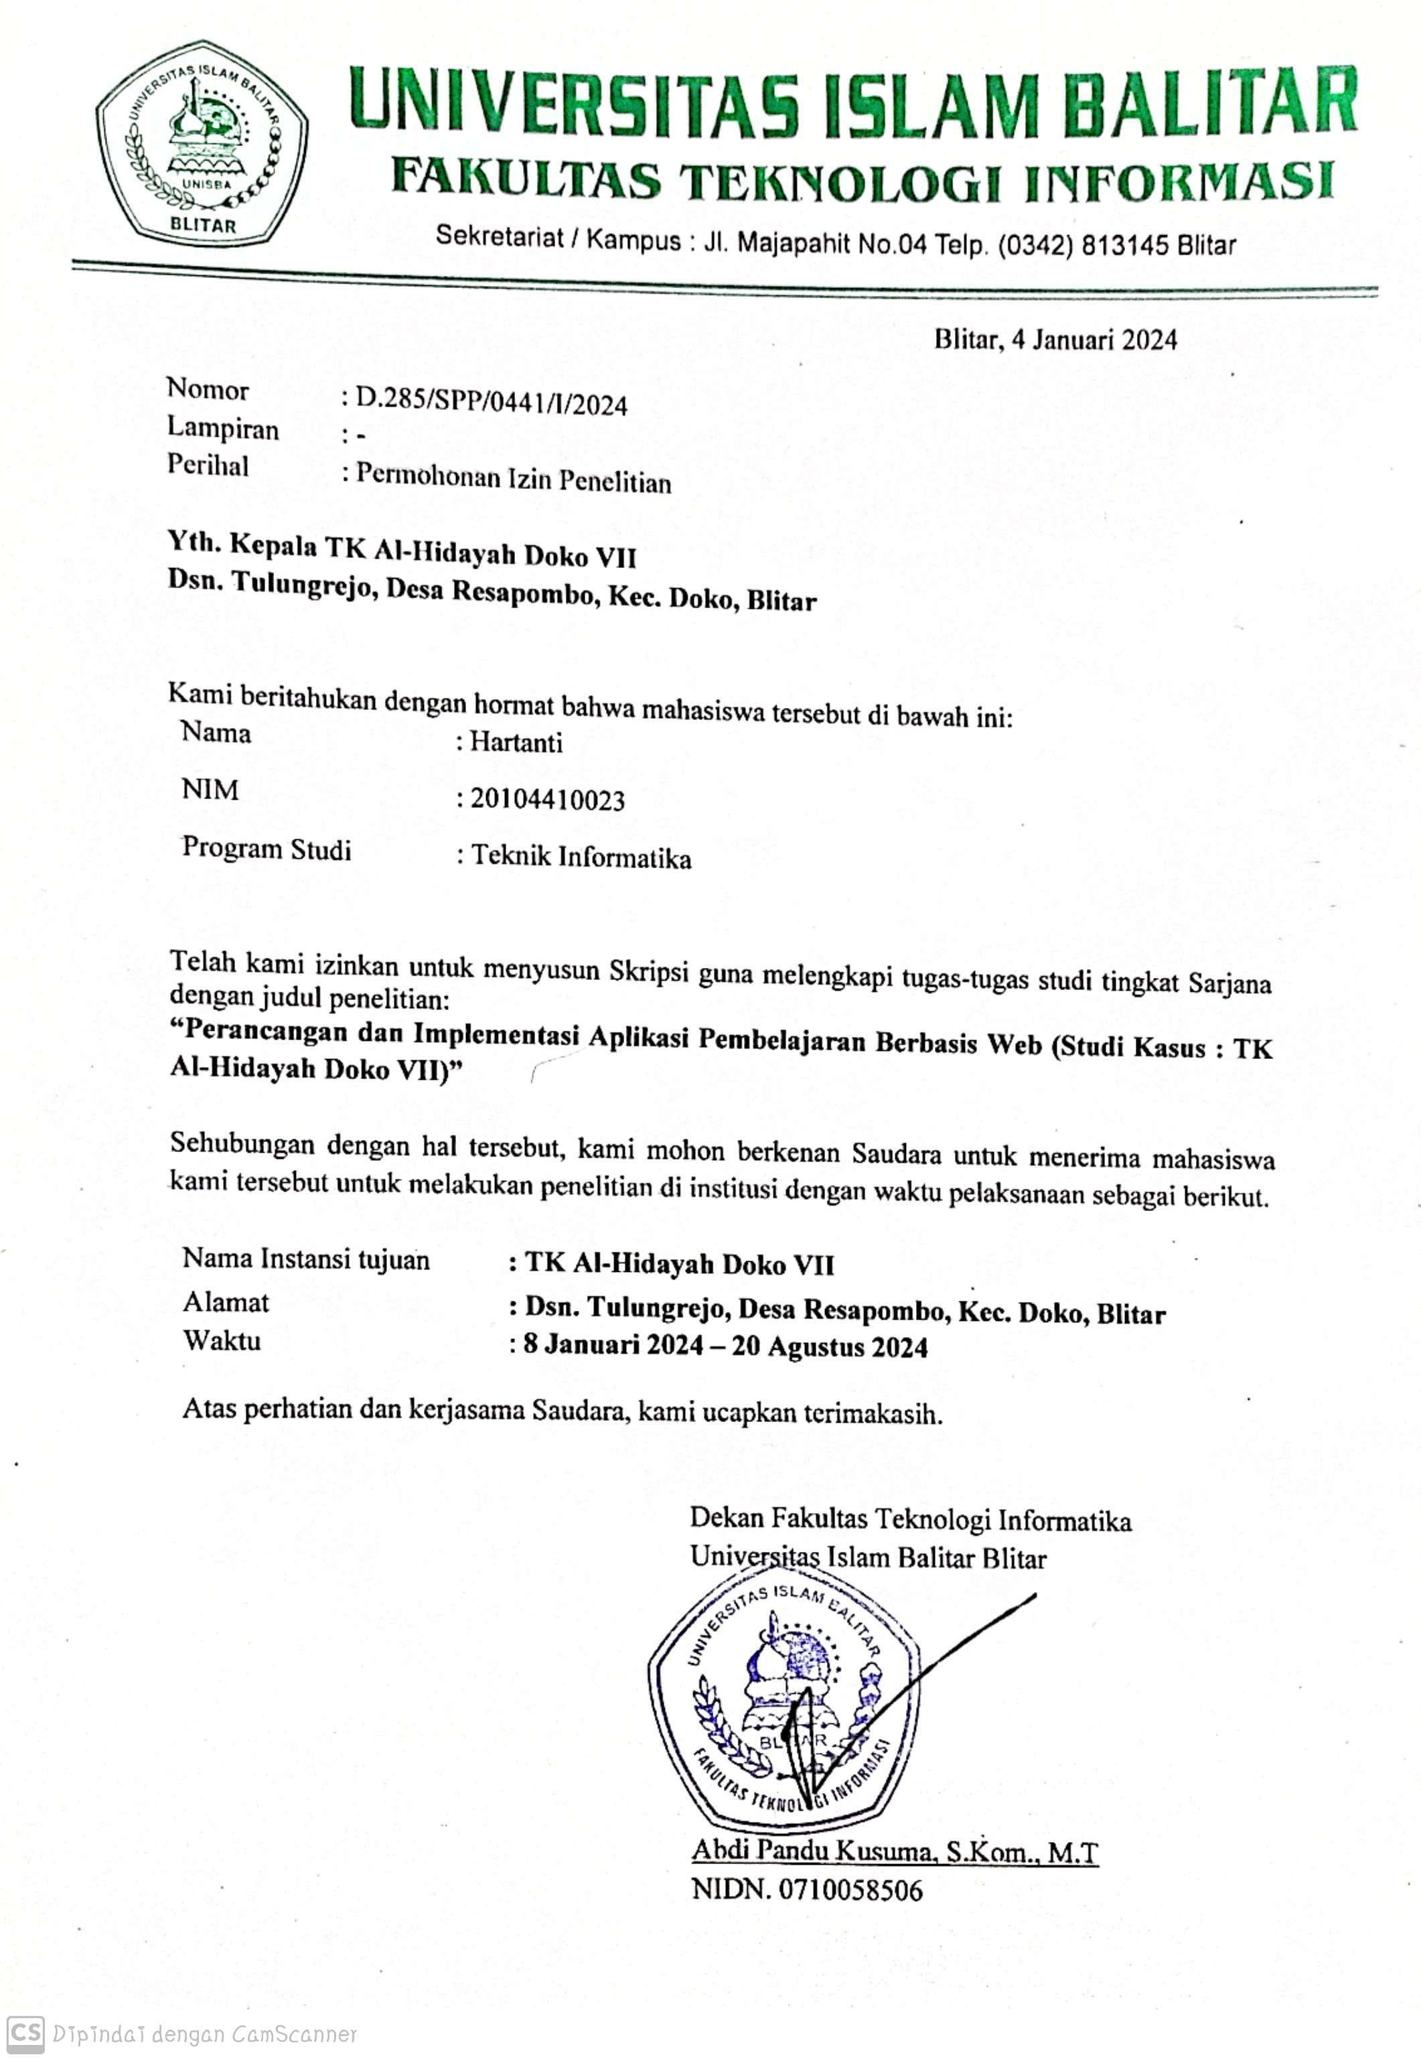
Lampiran 1. Surat Ijin Penelitian

Lampiran 2. Form Pertanyaan Wawancara
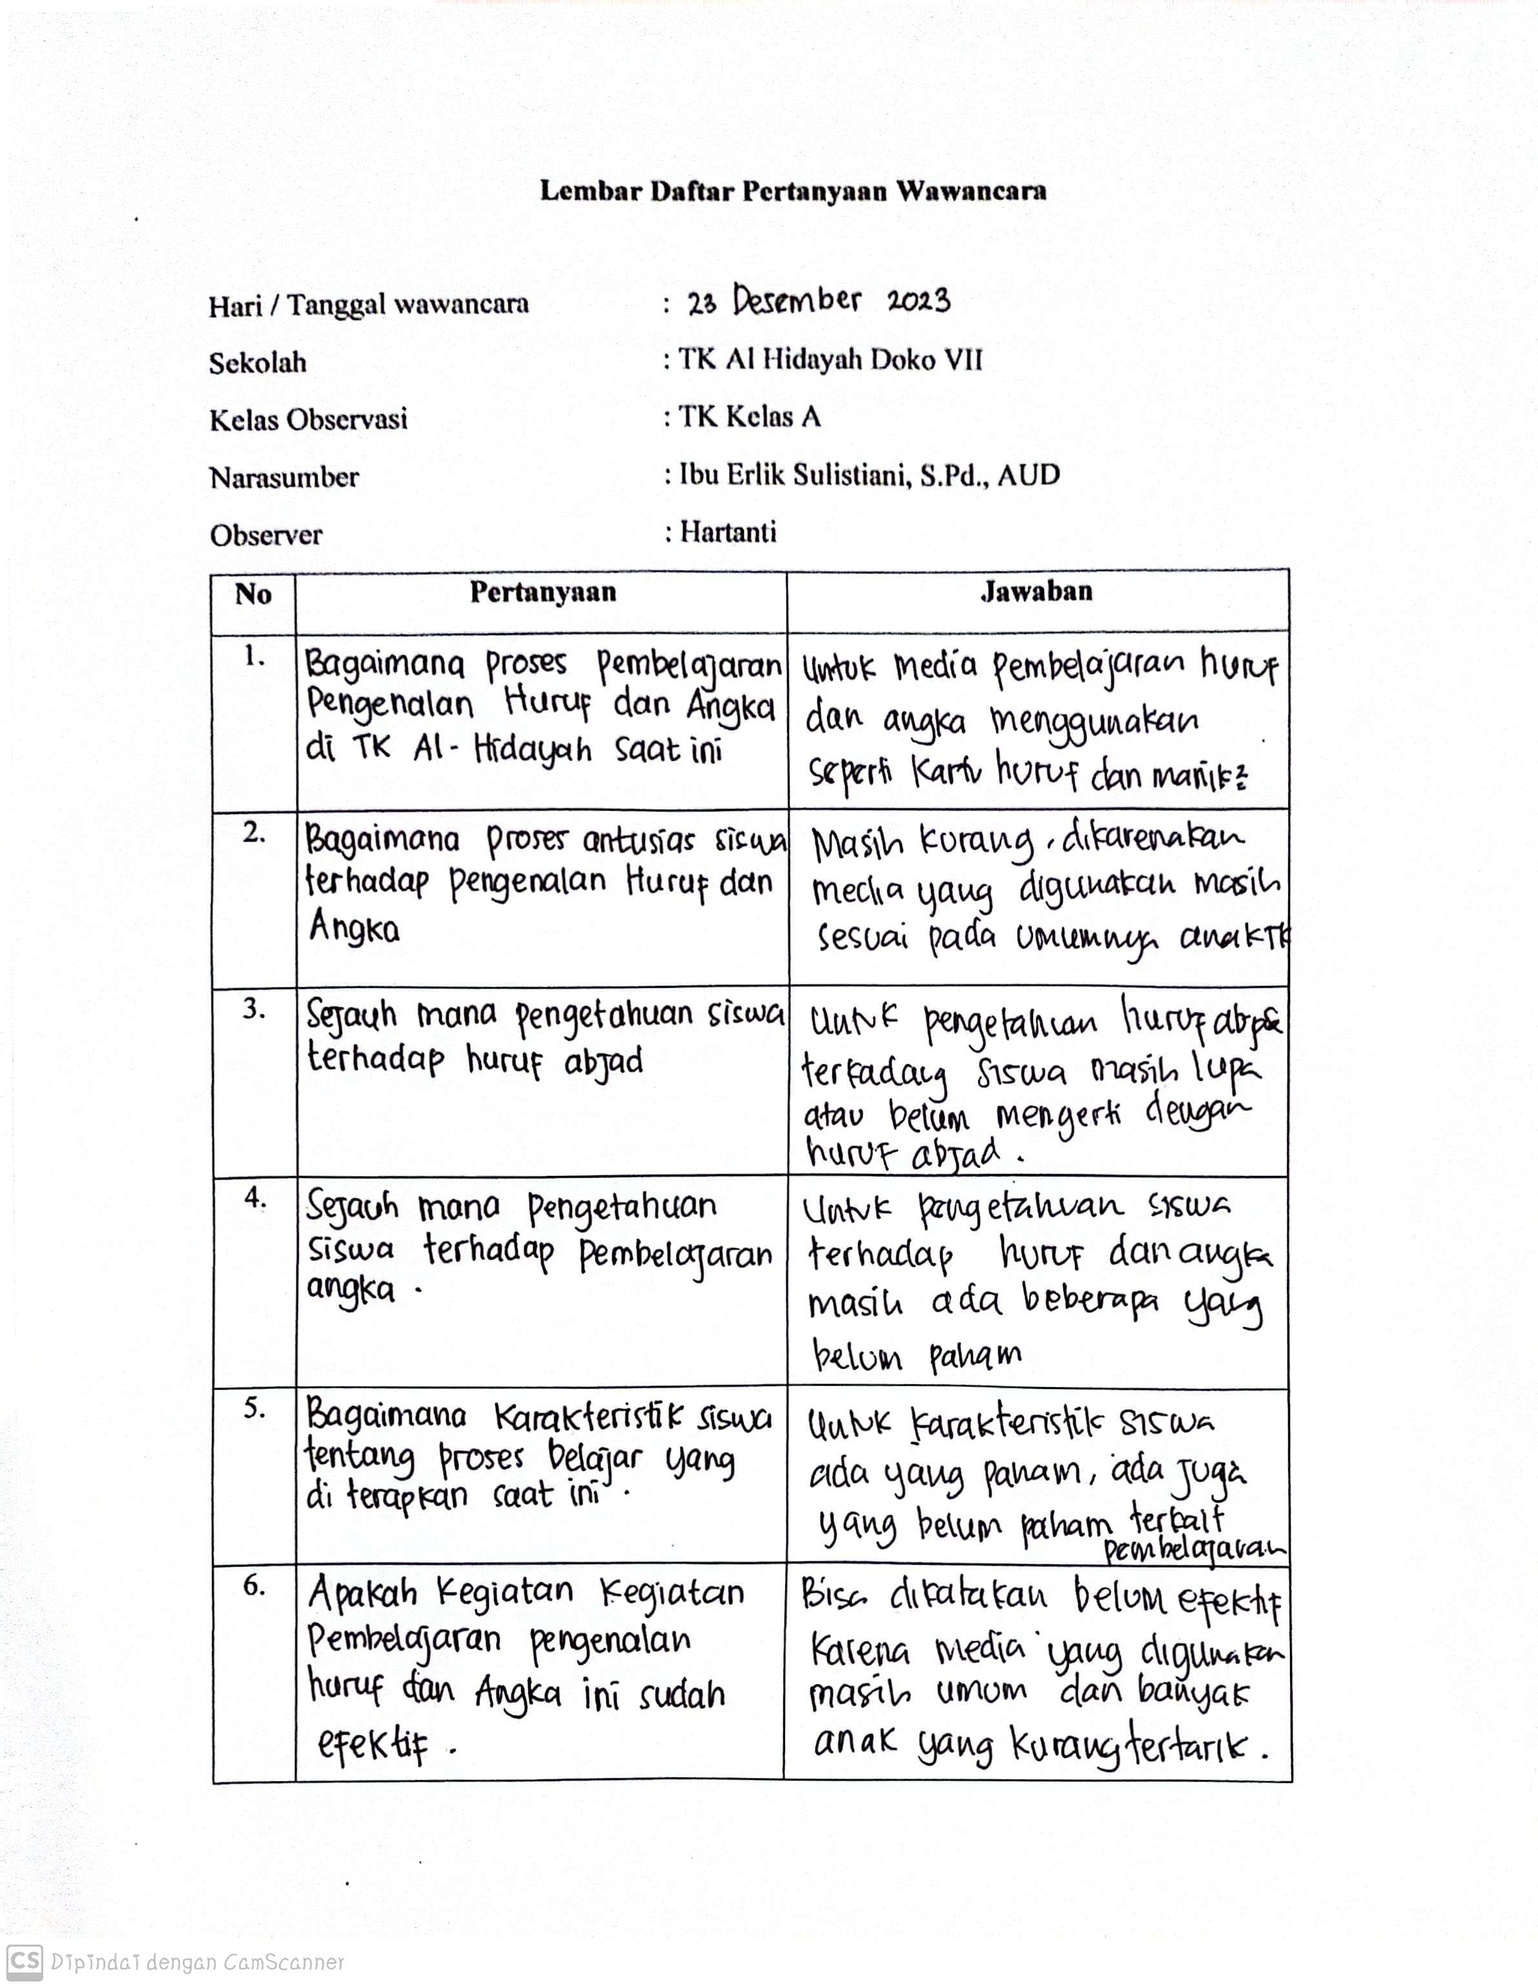
Lampiran 3. Foto Dokumentasi
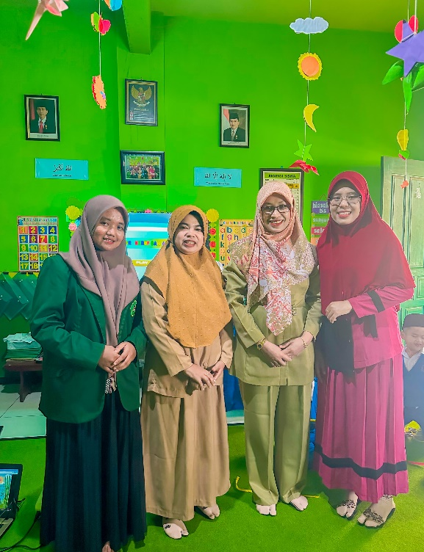

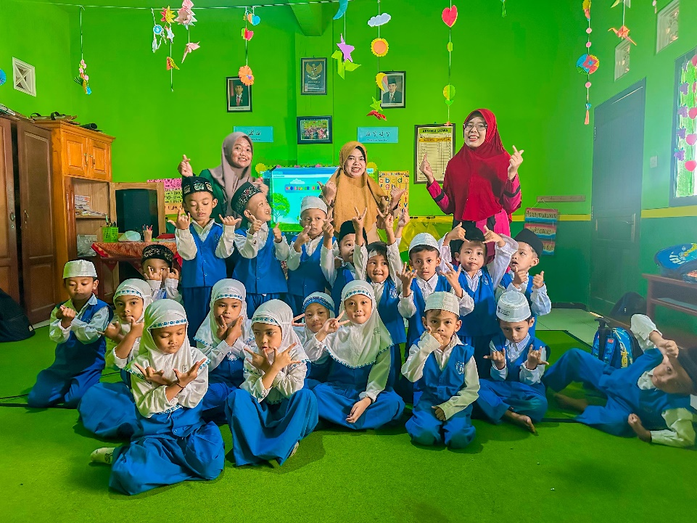

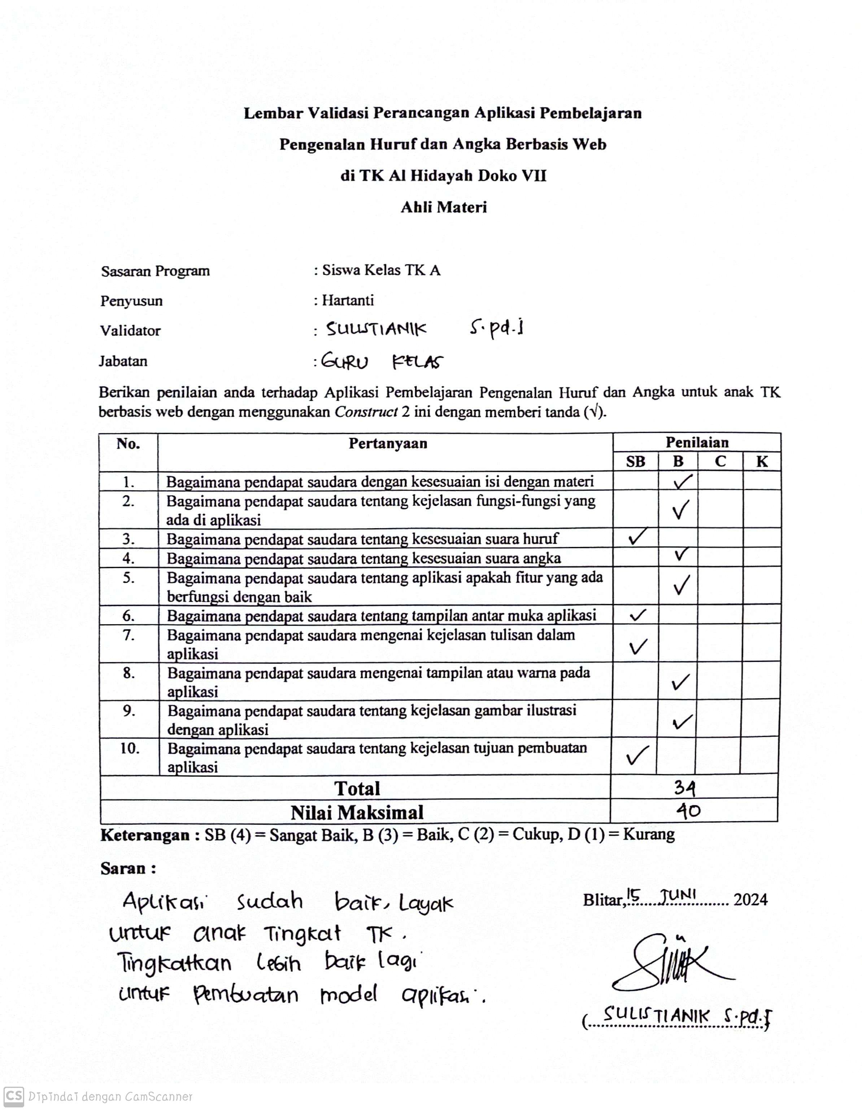
Lampiran 4. Form Validasi Ahli Materi I

Lampiran 5. Form Validasi Ahli Materi II
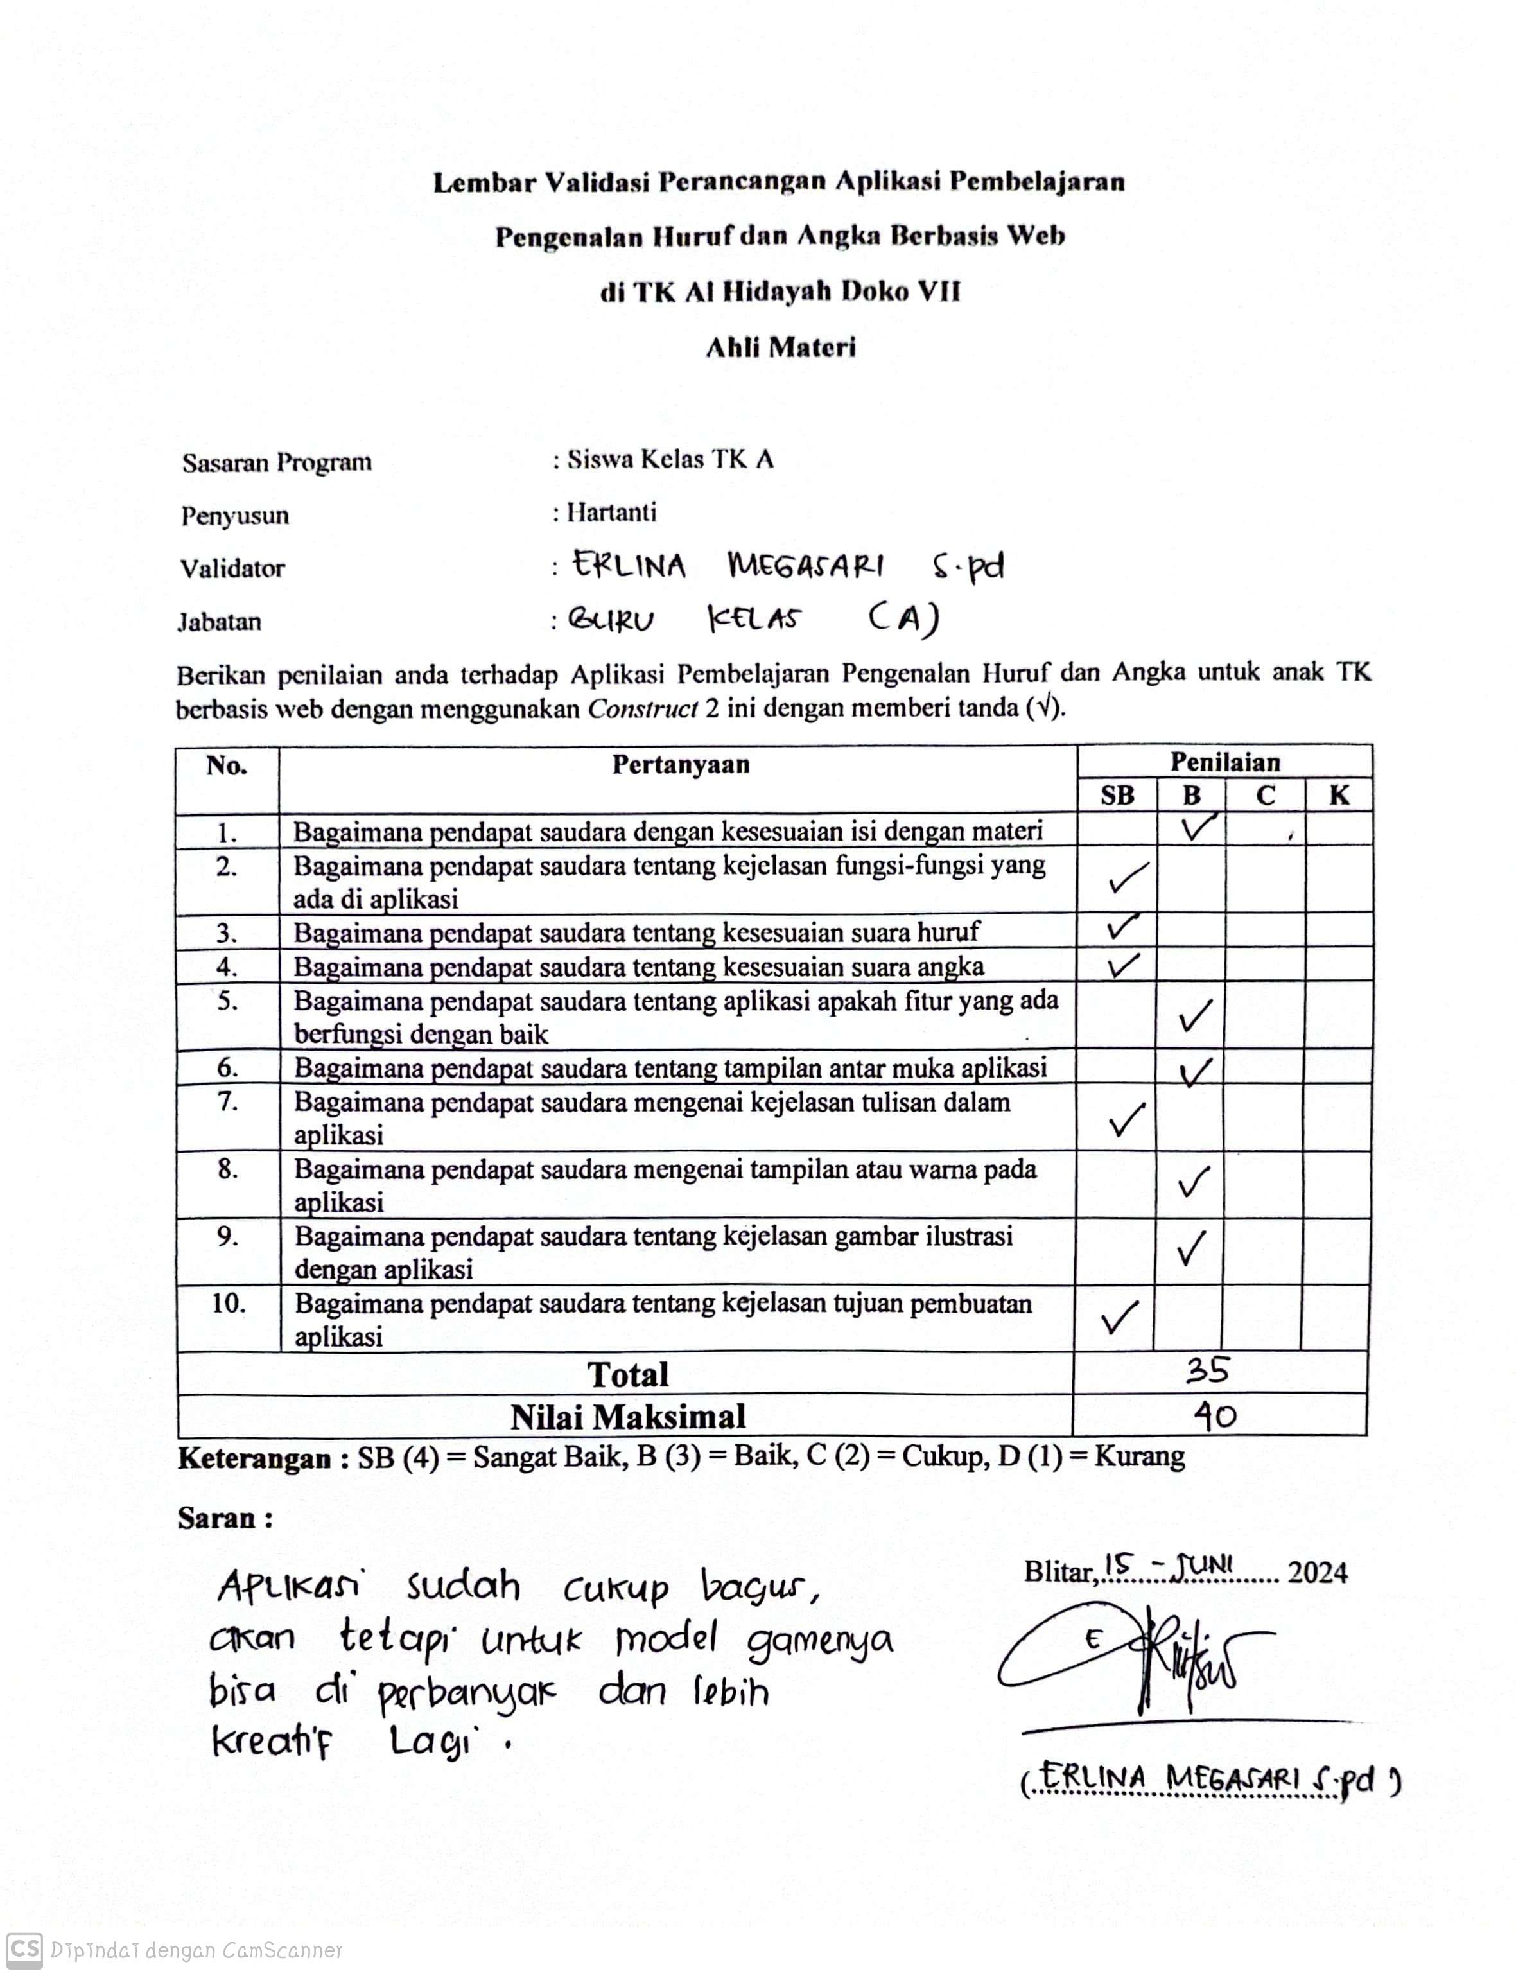

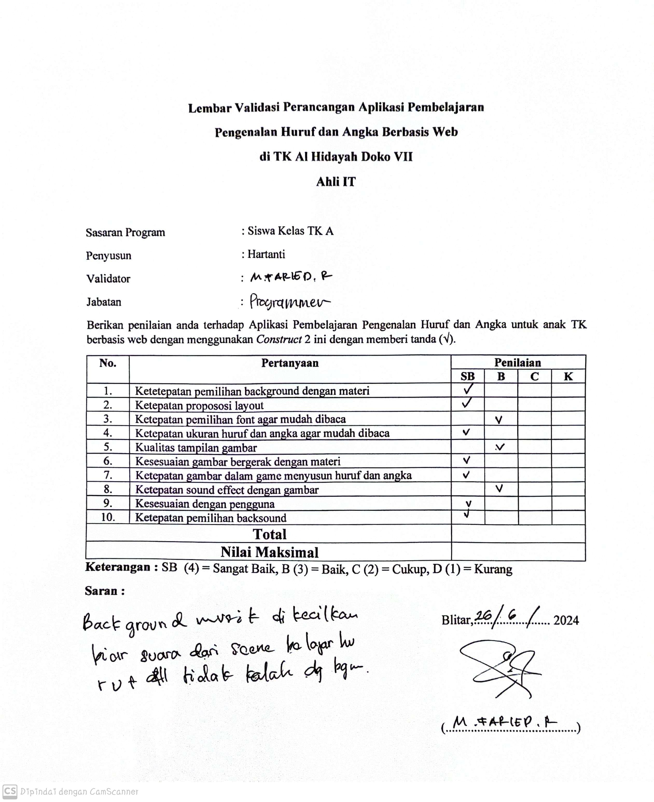
Lampiran 6. Form Validasi Ahli IT I

Lampiran 7. Form Validasi Ahli IT II

