LAMPIRAN

Lampiran I: Surat Permohonan Izin Penelitian
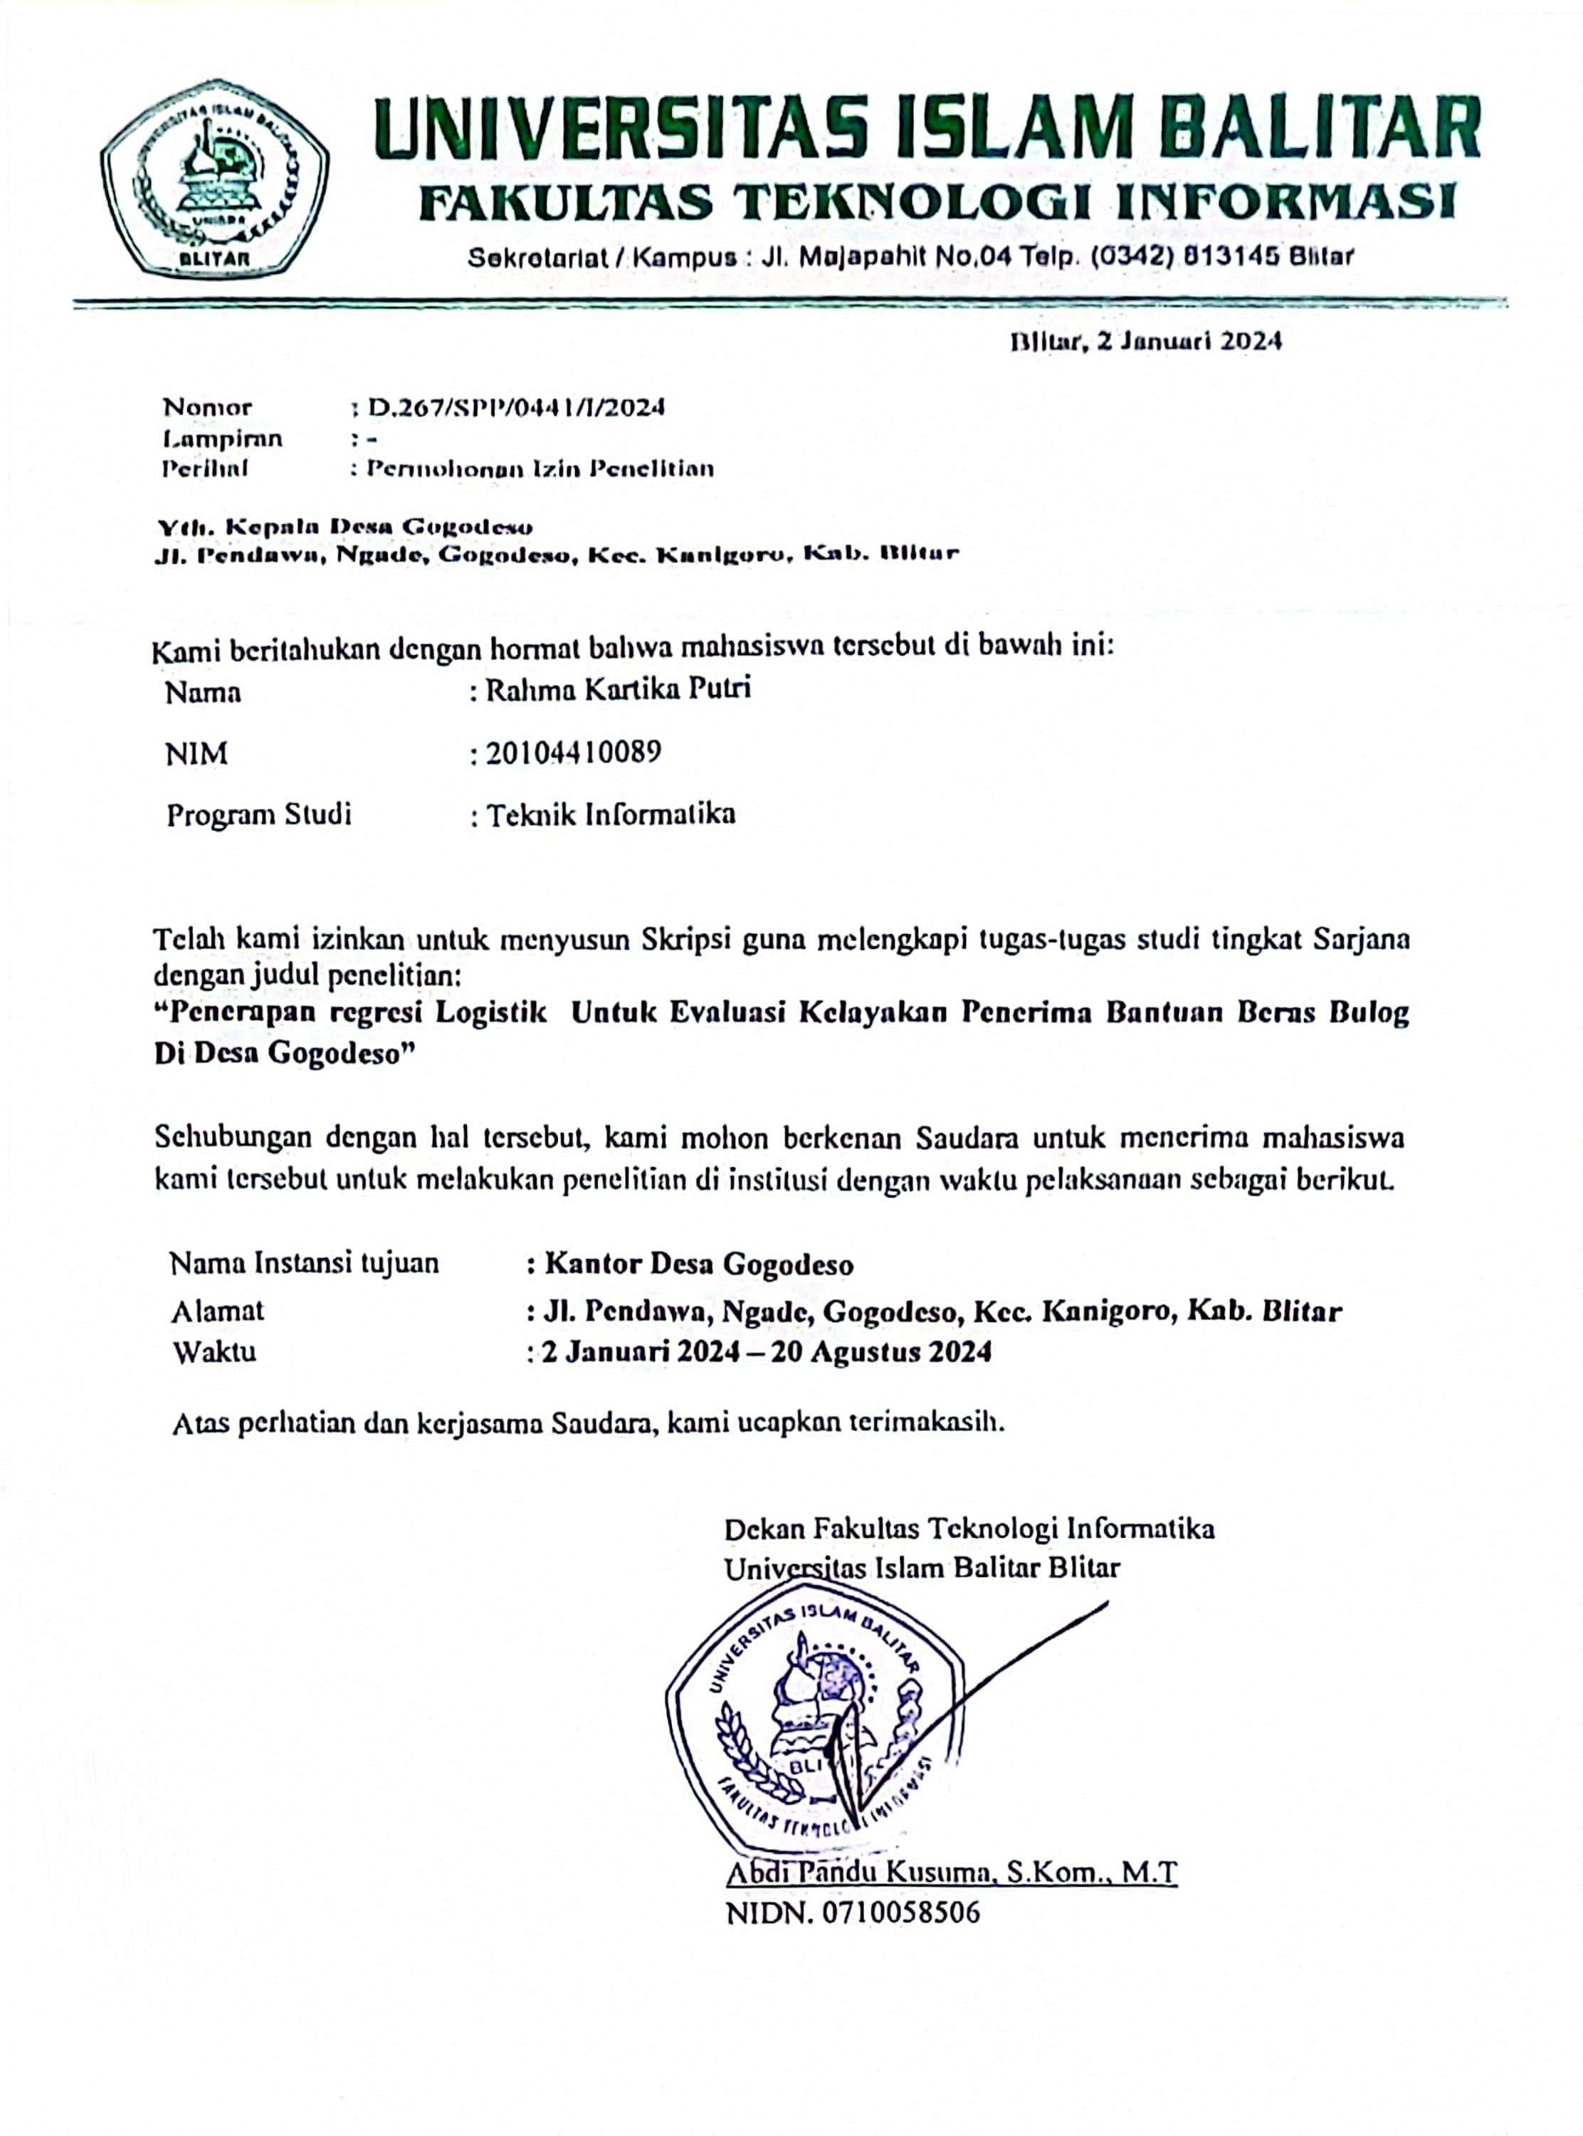
Lampiran II: Foto Pada Saat Penelitian
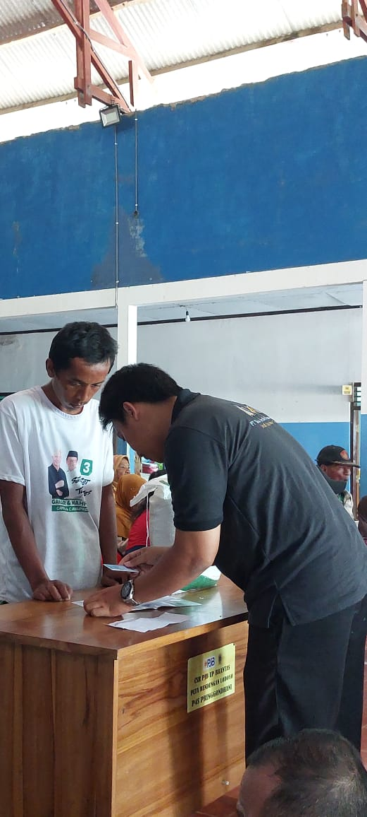 | 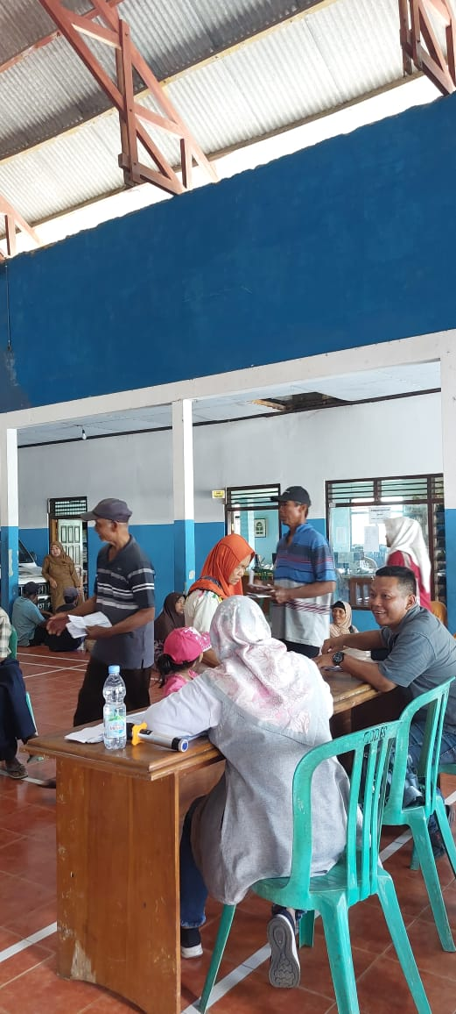 | 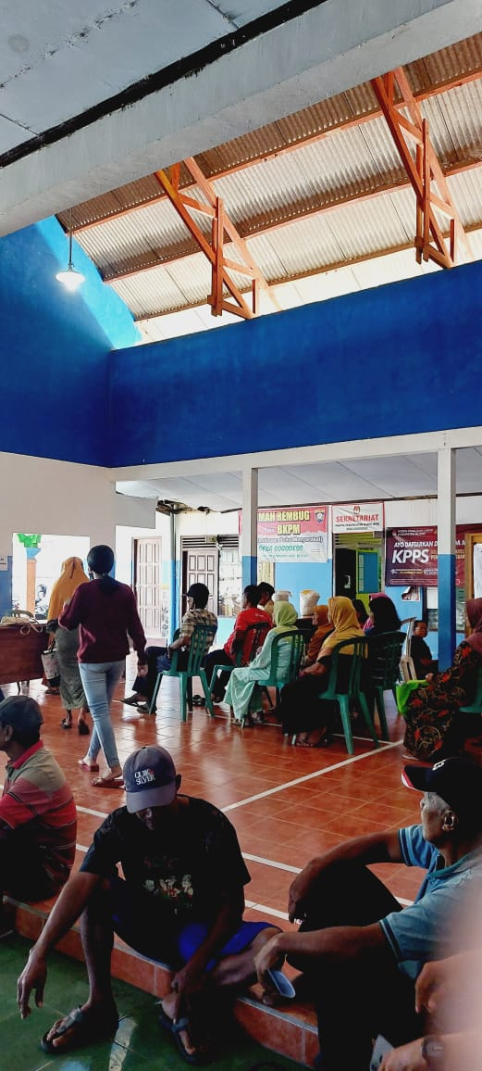
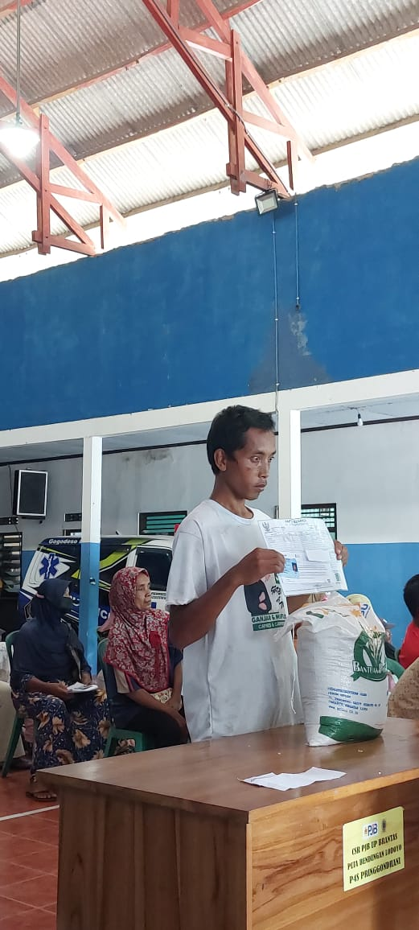 |  | 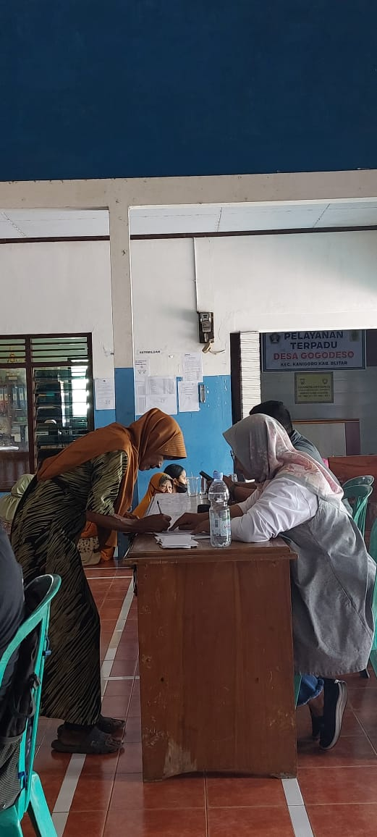

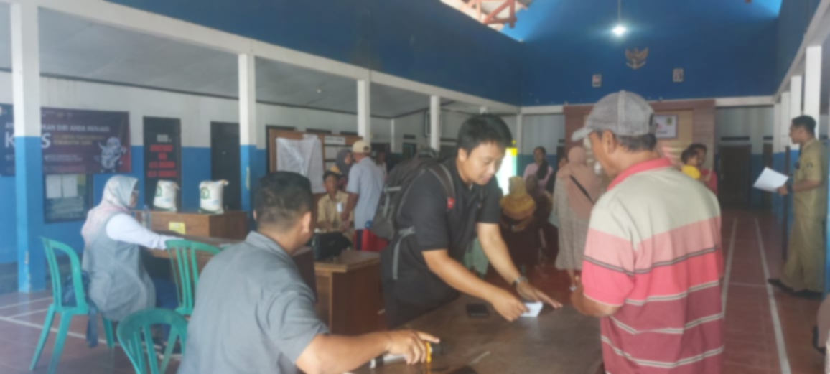
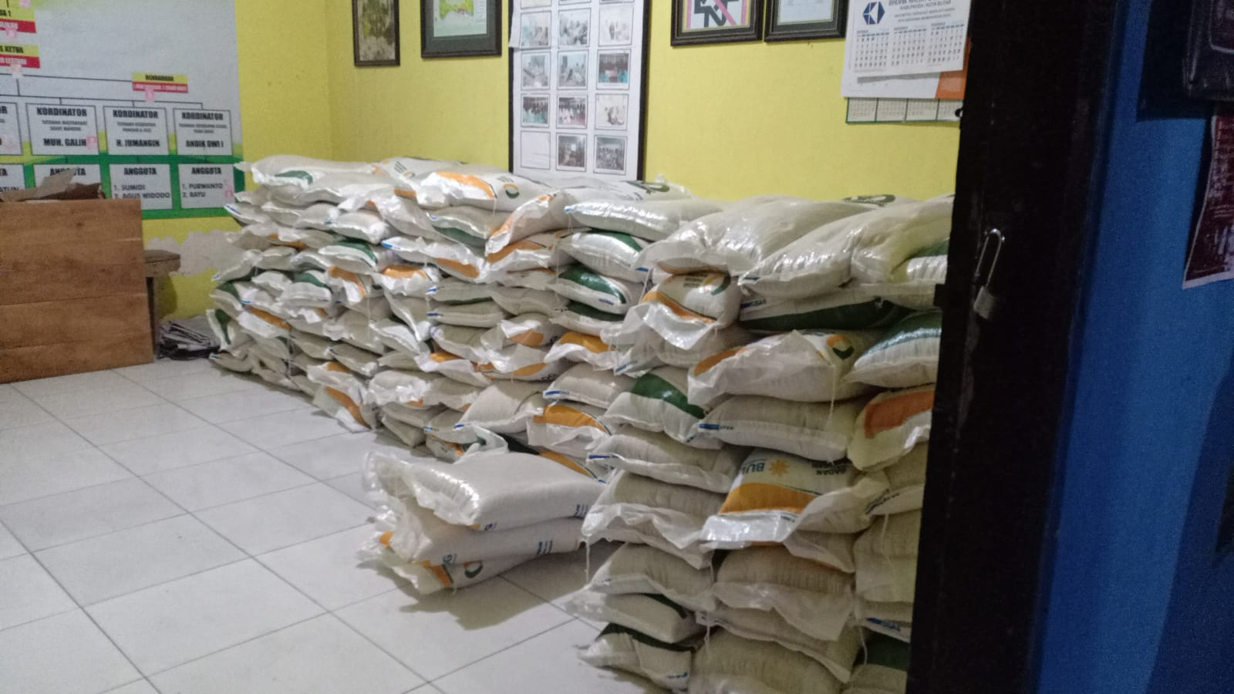


Lampiran III: Data
No | Nama | Alamat | Total Pendapatan | Kebutuhan Pokok | Status Sosial | Target
1 | Anita Dwi Anggraini | DDSN. DOGONG | 900000 | 225000 | rendah | mendapat
2 | Suratun | DSN DOGONG | 750000 | 250000 | rendah | mendapat
3 | Siti Khotimah | DSN DOGONG | 1500000 | 500000 | rendah | mendapat
4 | Rodiyah | DSN DOGONG | 1000000 | 250000 | rendah | mendapat
5 | Muklis Iwan Wibowo | DSN DOGONG | 1250000 | 416666,7 | rendah | mendapat
6 | Rombati | DSN DOGONG | 1900000 | 475000 | rendah | mendapat
7 | Sutiah | DSN DOGONG | 500000 | 166666,7 | rendah | mendapat
8 | Bibit Rahayu | DSN DOGONG | 1500000 | 750000 | rendah | mendapat
9 | Muhammad Rehan Febriansyah | DSN DOGONG | 500000 | 250000 | rendah | mendapat
10 | Suharti | DSN DOGONG | 1000000 | 200000 | rendah | mendapat
11 | Wiji | DSN DOGONG | 500000 | 500000 | rendah | mendapat
12 | Titik Suwarni | DSN DOGONG | 1000000 | 250000 | rendah | mendapat
13 | Sunarti | DSN DOGONG | 160000 | 40000 | rendah | mendapat
14 | Nur Wasito | DSN DOGONG | 2000000 | 666666,7 | tinggi | mendapat
15 | Sumartini | DSN DOGONG | 750000 | 375000 | rendah | mendapat
16 | Ratna Rahmawati | DSN DOGONG | 1650000 | 825000 | rendah | mendapat
17 | Mashfufah | DSN DOGONG | 1250000 | 312500 | rendah | mendapat
18 | Tri Tatik | DSN DOGONG | 960000 | 320000 | rendah | mendapat
19 | Jaetun | DSN DOGONG | 500000 | 250000 | rendah | mendapat
20 | Nasikin | DSN DOGONG | 1250000 | 1250000 | rendah | mendapat
21 | Surip | DSN DOGONG | 800000 | 800000 | rendah | mendapat
22 | Lilik Harmono | DSN DOGONG | 3250000 | 1625000 | tinggi | mendapat
23 | Sulamening | DSN DOGONG | 1250000 | 416666,7 | rendah | mendapat
24 | Mutmainah | DSN DOGONG | 500000 | 500000 | rendah | mendapat
25 | Fuat Zunani | DSN DOGONG | 160000 | 53333,33 | rendah | mendapat
26 | Sugeng Aminu Huda | DSN DOGONG | 900000 | 300000 | rendah | mendapat
27 | Siti Kasmiatun | DSN DOGONG | 2250000 | 750000 | tinggi | mendapat
28 | Sunarmi | DSN DOGONG | 2150000 | 1075000 | tinggi | mendapat
29 | Katmini | DSN DOGONG | 2250000 | 1125000 | tinggi | mendapat
30 | Samsiyah | DSN DOGONG | 2050000 | 1025000 | tinggi | mendapat
31 | Karmiasih | DSN DOGONG | 900000 | 300000 | rendah | mendapat
32 | Sarinem | DSN DOGONG | 1000000 | 1000000 | rendah | mendapat
33 | Eko Sugianto | DSN DOGONG | 1250000 | 1250000 | rendah | mendapat
34 | Mujiati | DSN DOGONG | 500000 | 166666,7 | rendah | mendapat
35 | Umi Masikah | DSN DOGONG | 910000 | 227500 | rendah | mendapat
36 | Siska Nur Aisyah | DSN DOGONG | 1250000 | 416666,7 | rendah | mendapat
37 | Ratna Purwanti | DSN DOGONG | 500000 | 125000 | rendah | mendapat
38 | Juwariah | DSN DOGONG | 1000000 | 500000 | rendah | mendapat
39 | Siti Rukayah | DSN DOGONG | 1500000 | 375000 | rendah | mendapat
40 | Binoto | DSN DOGONG | 1500000 | 750000 | rendah | mendapat
41 | Kairul Anam | DSN DOGONG | 2150000 | 716666,7 | tinggi | mendapat
42 | Wiwik Arumi | DSN DOGONG | 1900000 | 633333,3 | rendah | mendapat
43 | Jani | DSN DOGONG | 1500000 | 750000 | rendah | mendapat
44 | Dedy Setiyawan | DSN DOGONG | 1000000 | 250000 | rendah | mendapat
45 | Rahmat Tristan Noviandi | DSN DOGONG | 1000000 | 166666,7 | rendah | mendapat
46 | Mujiyat | DSN DOGONG | 160000 | 53333,33 | rendah | mendapat
47 | Enik Yunariyah | DSN DOGONG | 1250000 | 312500 | rendah | mendapat
48 | Mariyam | DSN DOGONG | 900000 | 450000 | rendah | mendapat
49 | Uswatun Khasanah | DSN DOGONG | 2000000 | 400000 | tinggi | mendapat
50 | Ahmad Yani | DSN DOGONG | 1900000 | 633333,3 | rendah | mendapat
51 | Siti Zulaikah | DSN DOGONG | 160000 | 40000 | rendah | mendapat
52 | Supini | DSN DOGONG | 1500000 | 750000 | rendah | mendapat
53 | Martiah | DSN DOGONG | 3000000 | 600000 | tinggi | mendapat
54 | Suharin | DSN DOGONG | 500000 | 250000 | rendah | mendapat
55 | Fatokah | DSN DOGONG | 2000000 | 1000000 | tinggi | mendapat
56 | Siti Asiyah | DSN DOGONG | 1000000 | 333333,3 | rendah | mendapat
57 | Mujinah | DSN DOGONG | 2250000 | 562500 | tinggi | mendapat
58 | Munik | DSN DOGONG | 500000 | 500000 | rendah | mendapat
59 | Siti Muninggar | DSN DOGONG | 2250000 | 562500 | tinggi | mendapat
60 | Sudarmi | DSN DOGONG | 1000000 | 125000 | rendah | mendapat
61 | Tukimin | DSN DOGONG | 1500000 | 500000 | rendah | mendapat
62 | Lasmini | DSN DOGONG | 2750000 | 916666,7 | tinggi | mendapat
63 | Mariyah | DSN DOGONG | 500000 | 500000 | rendah | mendapat
64 | Genik Hidayah | DSN DOGONG | 1000000 | 200000 | rendah | mendapat
65 | Rizal Effendi | DSN DOGONG | 2000000 | 500000 | tinggi | mendapat
66 | Lasinah | DSN DOGONG | 1000000 | 500000 | rendah | mendapat
67 | Yulastri | DSN DOGONG | 1000000 | 333333,3 | rendah | mendapat
68 | Siti Alfiah | DSN DOGONG | 1500000 | 750000 | rendah | mendapat
69 | Devi Binti Wulandari | DSN DOGONG | 1250000 | 416666,7 | rendah | mendapat
70 | Minten | DSN DOGONG | 1000000 | 1000000 | rendah | mendapat
71 | Susanti | DSN DOGONG | 750000 | 250000 | rendah | mendapat
72 | Safaroh | DSN DOGONG | 1800000 | 450000 | rendah | mendapat
73 | Yuliasih | DSN DOGONG | 1550000 | 310000 | rendah | mendapat
74 | Surini | DSN DOGONG | 1000000 | 250000 | rendah | mendapat
75 | Siti Rukoyah | DSN DOGONG | 1900000 | 633333,3 | rendah | mendapat
76 | Tukirah | DSN DOGONG | 800000 | 800000 | rendah | mendapat
77 | Susyanti | DSN DOGONG | 750000 | 187500 | rendah | mendapat
78 | Nuryati | DSN DOGONG | 2000000 | 500000 | tinggi | mendapat
79 | Sodikah | DSN DOGONG | 2250000 | 562500 | tinggi | mendapat
80 | Masithoh | DSN DOGONG | 1500000 | 500000 | rendah | mendapat
81 | Supiyati | DSN DOGONG | 1000000 | 500000 | rendah | mendapat
82 | Zulfa Anturida | DSN DOGONG | 1250000 | 1250000 | rendah | mendapat
83 | Mesiyem | DSN DOGONG | 1250000 | 1250000 | rendah | mendapat
84 | Mohtar | DSN DOGONG | 160000 | 160000 | rendah | mendapat
85 | Wiji Astutik | DSN DOGONG | 2000000 | 666666,7 | tinggi | mendapat
86 | Rosiyem | DSN DOGONG | 1250000 | 1250000 | rendah | mendapat
87 | Sirum | DSN DOGONG | 1000000 | 500000 | rendah | mendapat
88 | Bibit Utami | DSN DOGONG | 1000000 | 250000 | rendah | mendapat
89 | Supriyanto | DSN DOGONG | 900000 | 300000 | rendah | mendapat
90 | Mustakim | DSN DOGONG | 1500000 | 500000 | rendah | mendapat
91 | Boirah | DSN DOGONG | 500000 | 500000 | rendah | mendapat
92 | Dwi Novianto | DSN DOGONG | 900000 | 450000 | rendah | mendapat
93 | Suharin | Dsn Dogong | 500000 | 250000 | rendah | mendapat
94 | Sarotin | DSN DOGONG | 900000 | 300000 | rendah | mendapat
95 | Romiati | DSN DOGONG | 2000000 | 500000 | tinggi | mendapat
96 | Tukinem | DSN DOGONG | 3000000 | 1000000 | tinggi | mendapat
97 | Muniyem | DSN DOGONG | 800000 | 800000 | rendah | mendapat
98 | Mariyah | DSN DOGONG | 750000 | 375000 | rendah | mendapat
99 | Kavita Dira Puspita | DSN DOGONG | 1250000 | 416666,7 | rendah | mendapat
100 | Susi Andriani | DSN DOGONG | 1000000 | 250000 | rendah | mendapat
Link data: https://docs.google.com/spreadsheets/d/1Eww88VT4S2LgRT1Om6_D1vaE-5-HLBjJ/edit?usp=sharing&ouid=107205766004201889256&rtpof=true&sd=true
Lampiran IV: Coding
import pandas as pd
import numpy as np
import statsmodels.api as sm
from sklearn.preprocessing import LabelEncoder
from sklearn.model_selection import train_test_split
from sklearn.linear_model import LogisticRegression
from sklearn.preprocessing import StandardScaler, MinMaxScaler
from sklearn.metrics import accuracy_score, confusion_matrix, classification_report,recall_score
from sklearn.metrics import roc_auc_score, precision_score,f1_score
import matplotlib.pyplot as plt
from imblearn import SMOTE
from google.colab import drive
drive.mount('/content/drive')
%cd "/content/drive/MyDrive/Data"
df.duplicated().sum())
df
def kategori_pendapatan(pendapatan):
if pendapatan <= 500000:
return "1"
elif pendapatan <= 1500000:
return "2"
else:
return "3"
def kategori_kebutuhan(kebutuhan):
if kebutuhan <= 500000:
return "1"
elif kebutuhan <= 700000:
return "2"
else:
return "3"
# Tambahkan kolom kategori pendapatan ke DataFrame
df['Kategori Pendapatan'] = df['Total Pendapatan'].apply(kategori_pendapatan)
df['Kategori Kebutuhan'] = df['Kebutuhan Pokok'].apply(kategori_kebutuhan)
# Mengubah tipe data yang ada pada setiap kolom
le=LabelEncoder()
df["Status Sosial"]=le.fit_transform(df["Status Sosial"])
#df["Target"]=le.fit_transform(df["Target"])
# Buat mapping untuk encoding
mapping = {'mendapat': 1, 'tidak': 0}
df['Encoded_Target'] = df['Target'].map(mapping)
df['Encoded_Target'] = df['Target'].map(mapping)
df.drop('Target', axis=1, inplace=True) #hapus kolom
df['Kategori Kebutuhan'] = df['Kebutuhan Pokok'].apply(kategori_kebutuhan)
df = df.rename(columns={'Encoded_Target': 'Target'}) #merubah nama kolom
print(df)
# memisahkan antara data train dan test
X= df.drop(['No', 'Nama ','Target','Umur','Alamat','Anggota Keluarga','Total Pendapatan','Kebutuhan Pokok'], axis=1)
x= df['Target']
X_train, X_test, y_train, y_test = train_test_split(X, y, test_size=0.2, random_state=2022)
X= df.drop(['No', 'Nama ','Target','Umur','Alamat','Anggota Keluarga','Total Pendapatan','Kebutuhan Pokok'], axis=1)
y= df['Target']
#Skala data
scaler = StandarScaler()
X_train_scaled = scaler.fit_transfo(X_train)
X_test_scaled = scaler.transform(X_test)
# Membuat model regresi logistik
model = LogisticRegresion(max_iter=1000)
model.fi(X_train_scaled, y_train_resampled) # Melatih model menggunakan data latih
y_pred = model.predict(X_test_scaled) # Melakukan prediksi pada data uji
X_train_with_const = add_constant(X_train_scaled) # Menambahkan kolom konstanta ke data latih
result = model () #Model statsmodels
print(result.summary())
# Menghitung confusion matrix
model.fi(X_train_scaled, y_train_resampled)
conf_matrix = confusion_matrix(y_test, y_pred)
print("confusion matrix:")
print(conf_matrix)
# Evaluasi model
y_pred = model.(X_test_scaled)
accuracy = accuracy_score(y_test, y_pred)
print("Accuracy:", accuracy)
print("Classification Report:")
print(classification_report(y_test, y_pred))
# Menggunakan statsmodels untuk uji Wald
X_train = add_constant(X_train_scaled)
result = model_stats.fit()
y_pred = model.(X_test_scaled)
wald = result.wald_test_terms()
print('Uji Wald:', wald)
# Skalasi data
scaler = StandardScaler()
X_train_scaled = scaler.fit_transform(X_train_resampled2)

