LAMPIRAN

Lampiran 1. Sidik Ragam dan Uji Lanjut Tinggi Tanaman Kedelai Umur 1, 2, 3, 4 dan 5 MST.

Tests of Between-Subjects Effects

Dependent Variable: Tinggi Tanaman 1 MST
Source |  | Type III Sum of Squares | Df | Mean Square | F | Sig.
S | Hypothesis | 36,287 | 2 | 18,144 | 75,642 | ,000
S | Error | 3,838 | 16 | ,240ª
B | Hypothesis | 9,287 | 2 | 4,644 | 19,360 | ,000
B | Error | 3,838 | 16 | ,240ª
Ulangan | Hypothesis | 10,574 | 2 | 5,287 | 22,042 | ,000
Ulangan | Error | 3,838 | 16 | ,240ª
S * B | Hypothesis | 21,284 | 4 | 5,321 | 22,184 | ,000
S * B | Error | 3,838 | 16 | ,240ª
a. MS(Error)

Tests of Between-Subjects Effects

Dependent Variable: Tinggi Tanaman 2 MST
Source |  | Type III Sum of Squares | Df | Mean Square | F | Sig.
S | Hypothesis | 52,298 | 2 | 26,149 | 127,910 | ,000
S | Error | 3,271 | 16 | ,204ª
B | Hypothesis | 7,592 | 2 | 3,796 | 18,569 | ,000
B | Error | 3,271 | 16 | ,204ª
Ulangan | Hypothesis | 25,826 | 2 | 12,913 | 63,164 | ,000
Ulangan | Error | 3,271 | 16 | ,204ª
S * B | Hypothesis | 28,373 | 4 | 7,093 | 34,697 | ,000
S * B | Error | 3,271 | 16 | ,204ª
a. MS(Error)

Tests of Between-Subjects Effects

Dependent Variable: Tinggi Tanaman 3 MST
Source |  | Type III Sum of Squares | Df | Mean Square | F | Sig.
S | Hypothesis | 122,907 | 2 | 61,454 | 77,062 | ,000
S | Error | 12,759 | 16 | ,797ª
B | Hypothesis | 13,019 | 2 | 6,509 | 8,163 | ,004
B | Error | 12,759 | 16 | ,797ª
Ulangan | Hypothesis | 42,241 | 2 | 21,120 | 26,485 | ,000
Ulangan | Error | 12,759 | 16 | ,797ª
S * B | Hypothesis | 41,593 | 4 | 10,398 | 13,039 | ,000
S * B | Error | 12,759 | 16 | ,797ª
a. MS(Error)

Tests of Between-Subjects Effects

Dependent Variable: Tinggi Tanaman 4 MST
Source |  | Type III Sum of Squares | Df | Mean Square | F | Sig.
S | Hypothesis | 379,290 | 2 | 189,645 | 134,062 | ,000
S | Error | 22,634 | 16 | 1,415ª
B | Hypothesis | 37,365 | 2 | 18,682 | 13,207 | ,000
B | Error | 22,634 | 16 | 1,415ª
Ulangan | Hypothesis | 66,681 | 2 | 33,341 | 23,569 | ,000
Ulangan | Error | 22,634 | 16 | 1,415ª
S * B | Hypothesis | 61,385 | 4 | 15,346 | 10,848 | ,000
S * B | Error | 22,634 | 16 | 1,415ª
a. MS(Error)

Tests of Between-Subjects Effects

Dependent Variable: Tinggi Tanaman 5 MST
Source |  | Type III Sum of Squares | Df | Mean Square | F | Sig.
S | Hypothesis | 279,019 | 2 | 139,509 | 250,075 | ,000
S | Error | 8,926 | 16 | ,558ª
B | Hypothesis | 25,352 | 2 | 12,676 | 22,722 | ,000
B | Error | 8,926 | 16 | ,558ª
Ulangan | Hypothesis | 82,074 | 2 | 41,037 | 73,560 | ,000
Ulangan | Error | 8,926 | 16 | ,558ª
S * B | Hypothesis | 42,870 | 4 | 10,718 | 19,212 | ,000
S * B | Error | 8,926 | 16 | ,558ª
a. MS(Error)

Kombinasi Perlakuan | Tinggi Tanaman (cm)
Kombinasi Perlakuan | 1 MST | 2 MST | 3 MST | 4 MST | 5 MST
B1S1 (6 ml/L Bionanofertilizer + 6 gr/tan NPK) | 9,7 ab | 16,7 ab | 28,3 abc | 32,2 abc | 55 abc
B1S2 (6 ml/L Bionanofertilizer + 9 gr/tan NPK) | 10,1 ab | 17,1 ab | 29,8 bc | 35,3 bcd | 56 bc
B1S3 (6 ml/L Bionanofertilizer + 12 gr/tan NPK) | 9,5 ab | 16,7 ab | 28,2 abc | 33,2 abc | 54,2 abc
B2S1 (9 ml/L Bionanofertilizer + 6 gr/tan NPK) | 10,3 ab | 17,4 ab | 30,3 bc | 37 cd | 57,3 c
B2S2 (9 ml/L Bionanofertilizer + 9 gr/tan NPK) | 14,5 c | 21,7 c | 35,3 d | 44 e | 63,3 d
B2S3 (9 ml/L Bionanofertilizer + 12 gr/tan NPK) | 11,2 b | 18 b | 31,2 c | 38,9 d | 58,3 c
B3S1 (12 ml/L Bionanofertilizer + 6 gr/tan NPK) | 9,6 ab | 16,5 ab | 28 abc | 32 ab | 52,2 ab
B3S2 (12 ml/L Bionanofertilizer + 9 gr/tan NPK) | 9a | 15 a | 26 a | 30,2 a | 51,3 a
B3S3 (12 ml/L Bionanofertilizer + 12 gr/tan NPK) | 9,5 ab | 15,5 a | 27,5 ab | 31,1 ab | 52 ab

Lampiran 2. Sidik Ragam dan Uji Lanjut Diameter Batang Tanaman Kedelai Umur 1, 2, 3, 4 dan 5 MST.

Tests of Between-Subjects Effects

Dependent Variable: Diameter Batang 1 MST
Source |  | Type III Sum of Squares | df | Mean Square | F | Sig.
S | Hypothesis | 94,296 | 2 | 47,148 | 122,699 | ,000
S | Error | 6,148 | 16 | ,384ª
B | Hypothesis | 8,296 | 2 | 4,148 | 10,795 | ,001
B | Error | 6,148 | 16 | ,384ª
Ulangan | Hypothesis | 51,185 | 2 | 25,593 | 66,602 | ,000
Ulangan | Error | 6,148 | 16 | ,384ª
S * B | Hypothesis | 35,926 | 4 | 8,981 | 23,373 | ,000
S * B | Error | 6,148 | 16 | ,384ª
a. MS(Error)

Tests of Between-Subjects Effects

Dependent Variable: Diameter Batang 2 MST
Source |  | Type III Sum of Squares | Df | Mean Square | F | Sig.
S | Hypothesis | 105,056 | 2 | 52,528 | 95,145 | ,000
S | Error | 8,833 | 16 | ,552ª
B | Hypothesis | 27,556 | 2 | 13,778 | 24,956 | ,000
B | Error | 8,833 | 16 | ,552ª
Ulangan | Hypothesis | 28,167 | 2 | 14,083 | 25,509 | ,000
Ulangan | Error | 8,833 | 16 | ,552ª
S * B | Hypothesis | 61,556 | 4 | 15,389 | 27,874 | ,000
S * B | Error | 8,833 | 16 | ,552ª
a. MS(Error)

Tests of Between-Subjects Effects

Dependent Variable: Diameter Batang 3 MST
Source |  | Type III Sum of Squares | Df | Mean Square | F | Sig.
S | Hypothesis | 234,963 | 2 | 117,481 | 185,226 | ,000
S | Error | 10,148 | 16 | ,634ª
B | Hypothesis | 26,741 | 2 | 13,370 | 21,080 | ,000
B | Error | 10,148 | 16 | ,634ª
Ulangan | Hypothesis | 103,185 | 2 | 51,593 | 81,343 | ,000
Ulangan | Error | 10,148 | 16 | ,634ª
S * B | Hypothesis | 78,926 | 4 | 19,731 | 31,109 | ,000
S * B | Error | 10,148 | 16 | ,634ª
a. MS(Error)

Tests of Between-Subjects Effects

Dependent Variable: Diameter Batang 4 MST
Source |  | Type III Sum of Squares | df | Mean Square | F | Sig.
S | Hypothesis | 286,352 | 2 | 143,176 | 136,690 | ,000
S | Error | 16,759 | 16 | 1,047ª
B | Hypothesis | 32,019 | 2 | 16,009 | 15,284 | ,000
B | Error | 16,759 | 16 | 1,047ª
Ulangan | Hypothesis | 105,907 | 2 | 52,954 | 50,555 | ,000
Ulangan | Error | 16,759 | 16 | 1,047ª
S * B | Hypothesis | 58,259 | 4 | 14,565 | 13,905 | ,000
S * B | Error | 16,759 | 16 | 1,047ª
a. MS(Error)

Tests of Between-Subjects Effects

Dependent Variable: Diameter Batang 5 MST
Source |  | Type III Sum of Squares | df | Mean Square | F | Sig.
S | Hypothesis | 322,241 | 2 | 161,120 | 151,808 | ,000
S | Error | 16,981 | 16 | 1,061ª
B | Hypothesis | 28,130 | 2 | 14,065 | 13,252 | ,000
B | Error | 16,981 | 16 | 1,061ª
Ulangan | Hypothesis | 117,852 | 2 | 58,926 | 55,520 | ,000
Ulangan | Error | 16,981 | 16 | 1,061ª
S * B | Hypothesis | 56,815 | 4 | 14,204 | 13,383 | ,000
S * B | Error | 16,981 | 16 | 1,061ª
a. MS(Error)

Kombinasi Perlakuan | Diameter Batang
Kombinasi Perlakuan | 1 MST | 2 MST | 3 MST | 4 MST | 5 MST
B1S1 (6 ml/L Bionanofertilizer + 6 gr/tan NPK) | 17,7 ab | 24,2 a | 32 ab | 42,3 abc | 60,7 ab
B1S2 (6 ml/L Bionanofertilizer + 9 gr/tan NPK) | 20 b | 14,7 a | 33 ab | 43,2 abc | 62 ab
B1S3 (6 ml/L Bionanofertilizer + 12 gr/tan NPK) | 18,3 ab | 23,8 a | 31,7 ab | 42 abc | 61,8 ab
B2S1 (9 ml/L Bionanofertilizer + 6 gr/tan NPK) | 19,7 b | 24,3 a | 33,5 ab | 44,7 bc | 64,7 bc
B2S2 (9 ml/L Bionanofertilizer + 9 gr/tan NPK) | 23,7 c | 32 c | 42,3 c | 52 d | 71,8 d
B2S3 (9 ml/L Bionanofertilizer + 12 gr/tan NPK) | 20,7 bc | 27,7 b | 35,8 b | 46,5 c | 67,2 cd
B3S1 (12 ml/L Bionanofertilizer + 6 gr/tan NPK) | 17,7 ab | 23,8 | 30,5 a | 40,2 ab | 60,2 ab
B3S2 (12 ml/L Bionanofertilizer + 9 gr/tan NPK) | 15,3 a | 23,5 a | 28,7 a | 39,5 a | 59,2 a
B3S3 (12 ml/L Bionanofertilizer + 12 gr/tan NPK) | 17,3 ab | 23,5 a | 30,2 a | 40 ab | 60,3 ab

Lampiran 3. Sidik Ragam dan Uji Lanjut Jumlah Polong, Bobot Polong, Jumlaj Biji, Bobot Biji dan 100 Biji Tanaman Kedelai

Tests of Between-Subjects Effects

Dependent Variable: Jumlah Polong
Source |  | Type III Sum of Squares | Df | Mean Square | F | Sig.
S | Hypothesis | 3864,130 | 2 | 1932,065 | 58,329 | ,000
S | Error | 529,981 | 16 | 33,124ª
B | Hypothesis | 672,519 | 2 | 336,259 | 10,152 | ,001
B | Error | 529,981 | 16 | 33,124ª
Ulangan | Hypothesis | 1368,019 | 2 | 684,009 | 20,650 | ,000
Ulangan | Error | 529,981 | 16 | 33,124ª
S * B | Hypothesis | 2003,593 | 4 | 500,898 | 15,122 | ,000
S * B | Error | 529,981 | 16 | 33,124ª
a. MS(Error)

Tests of Between-Subjects Effects

Dependent Variable: Bobot Polong
Source |  | Type III Sum of Squares | df | Mean Square | F | Sig.
S | Hypothesis | 42077,907 | 2 | 21038,954 | 232,068 | ,000
S | Error | 1450,537 | 16 | 90,659ª
B | Hypothesis | 2838,463 | 2 | 1419,231 | 15,655 | ,000
B | Error | 1450,537 | 16 | 90,659ª
Ulangan | Hypothesis | 24090,130 | 2 | 12045,065 | 132,862 | ,000
Ulangan | Error | 1450,537 | 16 | 90,659ª
S * B | Hypothesis | 2710,815 | 4 | 677,704 | 7,475 | ,001
S * B | Error | 1450,537 | 16 | 90,659ª
a. MS(Error)

Tests of Between-Subjects Effects

Dependent Variable: Jumlah Biji
Source |  | Type III Sum of Squares | df | Mean Square | F | Sig.
S | Hypothesis | 69276,741 | 2 | 34638,370 | 159,326 | ,000
S | Error | 3478,481 | 16 | 217,405ª
B | Hypothesis | 6666,741 | 2 | 3333,370 | 15,333 | ,000
B | Error | 3478,481 | 16 | 217,405ª
Ulangan | Hypothesis | 23031,019 | 2 | 11515,509 | 52,968 | ,000
Ulangan | Error | 3478,481 | 16 | 217,405ª
S * B | Hypothesis | 9561,037 | 4 | 2390,259 | 10,994 | ,000
S * B | Error | 3478,481 | 16 | 217,405ª
a. MS(Error)

Tests of Between-Subjects Effects

Dependent Variable: Bobot Biji
Source |  | Type III Sum of Squares | df | Mean Square | F | Sig.
S | Hypothesis | 2543,722 | 2 | 1271,861 | 114,360 | ,000
S | Error | 177,944 | 16 | 11,122ª
B | Hypothesis | 229,056 | 2 | 114,528 | 10,298 | ,001
B | Error | 177,944 | 16 | 11,122ª
Ulangan | Hypothesis | 813,556 | 2 | 406,778 | 36,576 | ,000
Ulangan | Error | 177,944 | 16 | 11,122ª
S * B | Hypothesis | 477,889 | 4 | 119,472 | 10,742 | ,000
S * B | Error | 177,944 | 16 | 11,122ª
a. MS(Error)

Tests of Between-Subjects Effects
Dependent Variable: 100 Biji
Source |  | Type III Sum of Squares | df | Mean Square | F | Sig.
S | Hypothesis | 130,667 | 2 | 65,333 | 114,732 | ,000
S | Error | 9,111 | 16 | ,569ª
B | Hypothesis | 16,222 | 2 | 8,111 | 14,244 | ,000
B | Error | 9,111 | 16 | ,569ª
Ulangan | Hypothesis | 53,556 | 2 | 26,778 | 47,024 | ,000
Ulangan | Error | 9,111 | 16 | ,569ª
S * B | Hypothesis | 54,444 | 4 | 13,611 | 23,902 | ,000
S * B | Error | 9,111 | 16 | ,569ª
a. MS(Error)

Kombinasi Perlakuan | Jumlah Polong | Bobot Polong | Jumlah Biji | Bobot Biji | 100 Biji
B1S1 (6 ml/L Bionanofertilizer + 6 gr/tan NPK) | 144 bc | 196 ab | 308,3 abc | 52,8 ab | 17 abc
B1S2 (6 ml/L Bionanofertilizer + 9 gr/tan NPK) | 157,8 c | 224,7 abc | 348,3 bc | 64,2 bc | 17,6 abc
B1S3 (6 ml/L Bionanofertilizer + 12 gr/tan NPK) | 146,7 bc | 203,7 abc | 282,2 ab | 59 abc | 18 abc
B2S1 (9 ml/L Bionanofertilizer + 6 gr/tan NPK) | 158,3 c | 242,3 bcd | 353,3 c | 67,5 c | 18,7 bc
B2S2 (9 ml/L Bionanofertilizer + 9 gr/tan NPK) | 178,2 d | 294,7 d | 423,7 d | 82,7 d | 24,7 d
B2S3 (9 ml/L Bionanofertilizer + 12 gr/tan NPK) | 141,7 bc | 270,8 cd | 369,8 cd | 68,5 c | 19,3 c
B3S1 (12 ml/L Bionanofertilizer + 6 gr/tan NPK) | 136,7 ab | 174,8 ab | 275,8 a | 50,3 ab | 15,7 ab
B3S2 (12 ml/L Bionanofertilizer + 9 gr/tan NPK) | 122 a | 169,2 a | 245,8 a | 45,2 a | 14,7 a
B3S3 (12 ml/L Bionanofertilizer + 12 gr/tan NPK) | 133 ab | 177,5 ab | 253,8 a | 52,3 ab | 16,3 abc

Lampiran 4. Deskripsi Benih Kedelai Varietas Detap 1

DETAP-1
Nama Varietas | : | DETAP 1
Dilepas tahun | : | 22 Mei 2017
Asal | : | Seleksi persilangan G511H dengan Anjasmoro
Tipe tumbuh | : | Determinit
Potensi hasil | : | 3,58 t/ha biji kering (pada KA 12%)
Hasil biji rata – rata | : | ± 2,70 t/ha biji kering (pada KA 12%)
Umur berbunga | : | ± 35 hari
Umur masak | : | ± 78 hari
Tinggi tanaman | : | ± 68,7 cm
Warna daun | : | Hijau
Warna bulu | : | Putih
Bentuk daun | : | Agak bulat
Ukuran daun | : | Sedang
Warna hipokotil | : | Ungu
Warna epikotil | : | Hijau
Warna bunga | : | Ungu
Warna kulit polong | : | Kuning
Bentuk biji | : | Bulat
Warna kulit polong | : | Kuning
Bentuk biji | : | Bulat
Warna kulit biji | : | Kuning
Warna hilum | : | Kuning
Warna kotiledon | : | Putih
Kerebahan | : | Agak tahan rebah
Percabangan | : | 3 – 6 cabang/tanaman
Jumlah polong/tnm | : | ± 51 polong
Pecah polong | : | Tahan pecah polong
Bobot 100 butir | : | ± 15,37 g
Ukuran biji | : | Besar
Kecerahan kulit biji | : | Mengkilat
Kandungan protein | : | ± 40,11%
Kandungan lemak | : | ± 16,16 bk
Ketahanan terhadap hama dan penyakit | : | Peka terhadap hama ulat grayak (Spodopters litura), agak tahan terhadap hama penggerek polong (Etiella zinckenella), tahan terhadap hama penghisap polong (Riptortus linearis), dan tahan terhadap penyakit katar daun (Phakopsora pachiryzi Syd), peka terhadap penyakit virus SMV.
Pemulia | : | Ayda Krisnawati, M. Muchlish Adie, Gatut Wahyu AS.
Peneliti | : | Erliana Ginting, Eriyanto Yusnawan, Marida Santi Yudha Ika Bayu, Kurnia Paramita Sari, dan Didik Harnowo.

Lampiran 5. Dokumentasi – Gambar Pelaksanaan Penelitian
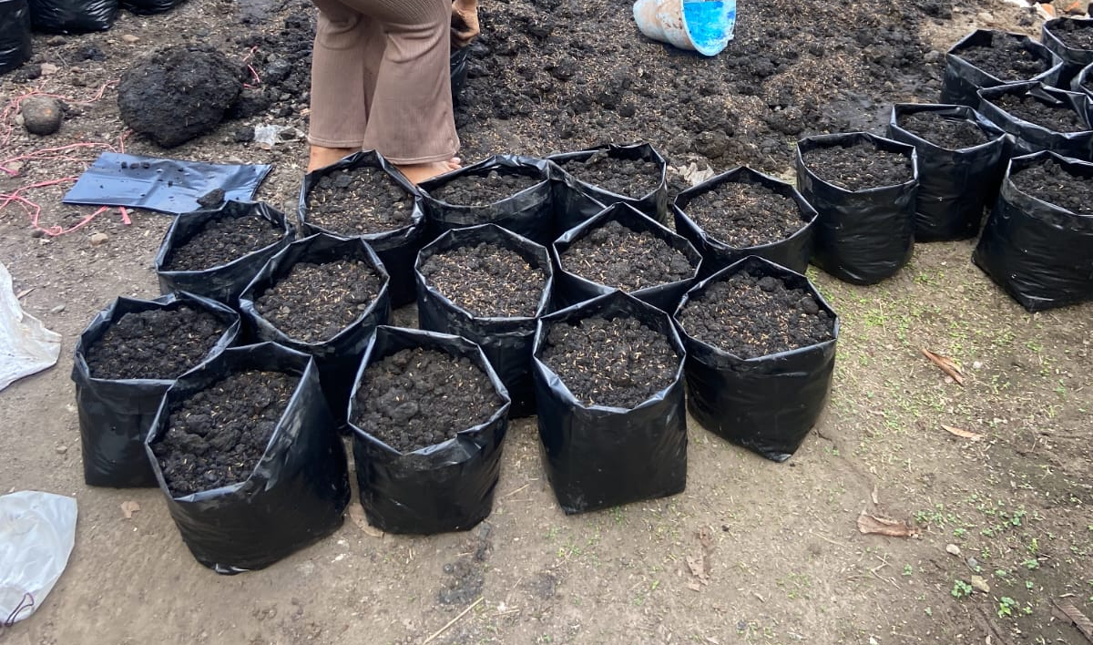
Gambar 1. Media Tanam Blotong Dan Arang Sekam

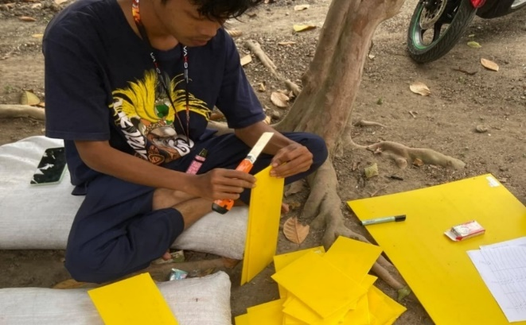
Gambar 2. Pembuatan label perlakuan
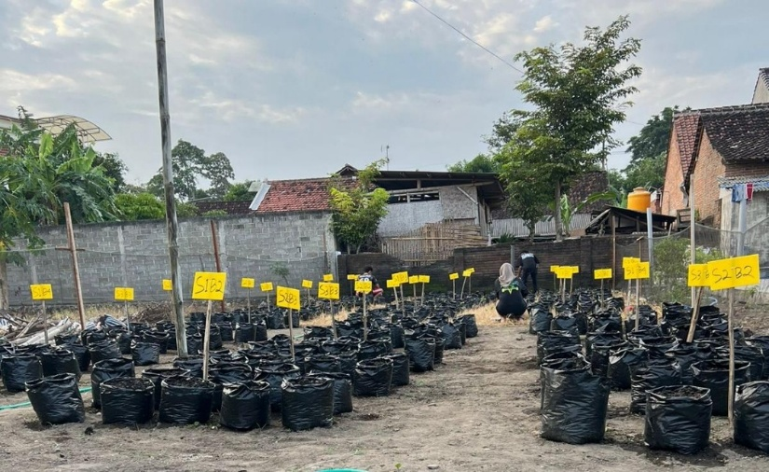
Gambar 3. Penataan polybag dan pemasangan label

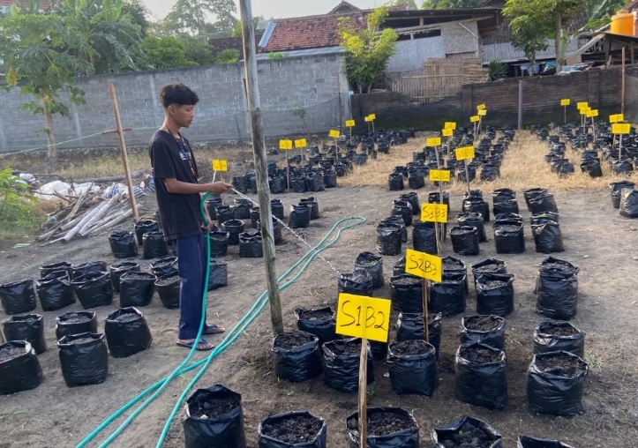
Gambar 4 Penyiraman Media Tanman
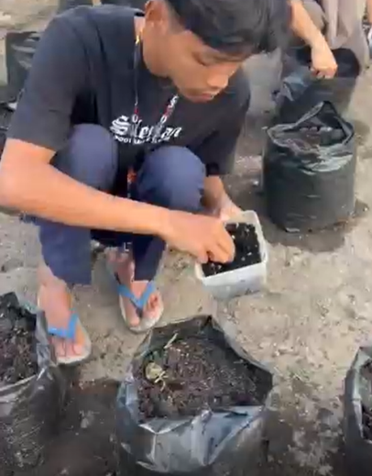
Gambar 5. Penanaman Bibit Kedelai

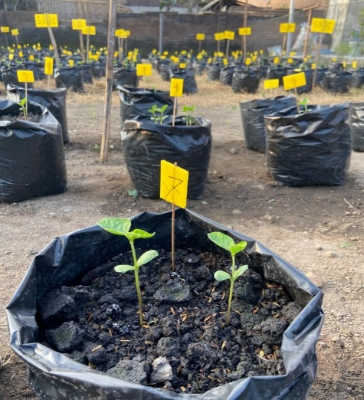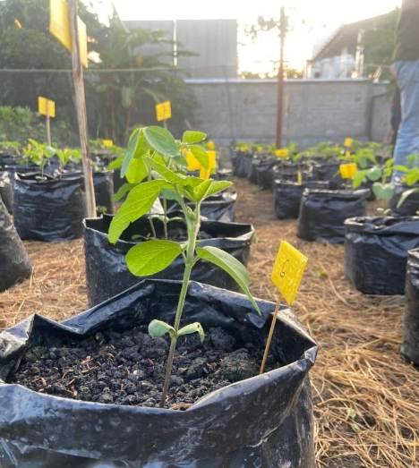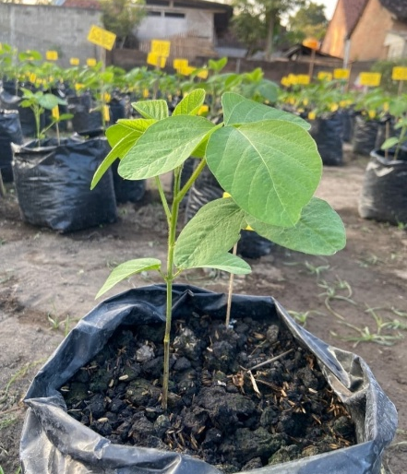
Gambar 6. Tanaman Kedelai Umur 1,2,3 MST

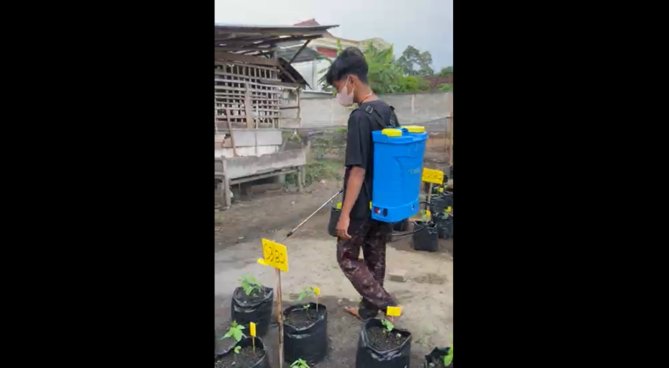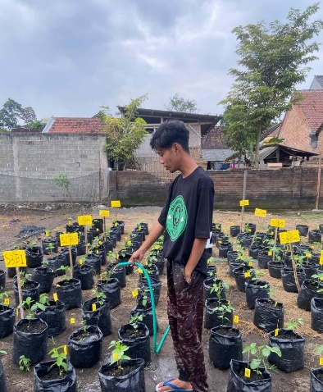
Gambar 7. Perawatan tanaman kedelai

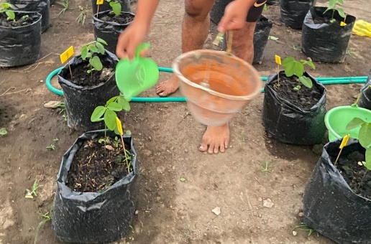
Gambar 8 Perlakuan Pupuk Konsentrasi Bionano Dan Dosis NPK

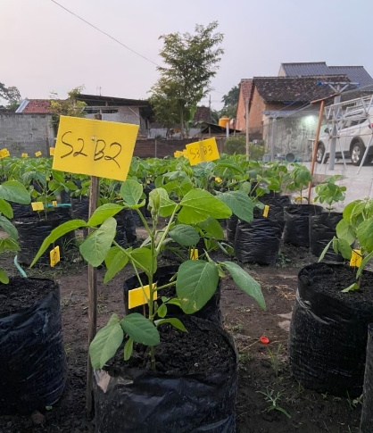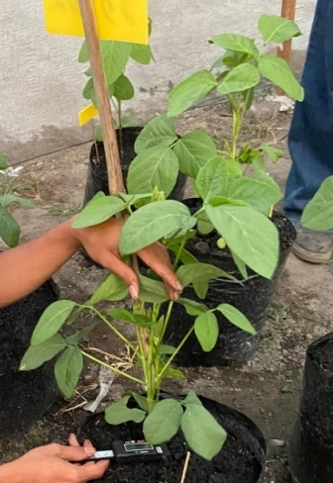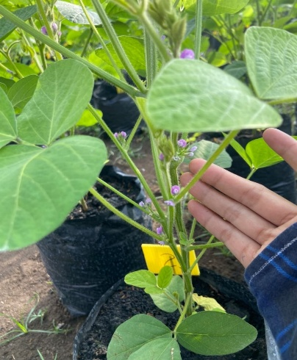
Gambar 9. Tanaman Kedelai di Umur 2,3,4 MST

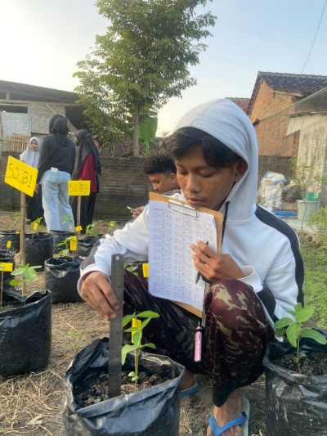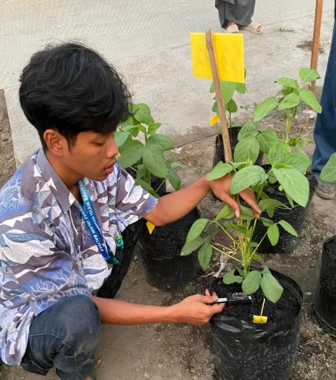
Gambar 10. Pengamatan Tanaman Kedelai Diameter Batang Dan Tinggi Tanaman

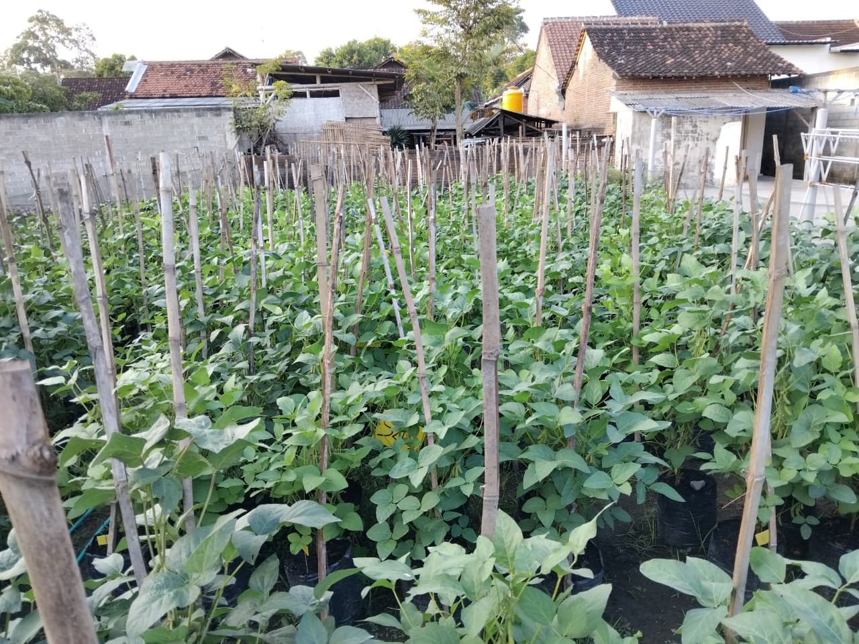
Gambar 11. Tanaman Kedele 70 HST

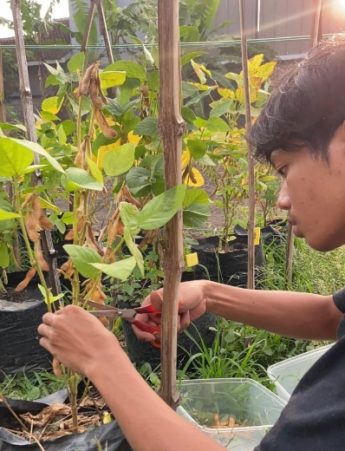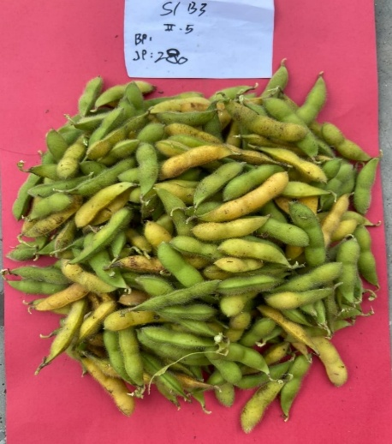
Gambar 12. Pemanenan Tanaman Kedelai

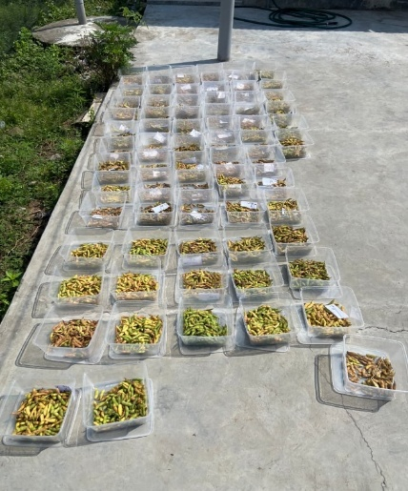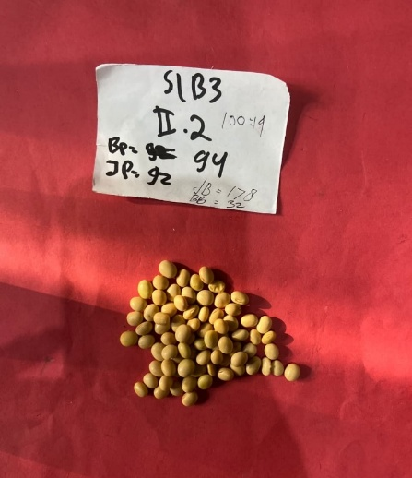
Gambar 13. Pengeringan biji dan Pengamatan 100 biji

