LAMPIRAN
Lampiran 1. Dokumentasi Penelitian
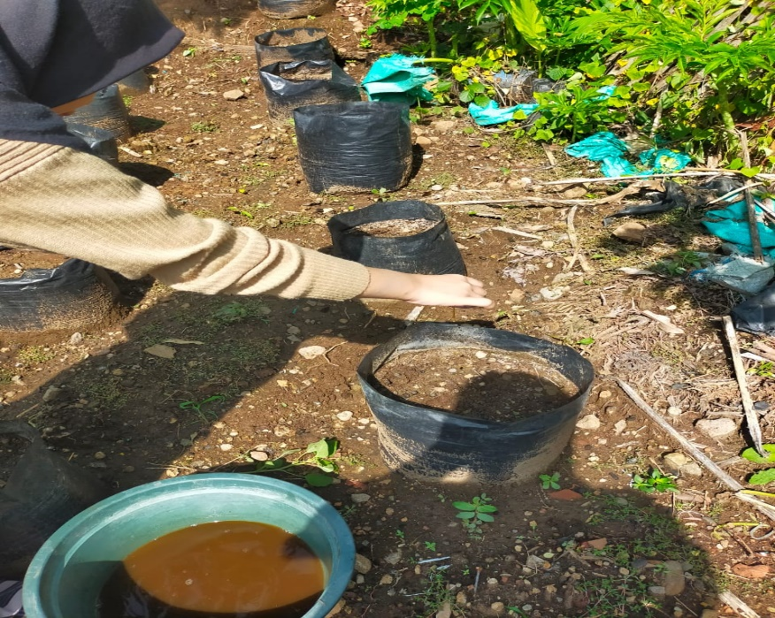
Lampiran 1. 1 Aplikasi Bio-Slurry

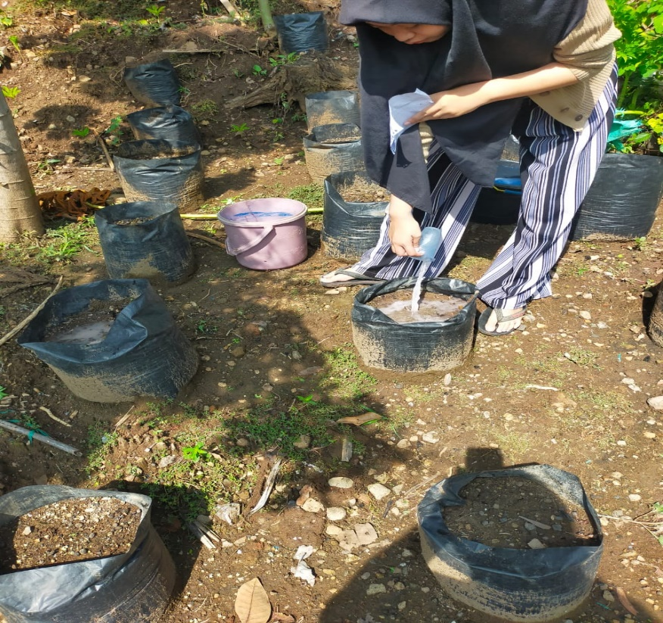
Lampiran 1.2 Aplikasi NPK
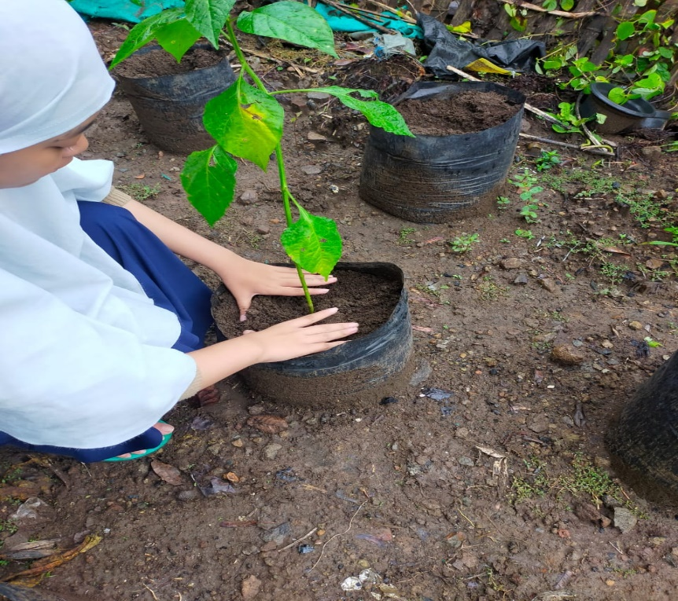
Lampiran 1.3 Pindah Tanam

Lampiran 1.4 Penyiraman

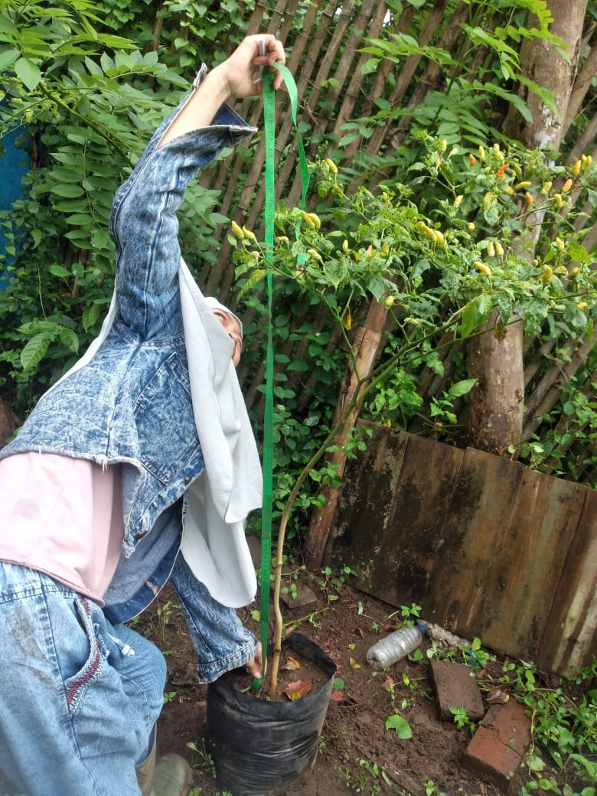
Lampiran 1.5 Pengukuran Tinggi Tanaman

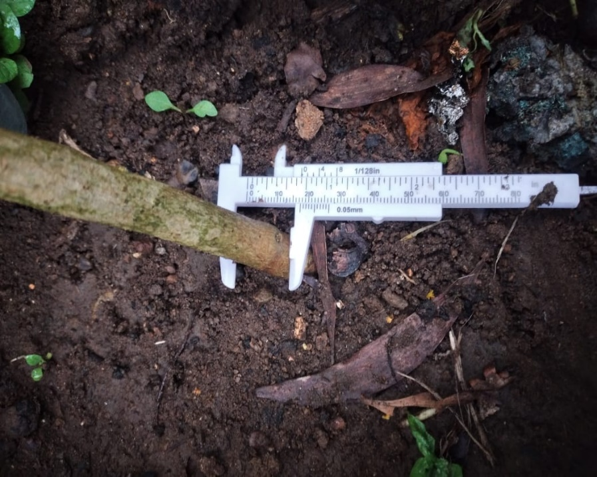
Lampiran 1.6 Pengukuran Diameter Batang

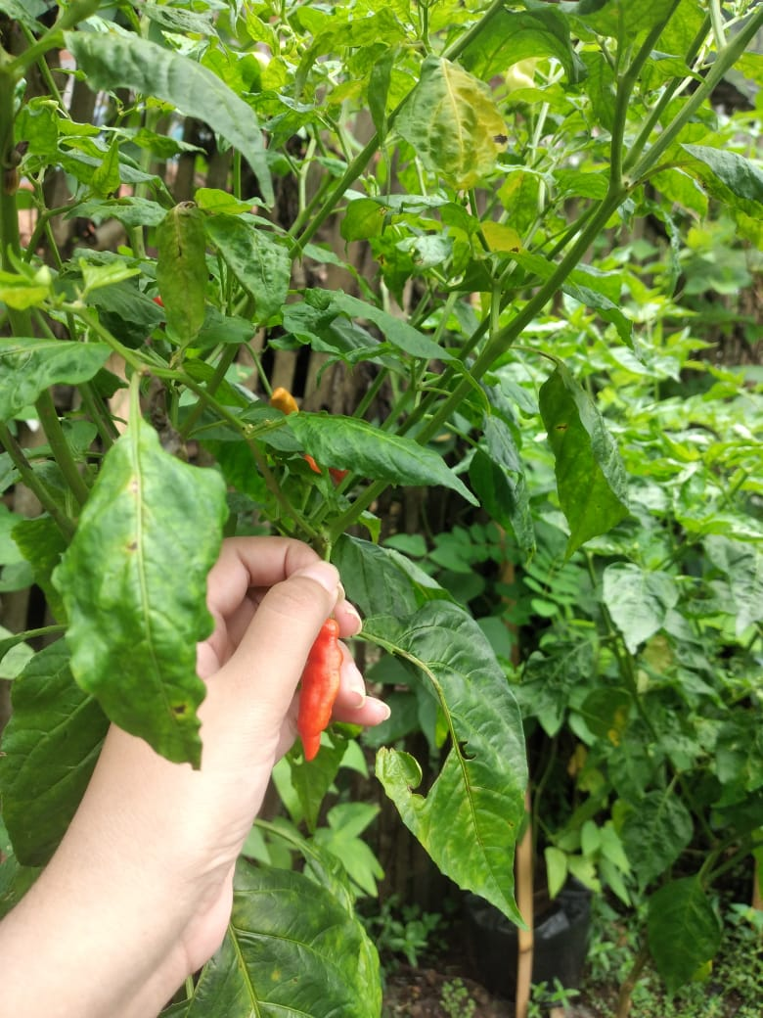
Lampiran 1.7 Pemetikan Cabai
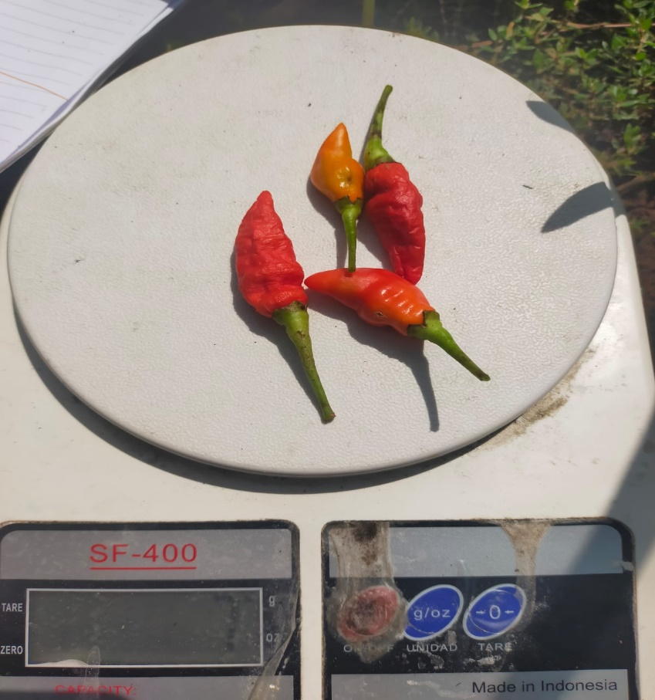
Lampiran 1.8 Penimbangan Bobot Cabai

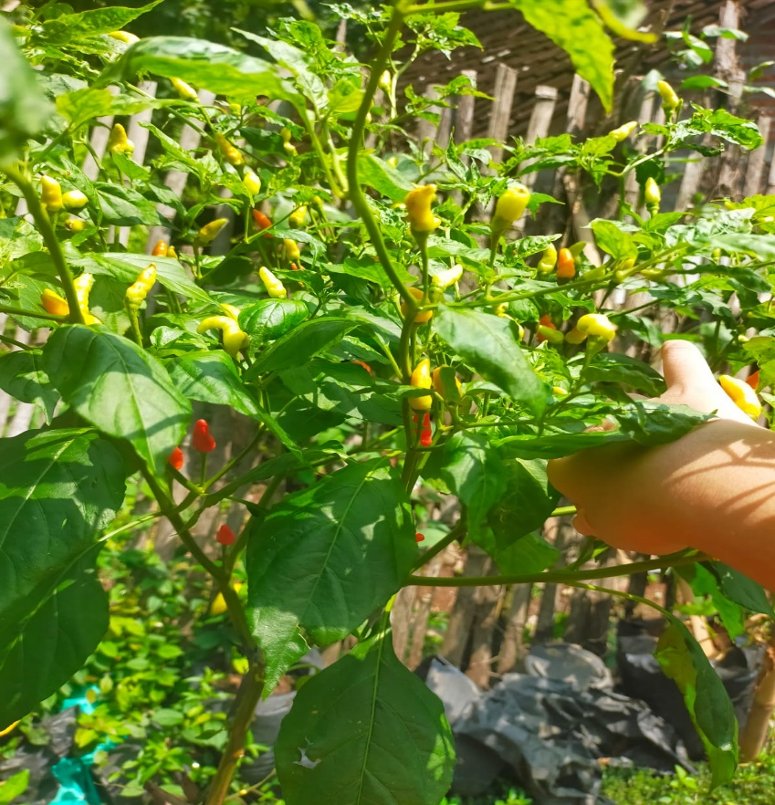
Lampiran 1.9 Pemetikan Cabai kedua
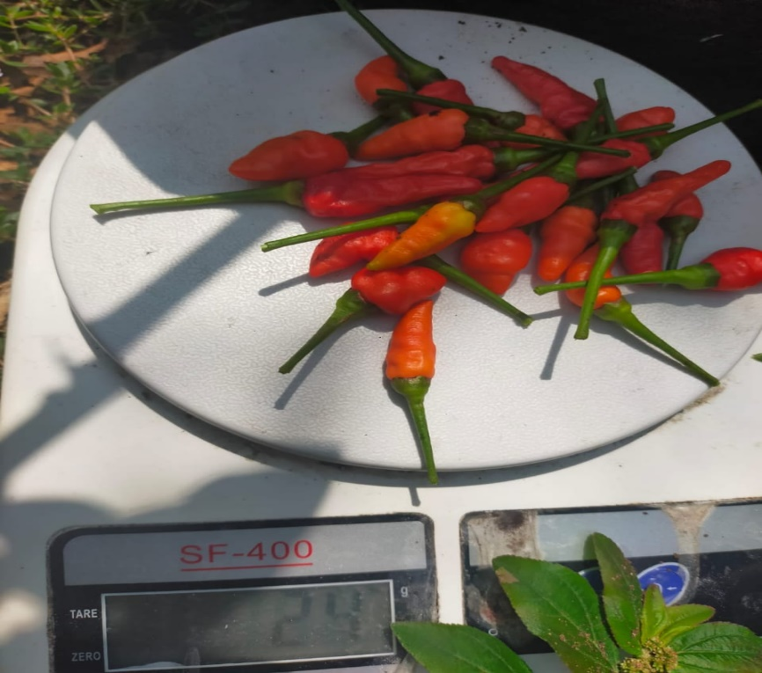
Lampiran 1.10 Penimbangan Bobot Cabai kedua

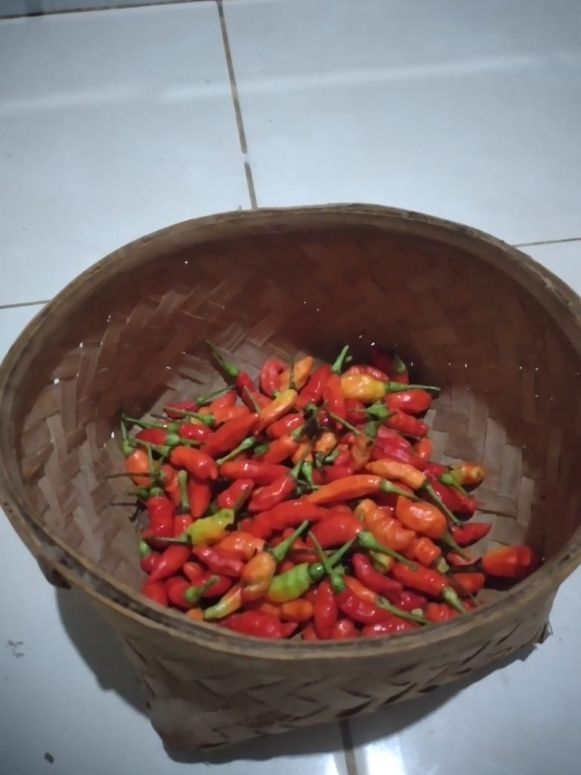
Lampiran 1.11 Hasil Panen Cabai Pertama
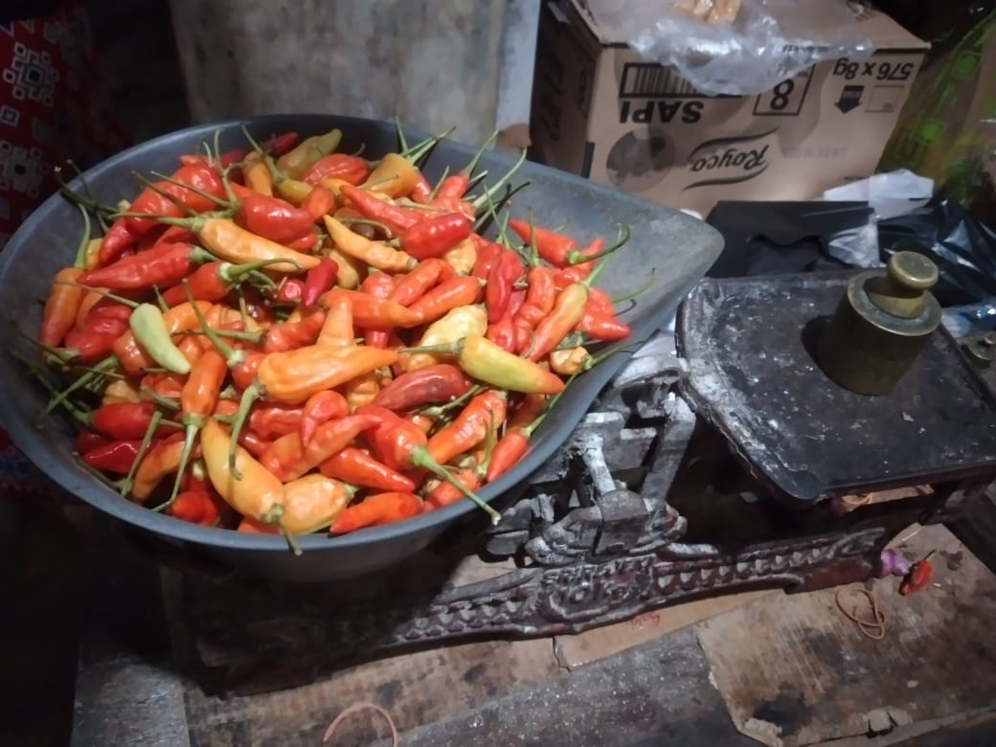
Lampiran 1.12 Hasil Panen Cabai Kedua

Lampiran 2. Hasil Analisis SPSS Duncan’s

Tests of Between-Subjects Effects
Dependent Variable:TINGGI TANAMAN 1
Source |  | Type III Sum of Squares | df | Mean Square | F | Sig.
B | Hypothesis | 5.189 | 2 | 2.594 | 9.496 | .002
B | Error | 4.372 | 16 | .273ª
N | Hypothesis | 1.110 | 2 | .555 | 2.031 | .164
N | Error | 4.372 | 16 | .273ª
ULANGAN | Hypothesis | .306 | 2 | .153 | .561 | .582
ULANGAN | Error | 4.372 | 16 | .273ª
B * N | Hypothesis | .410 | 4 | .102 | .375 | .823
B * N | Error | 4.372 | 16 | .273ª
a. MS(Error)
Lampiran 2.1 Tinggi Tanaman 1

Tests of Between-Subjects Effects
Dependent Variable:TINGGI TANAMAN 2
Source |  | Type III Sum of Squares | df | Mean Square | F | Sig.
B | Hypothesis | .754 | 2 | .377 | 3.529 | .054
B | Error | 1.708 | 16 | .107ª
N | Hypothesis | .228 | 2 | .114 | 1.069 | .367
N | Error | 1.708 | 16 | .107ª
ULANGAN | Hypothesis | .233 | 2 | .116 | 1.090 | .360
ULANGAN | Error | 1.708 | 16 | .107ª
B * N | Hypothesis | .238 | 4 | .060 | .558 | .697
B * N | Error | 1.708 | 16 | .107ª
a. MS(Error)
Lampiran 2.2 Tinggi Tanaman 2

Tests of Between-Subjects Effects
Dependent Variable:TINGGI TANAMAN 3
Source |  | Type III Sum of Squares | df | Mean Square | F | Sig.
B | Hypothesis | 33.267 | 2 | 16.634 | 54.403 | .000
B | Error | 4.892 | 16 | .306ª
N | Hypothesis | 18.273 | 2 | 9.137 | 29.883 | .000
N | Error | 4.892 | 16 | .306ª
ULANGAN | Hypothesis | 5.405 | 2 | 2.703 | 8.839 | .003
ULANGAN | Error | 4.892 | 16 | .306ª
B * N | Hypothesis | 9.676 | 4 | 2.419 | 7.912 | .001
B * N | Error | 4.892 | 16 | .306ª
a. MS(Error)
Lampiran 2.3 Tinggi Tanaman 3

Tests of Between-Subjects Effects
Dependent Variable:TINGGI TANAMAN 4
Source |  | Type III Sum of Squares | df | Mean Square | F | Sig.
B | Hypothesis | 14.051 | 2 | 7.025 | 23.128 | .000
B | Error | 4.860 | 16 | .304ª
N | Hypothesis | 11.121 | 2 | 5.560 | 18.305 | .000
N | Error | 4.860 | 16 | .304ª
ULANGAN | Hypothesis | 5.939 | 2 | 2.970 | 9.776 | .002
ULANGAN | Error | 4.860 | 16 | .304ª
B * N | Hypothesis | 9.107 | 4 | 2.277 | 7.495 | .001
B * N | Error | 4.860 | 16 | .304ª
a. MS(Error)
Lampiran 2.4 Tinggi Tanaman 4

Tests of Between-Subjects Effects
Dependent Variable:TINGGI TANAMAN 5
Source |  | Type III Sum of Squares | df | Mean Square | F | Sig.
B | Hypothesis | 32.060 | 2 | 16.030 | 46.978 | .000
B | Error | 5.460 | 16 | .341ª
N | Hypothesis | 12.161 | 2 | 6.081 | 17.820 | .000
N | Error | 5.460 | 16 | .341ª
ULANGAN | Hypothesis | 1.148 | 2 | .574 | 1.682 | .217
ULANGAN | Error | 5.460 | 16 | .341ª
B * N | Hypothesis | 4.741 | 4 | 1.185 | 3.474 | .032
B * N | Error | 5.460 | 16 | .341ª
a. MS(Error)
Lampiran 2.5 Tinggi Tanaman 5

Tests of Between-Subjects Effects
Dependent Variable:TINGGI TANAMAN 6
Source |  | Type III Sum of Squares | df | Mean Square | F | Sig.
B | Hypothesis | 21.304 | 2 | 10.652 | 28.758 | .000
B | Error | 5.926 | 16 | .370ª
N | Hypothesis | 9.063 | 2 | 4.532 | 12.235 | .001
N | Error | 5.926 | 16 | .370ª
ULANGAN | Hypothesis | 8.026 | 2 | 4.013 | 10.834 | .001
ULANGAN | Error | 5.926 | 16 | .370ª
B * N | Hypothesis | 9.317 | 4 | 2.329 | 6.288 | .003
B * N | Error | 5.926 | 16 | .370ª
a. MS(Error)
Lampiran 2.6 Tinggi Tanaman 6

Tests of Between-Subjects Effects
Dependent Variable:DIAMETER BATANG 1
Source |  | Type III Sum of Squares | df | Mean Square | F | Sig.
B | Hypothesis | .005 | 2 | .002 | .726 | .499
B | Error | .051 | 16 | .003ª
N | Hypothesis | .007 | 2 | .003 | 1.081 | .363
N | Error | .051 | 16 | .003ª
ULANGAN | Hypothesis | .011 | 2 | .006 | 1.792 | .199
ULANGAN | Error | .051 | 16 | .003ª
B * N | Hypothesis | .010 | 4 | .003 | .820 | .531
B * N | Error | .051 | 16 | .003ª
a. MS(Error)
Lampiran 2.7 Diameter Batang 1

Tests of Between-Subjects Effects
Dependent Variable:DIAMETER BATANG 2
Source |  | Type III Sum of Squares | df | Mean Square | F | Sig.
B | Hypothesis | .001 | 2 | .001 | .450 | .645
B | Error | .026 | 16 | .002ª
N | Hypothesis | .027 | 2 | .014 | 8.228 | .003
N | Error | .026 | 16 | .002ª
ULANGAN | Hypothesis | .003 | 2 | .002 | .987 | .394
ULANGAN | Error | .026 | 16 | .002ª
B * N | Hypothesis | .012 | 4 | .003 | 1.817 | .175
B * N | Error | .026 | 16 | .002ª
a. MS(Error)
Lampiran 2.8 Diameter Batang 2

Tests of Between-Subjects Effects
Dependent Variable:DIAMETER BATANG 3
Source |  | Type III Sum of Squares | df | Mean Square | F | Sig.
B | Hypothesis | .020 | 2 | .010 | 3.578 | .052
B | Error | .045 | 16 | .003ª
N | Hypothesis | .013 | 2 | .007 | 2.373 | .125
N | Error | .045 | 16 | .003ª
ULANGAN | Hypothesis | .015 | 2 | .007 | 2.578 | .107
ULANGAN | Error | .045 | 16 | .003ª
B * N | Hypothesis | .003 | 4 | .001 | .251 | .905
B * N | Error | .045 | 16 | .003ª
a. MS(Error)
Lampiran 2.9 Diameter Batang 3

Tests of Between-Subjects Effects
Dependent Variable:DIAMETER BATANG 4
Source |  | Type III Sum of Squares | df | Mean Square | F | Sig.
B | Hypothesis | .004 | 2 | .002 | 3.879 | .042
B | Error | .009 | 16 | .001ª
N | Hypothesis | .012 | 2 | .006 | 11.220 | .001
N | Error | .009 | 16 | .001ª
ULANGAN | Hypothesis | .004 | 2 | .002 | 4.040 | .038
ULANGAN | Error | .009 | 16 | .001ª
B * N | Hypothesis | .023 | 4 | .006 | 10.262 | .000
B * N | Error | .009 | 16 | .001ª
a. MS(Error)
Lampiran 2.10 Diameter Batang 4

Tests of Between-Subjects Effects
Dependent Variable:DIAMETER BATANG 5
Source |  | Type III Sum of Squares | df | Mean Square | F | Sig.
B | Hypothesis | .020 | 2 | .010 | 22.494 | .000
B | Error | .007 | 16 | .000ª
N | Hypothesis | .011 | 2 | .006 | 12.338 | .001
N | Error | .007 | 16 | .000ª
ULANGAN | Hypothesis | 5.185E-5 | 2 | 2.593E-5 | .057 | .945
ULANGAN | Error | .007 | 16 | .000ª
B * N | Hypothesis | .007 | 4 | .002 | 4.037 | .019
B * N | Error | .007 | 16 | .000ª
a. MS(Error)
Lampiran 2.11 Diameter Batang 5

Tests of Between-Subjects Effects
Dependent Variable:DIAMETER BATANG 6
Source |  | Type III Sum of Squares | df | Mean Square | F | Sig.
B | Hypothesis | .033 | 2 | .016 | 10.790 | .001
B | Error | .024 | 16 | .002ª
N | Hypothesis | .028 | 2 | .014 | 9.339 | .002
N | Error | .024 | 16 | .002ª
ULANGAN | Hypothesis | .002 | 2 | .001 | .662 | .529
ULANGAN | Error | .024 | 16 | .002ª
B * N | Hypothesis | .022 | 4 | .005 | 3.549 | .030
B * N | Error | .024 | 16 | .002ª
a. MS(Error)
Lampiran 2.12 Diameter Batang 6

Tests of Between-Subjects Effects
Dependent Variable:JUMLAH CABAI
Source |  | Type III Sum of Squares | df | Mean Square | F | Sig.
B | Hypothesis | 28843.852 | 2 | 14421.926 | 813.351 | .000
B | Error | 283.704 | 16 | 17.731ª
N | Hypothesis | 18760.074 | 2 | 9380.037 | 529.005 | .000
N | Error | 283.704 | 16 | 17.731ª
ULANGAN | Hypothesis | 91.630 | 2 | 45.815 | 2.584 | .107
ULANGAN | Error | 283.704 | 16 | 17.731ª
B * N | Hypothesis | 401.481 | 4 | 100.370 | 5.661 | .005
B * N | Error | 283.704 | 16 | 17.731ª
a. MS(Error)
Lampiran 2.13 Jumlah Cabai Rawit

Tests of Between-Subjects Effects
Dependent Variable:BOBOT CABAI
Source |  | Type III Sum of Squares | df | Mean Square | F | Sig.
B | Hypothesis | 271823.185 | 2 | 135911.593 | 803.242 | .000
B | Error | 2707.259 | 16 | 169.204ª
N | Hypothesis | 174883.852 | 2 | 87441.926 | 516.785 | .000
N | Error | 2707.259 | 16 | 169.204ª
ULANGAN | Hypothesis | 1141.407 | 2 | 570.704 | 3.373 | .060
ULANGAN | Error | 2707.259 | 16 | 169.204ª
B * N | Hypothesis | 4224.593 | 4 | 1056.148 | 6.242 | .003
B * N | Error | 2707.259 | 16 | 169.204ª
a. MS(Error)
Lampiran 2.14 Bobot Cabai

