LAMPIRAN
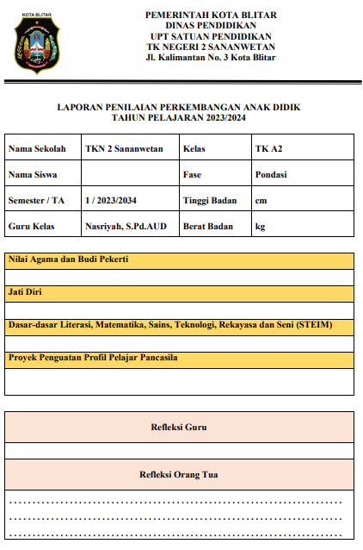
Lampiran 1 Bagian 1 - contoh rapor Kurikulum Merdeka
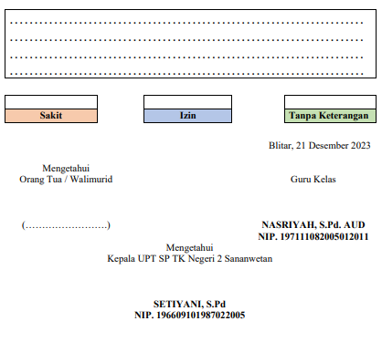
Lampiran 2 Bagian 2 - contoh Rapor Kurikulum Merdeka

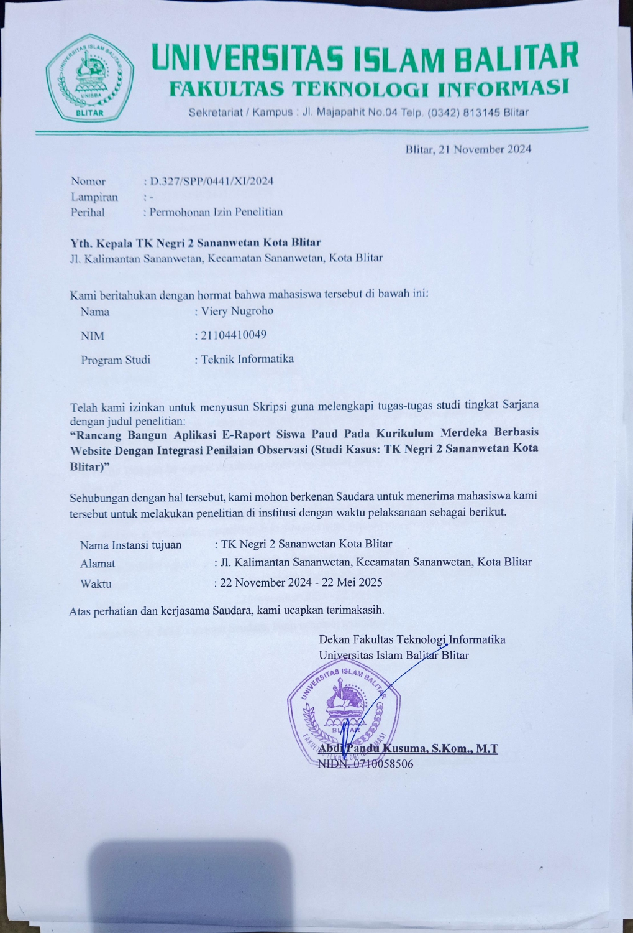
Lampiran 3 Surat pengantar skripsi

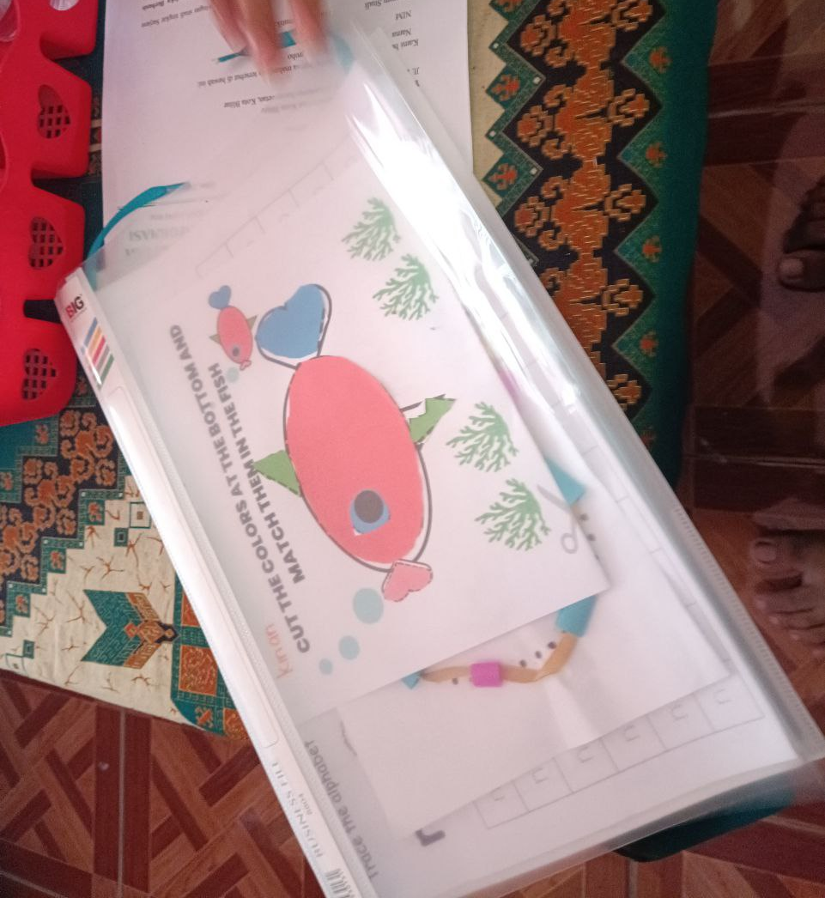
Lampiran 4 Contoh dokumen penilaian portofolio
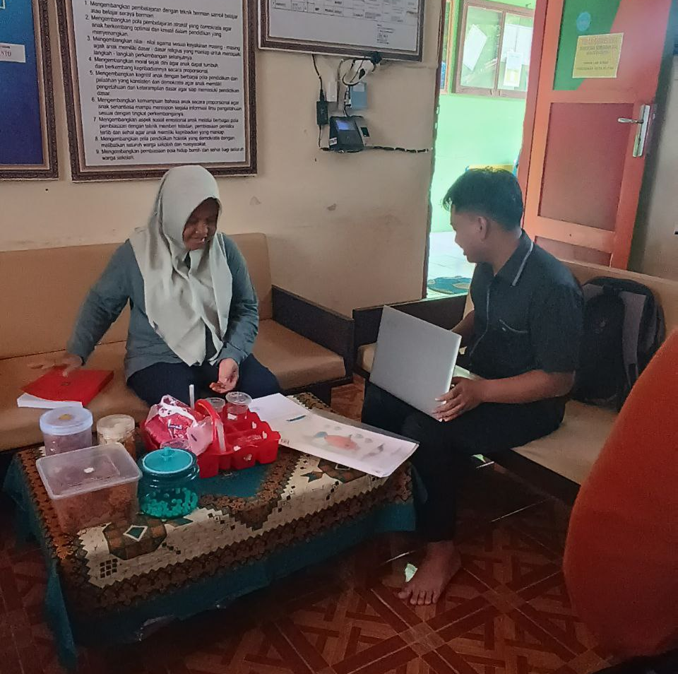
Lampiran 5 Proses pengumpulan data dengan teknik wawancara
// data rapor siswa

{
"id": 4,
"fullname": "Balya A Waff",
"gender": "PEREMPUAN",
"religion": "KONGHUCU",
"parentName": "Sutarmi",
"birthPlace": "Kabupaten Aceh Timur",
"birthDate": "2025-02-03T17:00:00.000Z",
"classID": 1,
"address": "Tapan, Basa Ampek Balai Tapan, Kabupaten Pesisir Selatan, Sumatera Barat",
"createdAt": "2025-02-25T06:29:30.678Z",
"updatedAt": "2025-02-25T06:29:30.678Z",
"Reflection": [
{
"id": 1,
"studentId": 4,
"periodId": 3,
"teacherId": 1,
"classId": 1,
"description": "<p>balya logout ganti konghucu, kacauu</p>",
"createdAt": "2025-02-25T14:57:30.967Z",
"updatedAt": "2025-02-25T14:57:30.967Z"
}
],
"Attendance": [
{
"id": 13,
"studentId": 4,
"periodId": 3,
"teacherId": 1,
"classId": null,
"sick": 1,
"permit": 0,
"absent": 0,
"createdAt": "2025-02-25T18:47:47.540Z",
"updatedAt": "2025-02-25T18:47:47.540Z"
}
],
"Class": {
"name": "Kelas A1",
"category": "A"
},
"Development": [
{
"height": 1659,
"weight": 1000,
"notes": "<p>Tinggi banget lohhh...</p>"
}
],
"Score": [
{
"id": 1,
"studentId": 4,
"periodId": 3,
"teacherId": 1,
"indicatorId": 1,
"description": "<p>Ini anak bandel banget</p>",
"value": "BB",
"createdAt": "2025-02-25T14:45:54.008Z",
"updatedAt": "2025-02-26T12:25:10.295Z",
"Indicator": {
"title": "Pendidikan Karakter",
"assesment_type": "JATI_DIRI"
},
"Teacher": {
"fullname": "NASRIYAH, S.Pd. AUD",
"identity_number": "197111082005012011"
},
"Period": {
"year": "2025",
"semester": "GANJIL"
}
},
{
"id": 2,
"studentId": 4,
"periodId": 3,
"teacherId": 1,
"indicatorId": 3,
"description": "<p>Apalah dia ini</p>",
"value": "BB",
"createdAt": "2025-02-25T14:45:54.227Z",
"updatedAt": "2025-02-26T12:25:10.633Z",
"Indicator": {
"title": "Pendidikan SAINTEK",
"assesment_type":"DASAR_LITERASI_MATEMATIKA_SAINS_TEKNOLOGI_REKAYASA_DA N_SENI"
},
"Teacher": {
"fullname": "NASRIYAH, S.Pd. AUD",
"identity_number": "197111082005012011"
},
"Period": {
"year": "2025",
"semester": "GANJIL"
}
},
{
"id": 3,
"studentId": 4,
"periodId": 3,
"teacherId": 1,
"indicatorId": 4,
"description": "<p>Apalah dia ini</p>",
"value": "BB",
"createdAt": "2025-02-25T14:45:54.227Z",
"updatedAt": "2025-02-26T12:25:10.633Z",
"Indicator": {
"title": "Pendidikan SAINTEK: Programming",
"assesment_type": "DASAR_LITERASI_MATEMATIKA_SAINS_TEKNOLOGI_REKAYASA_DAN_SENI"
},
"Teacher": {
"fullname": "NASRIYAH, S.Pd. AUD",
"identity_number": "197111082005012011"
},
"Period": {
"year": "2025",
"semester": "GANJIL"
}
},
{
"id": 4,
"studentId": 4,
"periodId": 3,
"teacherId": 1,
"indicatorId": 6,
"description": "<p>Astaghfirullah balyaaaaaaa... </p>",
"value": "BB",
"createdAt": "2025-02-25T14:45:55.138Z",
"updatedAt": "2025-02-26T12:25:11.447Z",
"Indicator": {
"title": "Pendidikan Agama Islam",
"assesment_type": "NILAI_AGAMA_DAN_BUDI_PEKERTI"
},
"Teacher": {
"fullname": "NASRIYAH, S.Pd. AUD",
"identity_number": "197111082005012011"
},
"Period": {
"year": "2025",
"semester": "GANJIL"
}
}
],
"filledAssessment": true,
"teacherClass": {
"fullname": "NASRIYAH, S.Pd. AUD",
"identity_number": "197111082005012011",
"classID": 1
},
"status": {
"hasDevelopment": true,
"hasAllScores": true,
"hasReflection": true,
"hasAttendance": true
},
"readyToPrint": true
}

Lampiran 6 Contoh data rapor siswa dalam format JSON
Kelengkapan dokumentasi: https://bit.ly/kelengkapan-lampiran-proposal

