LAMPIRAN
Lampiran 1 Kuisioner Penelitian
KUISIONER PENELITIAN
Kepada responden yang terhormat,
Dalam rangka untuk melaksanakan penelitian skripsi program sarjana (S1), Saya Hestian Ningsih mahasiswa program studi manajemen fakultas ekonomi Universitas Islam Balitar memerlukan informasi untuk mendukung penelitian yang saya lakukan yang berjudul : “Pengaruh Online Customer rating dan Online Customer Review terhadap Keputusan Pembelian Produk pada Aplikasi Tiktok Shop (Studi Kasus Mahasiswa Manajemen Angkatan 2021 Universitas Islam Balitar)”, Maka dari itu saya mohon kesediaan Saudara/I untuk meluangkan waktu mengisi kuesioner atau pernyataan yang dilampirkan.
Jawaban yang anda berikan akan sangat membantu penelitian ini dan kuesioner ini dapat digunakan apabila sudah terisi semua. Seluruh data dan informasi yang Saudara/I berikan akan dijaga kerahasiaannya dan hanya digunakan untuk kepentingan akademis penelitian semata. Saya ucapkan terima kasih kepada Saudara/I yang telah bersedia meluangkan waktu untuk mengisi kuesioner ini secara objektif dan benar.
- Identitas Responden:
Nama Lengkap
Usia
Jenis Kelamin = a) Laki – Laki
b) Perempuan

- Petunjuk Kuisioner
Pada setiap item kuisioner, berilah penilaian seberapa jauh Saudara/I setuju dengan persyaratan yang tersedia. Isilah jawaban atas pertanyaan pada kuisioner ini dan jangan ada yang terlewatkan dan berikan jawaban yang sesuai dengan pengalaman yang telah dirasakan:
Keterangan:
5. SS = Sangat Setuju
4. S = Setuju
3. N = Netral
2. TS = Tidak Setuju
1. STS = Sangat Tidak Setuju
- Kuisioner
- Online Customer rating (X1)
No. | Pertanyaan | Jawaban
No. | Pertanyaan | SS | S | N | TS | STS
1. | Manfaat Yang dirasakan
 | Saya merasa lebih yakin membeli produk setekah melihat rating pelanggan sebelumnya di Tiktok Shop
2. | Kenyamanan Yang Dirasakan
 | Saya merasa nyaman ketika melihat rating produk di Tiktok Shop karena mamberikan kepastian tentang produk yang saya beli
3. | Kontrol Diri
 | Saya merasa dapat mengontrol keputusan pembelian saya berdasarkan rating yang saya baca di Tiktok Shop

- Online Customer Riview (X2)
No. | Pertanyaan | Jawaban
No. | Pertanyaan | SS | S | N | TS | STS
1. | Kredibilitas Sumber
 | Saya percaya bahwa ulasan yang saya baca di Tiktok Shop berasal dari sumber yang dapat dipercaya
2. | Kualitas Argumen
 | Saya merasa ulasan produk di Tiktok Shop memberikan informasi yang berguna dan mendalam mengenai kelebihan dan kekurangan produk
3. | Manfaat yang Dirasakan
 | Ulasan di Tiktok Shop membuat saya merasa lebih yakin bahwa produk yang saya beli akan memberikan manfaat sesuai dengan yang saya harapkan
4. | Ulasan Gabungan
 | Saya merasa bahwa ulasan gabungan dari berbagai konsumen di Tiktok Shop memberikan gambaran yang lebih lengkap tentang produk
5. | Jumlah Ulasan
 | Saya merasa produk dengan jumlah ulasan yang banyak memiliki kualitas yang lebih terjamin

- Keputusan Pembelian (Y)
No. | Pertanyaan | Jawaban
No. | Pertanyaan | SS | S | N | TS | STS
1. | Pemilihan Produk
 | Rating dan ualasan produk mempengaruhi keputusan saya dalam memilih produk di Tiktok Shop
2. | Pemeliharaan Merk
 | Rating dan ulasan dari pembeli sebelumnya mempengaruhi keputusan saya untuk memilih merk dan produk yang sudah saya kenal atau baru
3. | Pemilihan Penyalur
 | Saya lebih cenderung membeli produk dari penjual yang memiliki rating dan ulasan positif di Tiktok Shop
4. | Waktu Pembelian
 | Rating dan rivew yang baik sering kali mempercepat keputusan saya dalam membeli suatu produk, terutama ketika saya membutuhkan produk tersebut segara
5. | Jumlah Pembelian
 | Saya cenderung membeli lebih banyak produk jika produk tersebut memiliki rating tinggi dan banyak ulasan positif di Tiktok Shop
6. | Metode Pembayaran
 | Penilaian dan ulasan positif yang saya temukan membuat saya merasa lebih aman saat menggunakan metode pembayaran online di Tiktok Shop

Lampiran 2 Tabulasi Data
- Tabulasi Jawaban Responden Variabel Online Customer rating (X1)
No | Online Customer rating (X1) |  |  | Total
No | X1.1 | X1.2 | X1.3 | Total
 | 4 | 5 | 5 | 14
 | 5 | 5 | 4 | 14
 | 5 | 5 | 4 | 14
 | 5 | 4 | 4 | 13
 | 5 | 4 | 5 | 14
 | 4 | 5 | 4 | 13
 | 5 | 4 | 4 | 13
 | 2 | 4 | 4 | 10
 | 5 | 4 | 5 | 14
 | 5 | 3 | 4 | 12
 | 5 | 4 | 4 | 13
 | 5 | 4 | 4 | 13
 | 5 | 4 | 4 | 13
 | 4 | 4 | 4 | 12
 | 4 | 3 | 4 | 11
 | 5 | 5 | 4 | 14
 | 5 | 5 | 5 | 15
 | 4 | 4 | 4 | 12
 | 2 | 3 | 4 | 9
 | 4 | 4 | 3 | 11
 | 5 | 5 | 4 | 14
 | 4 | 3 | 2 | 9
 | 5 | 4 | 5 | 14
 | 5 | 5 | 4 | 14
 | 4 | 4 | 4 | 12
 | 5 | 4 | 4 | 13
 | 4 | 5 | 4 | 13
 | 5 | 4 | 4 | 13
 | 4 | 4 | 5 | 13
 | 4 | 5 | 5 | 14
 | 4 | 4 | 3 | 11
 | 2 | 2 | 2 | 6
 | 5 | 5 | 4 | 14
 | 5 | 4 | 5 | 14
 | 5 | 5 | 4 | 14
 | 4 | 3 | 5 | 12
 | 4 | 4 | 5 | 13
 | 4 | 4 | 3 | 11
 | 5 | 4 | 3 | 12
 | 5 | 5 | 3 | 13
 | 5 | 5 | 4 | 14
 | 5 | 4 | 5 | 14
 | 5 | 4 | 4 | 13
 | 5 | 4 | 3 | 12
 | 5 | 5 | 5 | 15
 | 3 | 3 | 4 | 10
 | 4 | 4 | 5 | 13
 | 4 | 3 | 3 | 10
 | 5 | 5 | 5 | 15
 | 5 | 5 | 4 | 14
 | 4 | 4 | 5 | 13
 | 5 | 5 | 5 | 15
 | 4 | 5 | 3 | 12
 | 5 | 4 | 3 | 12
 | 4 | 4 | 5 | 13
 | 5 | 5 | 4 | 14
 | 3 | 4 | 5 | 12
 | 4 | 4 | 3 | 11
 | 5 | 5 | 4 | 14
 | 5 | 4 | 4 | 13
 | 3 | 4 | 3 | 10
 | 5 | 5 | 4 | 14
 | 5 | 4 | 4 | 13
 | 4 | 4 | 5 | 13
 | 5 | 4 | 4 | 13
 | 4 | 4 | 4 | 12
 | 3 | 3 | 4 | 10
 | 5 | 4 | 3 | 12
 | 5 | 5 | 5 | 15
 | 4 | 4 | 3 | 11
 | 5 | 5 | 4 | 14
 | 4 | 4 | 5 | 13
 | 5 | 5 | 5 | 15
 | 5 | 4 | 5 | 14
 | 5 | 4 | 5 | 14

- Tabulasi Jawaban Responden Variabel Online Customer Riview (X2)
No. | Online Customer Riview (X2) |  |  |  |  | Total
No. | X2.1 | X2.2 | X2.3 | X2.4 | X2.5 | Total
 | 3 | 3 | 4 | 5 | 3 | 18
 | 4 | 4 | 5 | 5 | 4 | 22
 | 4 | 4 | 5 | 4 | 5 | 22
 | 4 | 4 | 5 | 4 | 5 | 22
 | 4 | 5 | 5 | 5 | 4 | 23
 | 2 | 4 | 4 | 5 | 2 | 17
 | 3 | 4 | 3 | 3 | 3 | 16
 | 3 | 3 | 4 | 3 | 5 | 18
 | 4 | 4 | 4 | 4 | 5 | 21
 | 4 | 5 | 4 | 5 | 3 | 21
 | 4 | 5 | 4 | 4 | 5 | 22
 | 4 | 5 | 4 | 4 | 4 | 21
 | 5 | 5 | 5 | 5 | 4 | 24
 | 3 | 3 | 3 | 3 | 3 | 15
 | 3 | 5 | 4 | 4 | 3 | 19
 | 3 | 4 | 4 | 5 | 2 | 18
 | 4 | 5 | 4 | 3 | 3 | 19
 | 4 | 5 | 4 | 5 | 4 | 22
 | 1 | 3 | 2 | 4 | 5 | 15
 | 5 | 5 | 3 | 4 | 5 | 22
 | 4 | 5 | 4 | 4 | 5 | 22
 | 5 | 4 | 5 | 4 | 3 | 21
 | 4 | 4 | 4 | 5 | 4 | 21
 | 4 | 5 | 5 | 4 | 4 | 22
 | 5 | 4 | 3 | 4 | 5 | 21
 | 4 | 5 | 5 | 5 | 3 | 22
 | 5 | 3 | 5 | 4 | 4 | 21
 | 5 | 4 | 1 | 5 | 4 | 19
 | 3 | 4 | 4 | 4 | 3 | 18
 | 4 | 5 | 5 | 5 | 2 | 21
 | 3 | 3 | 4 | 4 | 3 | 17
 | 3 | 4 | 4 | 3 | 2 | 16
 | 4 | 5 | 4 | 3 | 4 | 20
 | 4 | 5 | 5 | 4 | 4 | 22
 | 5 | 4 | 5 | 5 | 5 | 24
 | 3 | 2 | 4 | 5 | 5 | 19
 | 3 | 5 | 3 | 5 | 4 | 20
 | 3 | 5 | 5 | 3 | 2 | 18
 | 4 | 5 | 4 | 4 | 3 | 20
 | 4 | 5 | 3 | 5 | 4 | 21
 | 4 | 4 | 4 | 4 | 4 | 20
 | 3 | 4 | 5 | 4 | 3 | 19
 | 3 | 4 | 5 | 3 | 4 | 19
 | 4 | 4 | 3 | 4 | 5 | 20
 | 5 | 5 | 5 | 5 | 5 | 25
 | 2 | 4 | 3 | 4 | 2 | 15
 | 4 | 5 | 4 | 5 | 3 | 21
 | 4 | 5 | 4 | 3 | 4 | 20
 | 4 | 5 | 5 | 4 | 4 | 22
 | 4 | 3 | 4 | 4 | 5 | 20
 | 4 | 5 | 4 | 3 | 4 | 20
 | 5 | 5 | 4 | 5 | 4 | 23
 | 3 | 5 | 4 | 4 | 5 | 21
 | 3 | 5 | 4 | 3 | 3 | 18
 | 4 | 3 | 4 | 3 | 4 | 18
 | 5 | 4 | 5 | 4 | 5 | 23
 | 3 | 4 | 4 | 2 | 4 | 17
 | 5 | 5 | 4 | 4 | 4 | 22
 | 4 | 4 | 4 | 5 | 4 | 21
 | 4 | 4 | 4 | 4 | 4 | 20
 | 4 | 4 | 4 | 4 | 3 | 19
 | 4 | 5 | 5 | 4 | 4 | 22
 | 3 | 5 | 4 | 4 | 4 | 20
 | 3 | 4 | 5 | 5 | 3 | 20
 | 5 | 5 | 4 | 4 | 3 | 21
 | 5 | 5 | 4 | 5 | 4 | 23
 | 3 | 4 | 4 | 4 | 3 | 18
 | 4 | 5 | 4 | 4 | 5 | 22
 | 4 | 5 | 5 | 5 | 2 | 21
 | 4 | 3 | 3 | 3 | 3 | 16
 | 4 | 5 | 5 | 4 | 4 | 22
 | 4 | 5 | 4 | 5 | 4 | 22
 | 5 | 5 | 5 | 5 | 5 | 25
 | 3 | 4 | 4 | 3 | 5 | 19
 | 4 | 4 | 4 | 4 | 4 | 20

- Tabulasi Jawaban Responden Variabel Keputusan Pembelian (Y)
No. | Keputusan Pembelian (Y) |  |  |  |  |  | Total
No. | Y1.1 | Y1.2 | Y1.3 | Y1.4 | Y1.5 | Y1.6 | Total
 | 4 | 3 | 3 | 5 | 3 | 5 | 23
 | 5 | 4 | 5 | 5 | 4 | 4 | 27
 | 5 | 5 | 5 | 4 | 4 | 4 | 27
 | 5 | 5 | 5 | 5 | 4 | 4 | 28
 | 5 | 5 | 5 | 4 | 4 | 5 | 28
 | 5 | 1 | 5 | 2 | 1 | 4 | 18
 | 4 | 3 | 3 | 3 | 4 | 3 | 20
 | 4 | 3 | 3 | 2 | 2 | 3 | 17
 | 4 | 4 | 5 | 4 | 4 | 4 | 25
 | 3 | 2 | 5 | 3 | 2 | 4 | 19
 | 5 | 4 | 5 | 5 | 4 | 4 | 27
 | 5 | 4 | 5 | 5 | 4 | 4 | 27
 | 5 | 5 | 5 | 4 | 5 | 4 | 28
 | 4 | 3 | 4 | 4 | 3 | 4 | 22
 | 4 | 4 | 3 | 4 | 3 | 4 | 22
 | 5 | 4 | 4 | 4 | 3 | 3 | 23
 | 5 | 5 | 4 | 5 | 4 | 5 | 28
 | 3 | 5 | 4 | 5 | 4 | 3 | 24
 | 2 | 4 | 4 | 5 | 1 | 1 | 17
 | 5 | 4 | 3 | 4 | 5 | 4 | 25
 | 5 | 4 | 4 | 4 | 3 | 4 | 24
 | 5 | 3 | 4 | 5 | 4 | 3 | 24
 | 5 | 5 | 4 | 4 | 3 | 4 | 25
 | 5 | 5 | 5 | 5 | 3 | 4 | 27
 | 4 | 4 | 5 | 5 | 4 | 4 | 26
 | 4 | 4 | 4 | 5 | 3 | 3 | 23
 | 5 | 3 | 4 | 3 | 5 | 2 | 22
 | 3 | 4 | 5 | 3 | 3 | 3 | 21
 | 3 | 4 | 4 | 4 | 3 | 3 | 21
 | 5 | 4 | 5 | 4 | 2 | 3 | 23
 | 4 | 4 | 4 | 4 | 4 | 4 | 24
 | 3 | 5 | 3 | 2 | 5 | 4 | 22
 | 5 | 4 | 5 | 4 | 3 | 4 | 25
 | 5 | 5 | 4 | 5 | 5 | 4 | 28
 | 4 | 5 | 5 | 5 | 5 | 5 | 29
 | 4 | 3 | 2 | 5 | 4 | 3 | 21
 | 4 | 3 | 4 | 5 | 2 | 3 | 21
 | 4 | 2 | 5 | 3 | 3 | 3 | 20
 | 4 | 4 | 5 | 4 | 3 | 4 | 24
 | 4 | 5 | 5 | 5 | 3 | 5 | 27
 | 5 | 4 | 4 | 4 | 4 | 4 | 25
 | 5 | 3 | 4 | 4 | 2 | 4 | 22
 | 4 | 5 | 3 | 4 | 3 | 4 | 23
 | 4 | 3 | 4 | 4 | 2 | 4 | 21
 | 5 | 5 | 5 | 5 | 5 | 5 | 30
 | 4 | 2 | 4 | 4 | 4 | 4 | 22
 | 3 | 5 | 5 | 5 | 5 | 5 | 28
 | 5 | 4 | 4 | 2 | 4 | 5 | 24
 | 5 | 5 | 5 | 5 | 4 | 5 | 29
 | 5 | 4 | 5 | 5 | 4 | 4 | 27
 | 3 | 3 | 4 | 5 | 4 | 5 | 24
 | 5 | 4 | 5 | 5 | 5 | 5 | 29
 | 3 | 4 | 4 | 5 | 4 | 3 | 23
 | 5 | 5 | 4 | 4 | 3 | 3 | 24
 | 3 | 3 | 4 | 4 | 4 | 4 | 22
 | 4 | 3 | 3 | 4 | 5 | 4 | 23
 | 3 | 5 | 4 | 4 | 2 | 3 | 21
 | 5 | 4 | 5 | 3 | 3 | 3 | 23
 | 4 | 4 | 5 | 5 | 4 | 4 | 26
 | 4 | 4 | 5 | 5 | 5 | 4 | 27
 | 4 | 3 | 4 | 3 | 4 | 4 | 22
 | 4 | 4 | 4 | 5 | 3 | 4 | 24
 | 5 | 5 | 5 | 5 | 4 | 5 | 29
 | 4 | 4 | 5 | 2 | 3 | 4 | 22
 | 5 | 4 | 5 | 4 | 4 | 4 | 26
 | 5 | 4 | 5 | 3 | 3 | 4 | 24
 | 4 | 4 | 4 | 4 | 4 | 5 | 25
 | 4 | 4 | 4 | 4 | 4 | 4 | 24
 | 5 | 5 | 5 | 5 | 3 | 4 | 27
 | 4 | 3 | 4 | 4 | 3 | 4 | 22
 | 5 | 5 | 5 | 5 | 4 | 4 | 28
 | 4 | 5 | 4 | 4 | 3 | 4 | 24
 | 5 | 5 | 5 | 5 | 5 | 5 | 30
 | 2 | 1 | 3 | 4 | 3 | 5 | 18
 | 5 | 5 | 4 | 5 | 3 | 4 | 26

Lampiran 3 Hasil Uji Instrumen
- Hasil Uji Validitas
Online Customer rating (X1)
Correlations
 |  | X1.1 | X1.2 | X1.3 | Online Customer Rating
X1.1 | Pearson Correlation | 1 | .525** | .201 | .777**
X1.1 | Sig. (2-tailed) |  | .000 | .084 | .000
X1.1 | N | 75 | 75 | 75 | 75
X1.2 | Pearson Correlation | .525** | 1 | .273* | .783**
X1.2 | Sig. (2-tailed) | .000 |  | .018 | .000
X1.2 | N | 75 | 75 | 75 | 75
X1.3 | Pearson Correlation | .201 | .273* | 1 | .674**
X1.3 | Sig. (2-tailed) | .084 | .018 |  | .000
X1.3 | N | 75 | 75 | 75 | 75
Online Customer Rating | Pearson Correlation | .777** | .783** | .674** | 1
Online Customer Rating | Sig. (2-tailed) | .000 | .000 | .000
Online Customer Rating | N | 75 | 75 | 75 | 75
**. Correlation is significant at the 0.01 level (2-tailed).
*. Correlation is significant at the 0.05 level (2-tailed).

Online Customer Review (X2)
Correlations
 |  | X2.1 | X2.2 | X2.3 | X2.4 | X2.5 | Online Customer Riview
X2.1 | Pearson Correlation | 1 | .330** | .229* | .257* | .329** | .764**
X2.1 | Sig. (2-tailed) |  | .004 | .048 | .026 | .004 | .000
X2.1 | N | 75 | 75 | 75 | 75 | 75 | 75
X2.2 | Pearson Correlation | .330** | 1 | .233* | .166 | -.062 | .555**
X2.2 | Sig. (2-tailed) | .004 |  | .044 | .155 | .599 | .000
X2.2 | N | 75 | 75 | 75 | 75 | 75 | 75
X2.3 | Pearson Correlation | .229* | .233* | 1 | .115 | -.044 | .517**
X2.3 | Sig. (2-tailed) | .048 | .044 |  | .327 | .708 | .000
X2.3 | N | 75 | 75 | 75 | 75 | 75 | 75
X2.4 | Pearson Correlation | .257* | .166 | .115 | 1 | -.006 | .514**
X2.4 | Sig. (2-tailed) | .026 | .155 | .327 |  | .958 | .000
X2.4 | N | 75 | 75 | 75 | 75 | 75 | 75
X2.5 | Pearson Correlation | .329** | -.062 | -.044 | -.006 | 1 | .488**
X2.5 | Sig. (2-tailed) | .004 | .599 | .708 | .958 |  | .000
X2.5 | N | 75 | 75 | 75 | 75 | 75 | 75
Online Customer Riview | Pearson Correlation | .764** | .555** | .517** | .514** | .488** | 1
Online Customer Riview | Sig. (2-tailed) | .000 | .000 | .000 | .000 | .000
Online Customer Riview | N | 75 | 75 | 75 | 75 | 75 | 75
**. Correlation is significant at the 0.01 level (2-tailed).
*. Correlation is significant at the 0.05 level (2-tailed).

Keputusan Pembelian(Y)
Correlations
 |  | Y1.1 | Y1.2 | Y1.3 | Y1.4 | Y1.5 | Y1.6 | Keputusan Pembelian
Y1.1 | Pearson Correlation | 1 | .296* | .336** | .078 | .198 | .214 | .565**
Y1.1 | Sig. (2-tailed) |  | .010 | .003 | .503 | .089 | .066 | .000
Y1.1 | N | 75 | 75 | 75 | 75 | 75 | 75 | 75
Y1.2 | Pearson Correlation | .296* | 1 | .284* | .375** | .330** | .178 | .707**
Y1.2 | Sig. (2-tailed) | .010 |  | .013 | .001 | .004 | .126 | .000
Y1.2 | N | 75 | 75 | 75 | 75 | 75 | 75 | 75
Y1.3 | Pearson Correlation | .336** | .284* | 1 | .161 | .060 | .212 | .528**
Y1.3 | Sig. (2-tailed) | .003 | .013 |  | .168 | .611 | .068 | .000
Y1.3 | N | 75 | 75 | 75 | 75 | 75 | 75 | 75
Y1.4 | Pearson Correlation | .078 | .375** | .161 | 1 | .258* | .182 | .584**
Y1.4 | Sig. (2-tailed) | .503 | .001 | .168 |  | .026 | .117 | .000
Y1.4 | N | 75 | 75 | 75 | 75 | 75 | 75 | 75
Y1.5 | Pearson Correlation | .198 | .330** | .060 | .258* | 1 | .391** | .648**
Y1.5 | Sig. (2-tailed) | .089 | .004 | .611 | .026 |  | .001 | .000
Y1.5 | N | 75 | 75 | 75 | 75 | 75 | 75 | 75
Y1.6 | Pearson Correlation | .214 | .178 | .212 | .182 | .391** | 1 | .581**
Y1.6 | Sig. (2-tailed) | .066 | .126 | .068 | .117 | .001 |  | .000
Y1.6 | N | 75 | 75 | 75 | 75 | 75 | 75 | 75
Keputusan Pembelian | Pearson Correlation | .565** | .707** | .528** | .584** | .648** | .581** | 1
Keputusan Pembelian | Sig. (2-tailed) | .000 | .000 | .000 | .000 | .000 | .000
Keputusan Pembelian | N | 75 | 75 | 75 | 75 | 75 | 75 | 75
*. Correlation is significant at the 0.05 level (2-tailed).
**. Correlation is significant at the 0.01 level (2-tailed).

- Hasil Uji Reabilitas
- Variabel Online Customer rating (X1)
Reliability Statistics
Cronbach's Alpha | N of Items
.798 | 4

- Variabel Online Customer Review (X2)
Reliability Statistics
Cronbach's Alpha | N of Items
.712 | 6

- Variabel Keputusan Pembelian (Y)

Reliability Statistics
Cronbach's Alpha | N of Items
.742 | 7

Lampiran 4 Hasil Uji Asumsi Klasik
- Hasil Uji Normalitas
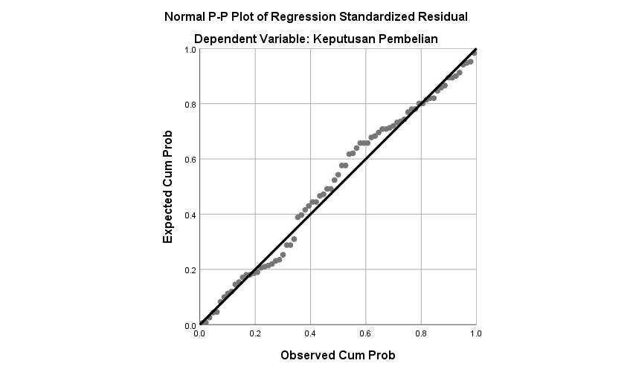
Metode Grafik

Metode Kolmogorov Smirnov
One-Sample Kolmogorov-Smirnov Test
 |  | Standardized Residual
N |  | 75
Normal Parameters^{a,b} | Mean | .0000000
Normal Parameters^{a,b} | Std. Deviation | .98639392
Most Extreme Differences | Absolute | .086
Most Extreme Differences | Positive | .062
Most Extreme Differences | Negative | -.086
Test Statistic |  | .086
Asymp. Sig. (2-tailed) |  | .200^{c,d}
a. Test distribution is Normal.
b. Calculated from data.
c. Lilliefors Significance Correction.
d. This is a lower bound of the true significance.

- Hasil Uji Multikolinearitas

Coefficientsª
Model |  | Unstandardized Coefficients |  | Standardized Coefficients | T | Sig. | Collinearity Statistics
 |  | B | Std. Error | Beta | T | Sig. | Tolerance | VIF
1 | (Constant) | 3.766 | 2.554 |  | 1.475 | .145
1 | Online Customer Rating | .403 | .186 | .215 | 2.165 | .034 | .735 | 1.360
1 | Online Customer Riview | .757 | .136 | .555 | 5.585 | .000 | .735 | 1.360
a. Dependent Variable: Keputusan Pembelian

- Hasil Uji Heteroskedastisitas
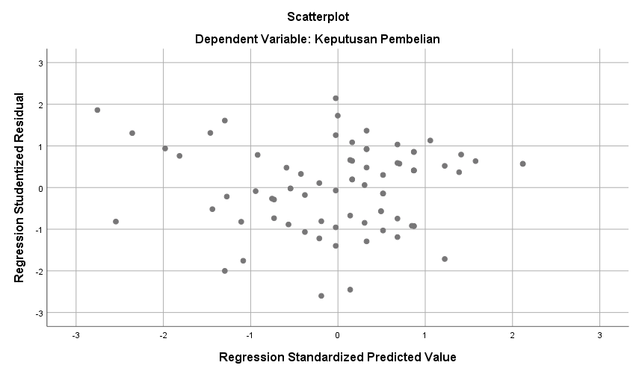

Uji Gletser
Coefficientsª
Model |  | Unstandardized Coefficients |  | Standardized Coefficie nts | t | Sig.
 |  | B | Std. Error | Beta | t | Sig.
1 | (Constant) | 1.630 | .625 |  | 2.606 | .011
1 | Online Customer Rating | -.021 | .046 | -.062 | -.458 | .649
1 | Online Customer Riview | -.027 | .033 | -.112 | -.826 | .412
a. Dependent Variable: ABSRES

- Hasil Uji Autokorelasi
Model Summary^{b}
Model | R | R Square | Adjusted R Square | Std. Error of the Estimate | Durbin-Watson
1 | .691ª | .477 | .463 | 2.27472 | 1.930
a. Predictors: (Constant), Online Customer Riview, Online Customer Rating
b. Dependent Variable: Keputusan Pembelian

Lampiran 5 Hasil Uji Regresi Linier Berganda
Coefficientsª
Model |  | Unstandardized Coefficients |  | Standardized Coefficients | T | Sig. | Collinearity Statistics
 |  | B | Std. Error | Beta | T | Sig. | Tolerance | VIF
1 | (Constant) | 3.766 | 2.554 |  | 1.475 | .145
1 | Online Customer Rating | .403 | .186 | .215 | 2.165 | .034 | .735 | 1.360
1 | Online Customer Riview | .757 | .136 | .555 | 5.585 | .000 | .735 | 1.360
a. Dependent Variable: Keputusan Pembelian

Lampiran 6 Hasil Uji Hipotesis
- Hasil Uji T
Coefficientsª
Model |  | Unstandardized Coefficients |  | Standardized Coefficients | T | Sig.
 |  | B | Std. Error | Beta | T | Sig.
1 | (Constant) | 3.766 | 2.554 |  | 1.475 | .145
1 | Online Customer Rating | .403 | .186 | .215 | 2.165 | .034
1 | Online Customer Riview | .757 | .136 | .555 | 5.585 | .000
a. Dependent Variable: Keputusan Pembelian

- Hasil Uji F
ANOVAª
Model |  | Sum of Squares | Df | Mean Square | F | Sig.
1 | Regression | 340.032 | 2 | 170.016 | 32.857 | .000^{b}
1 | Residual | 372.554 | 72 | 5.174
1 | Total | 712.587 | 74
a. Dependent Variable: Keputusan Pembelian
b. Predictors: (Constant), Online Customer Riview, Online Customer Rating

Lampiran 7 Hasil Uji Koefisien Determinasi ($R^{2}$)
Model Summary^{b}
Model | R | R Square | Adjusted R Square | Std. Error of the Estimate
1 | .691ª | .477 | .463 | 2.27472
a. Predictors: (Constant), Online Customer Riview, Online Customer Rating
b. Dependent Variable: Keputusan Pembelian

Lampiran 8 Pengajuan Judul
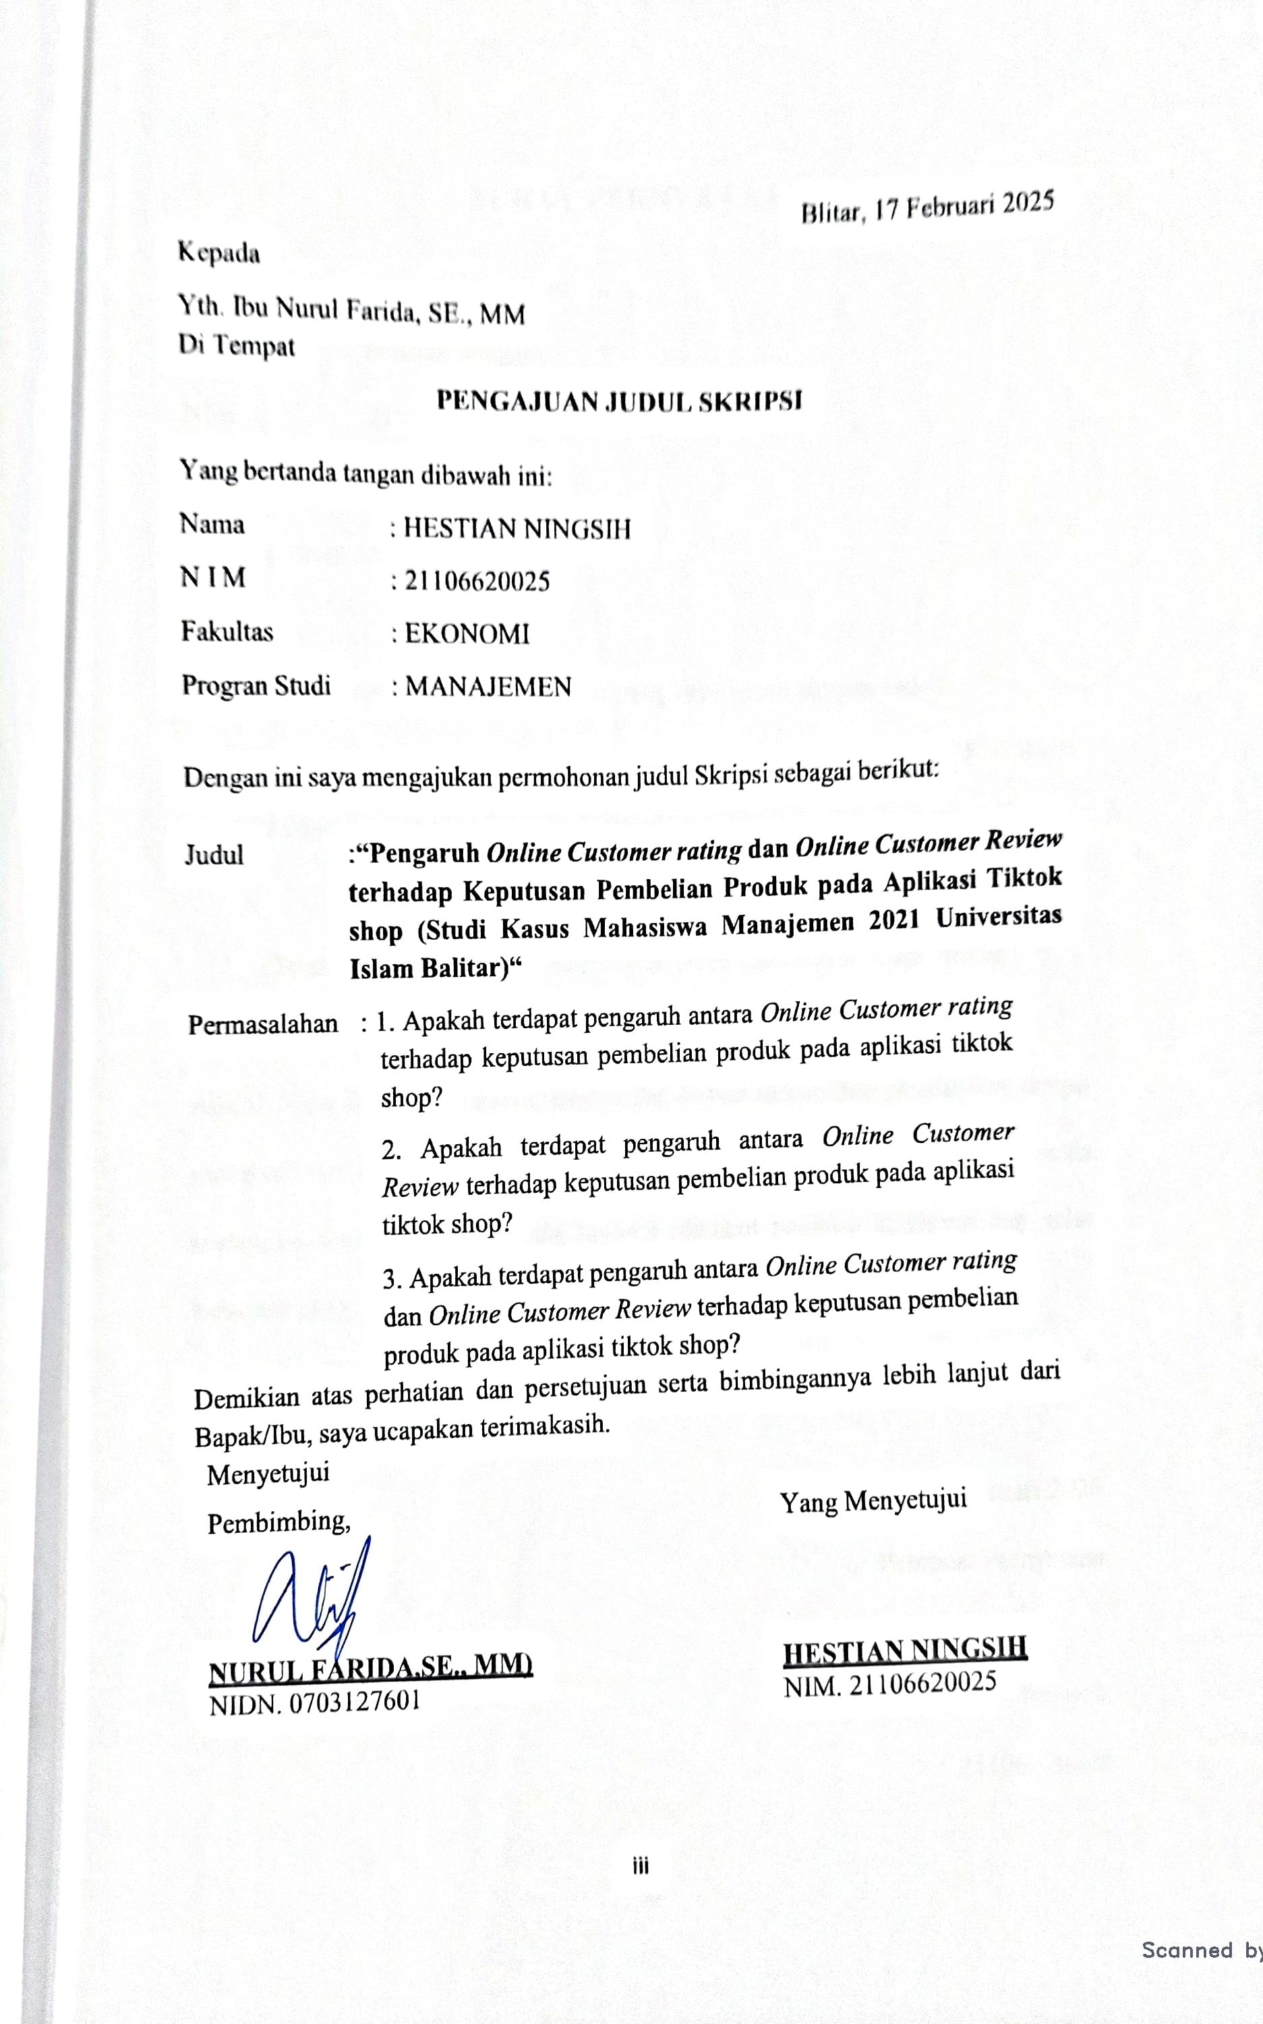

Lampiran 9 Berita Acara Bimbingan Skripsi



Berita Acara Bimbingan Skripsi
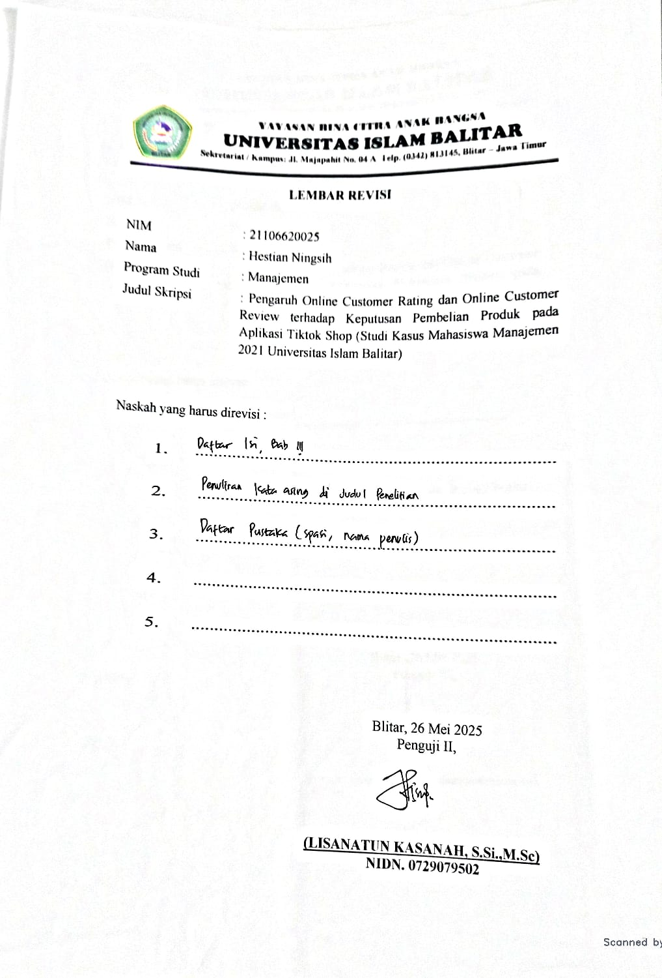

Berita Acara Bimbingan Skripsi
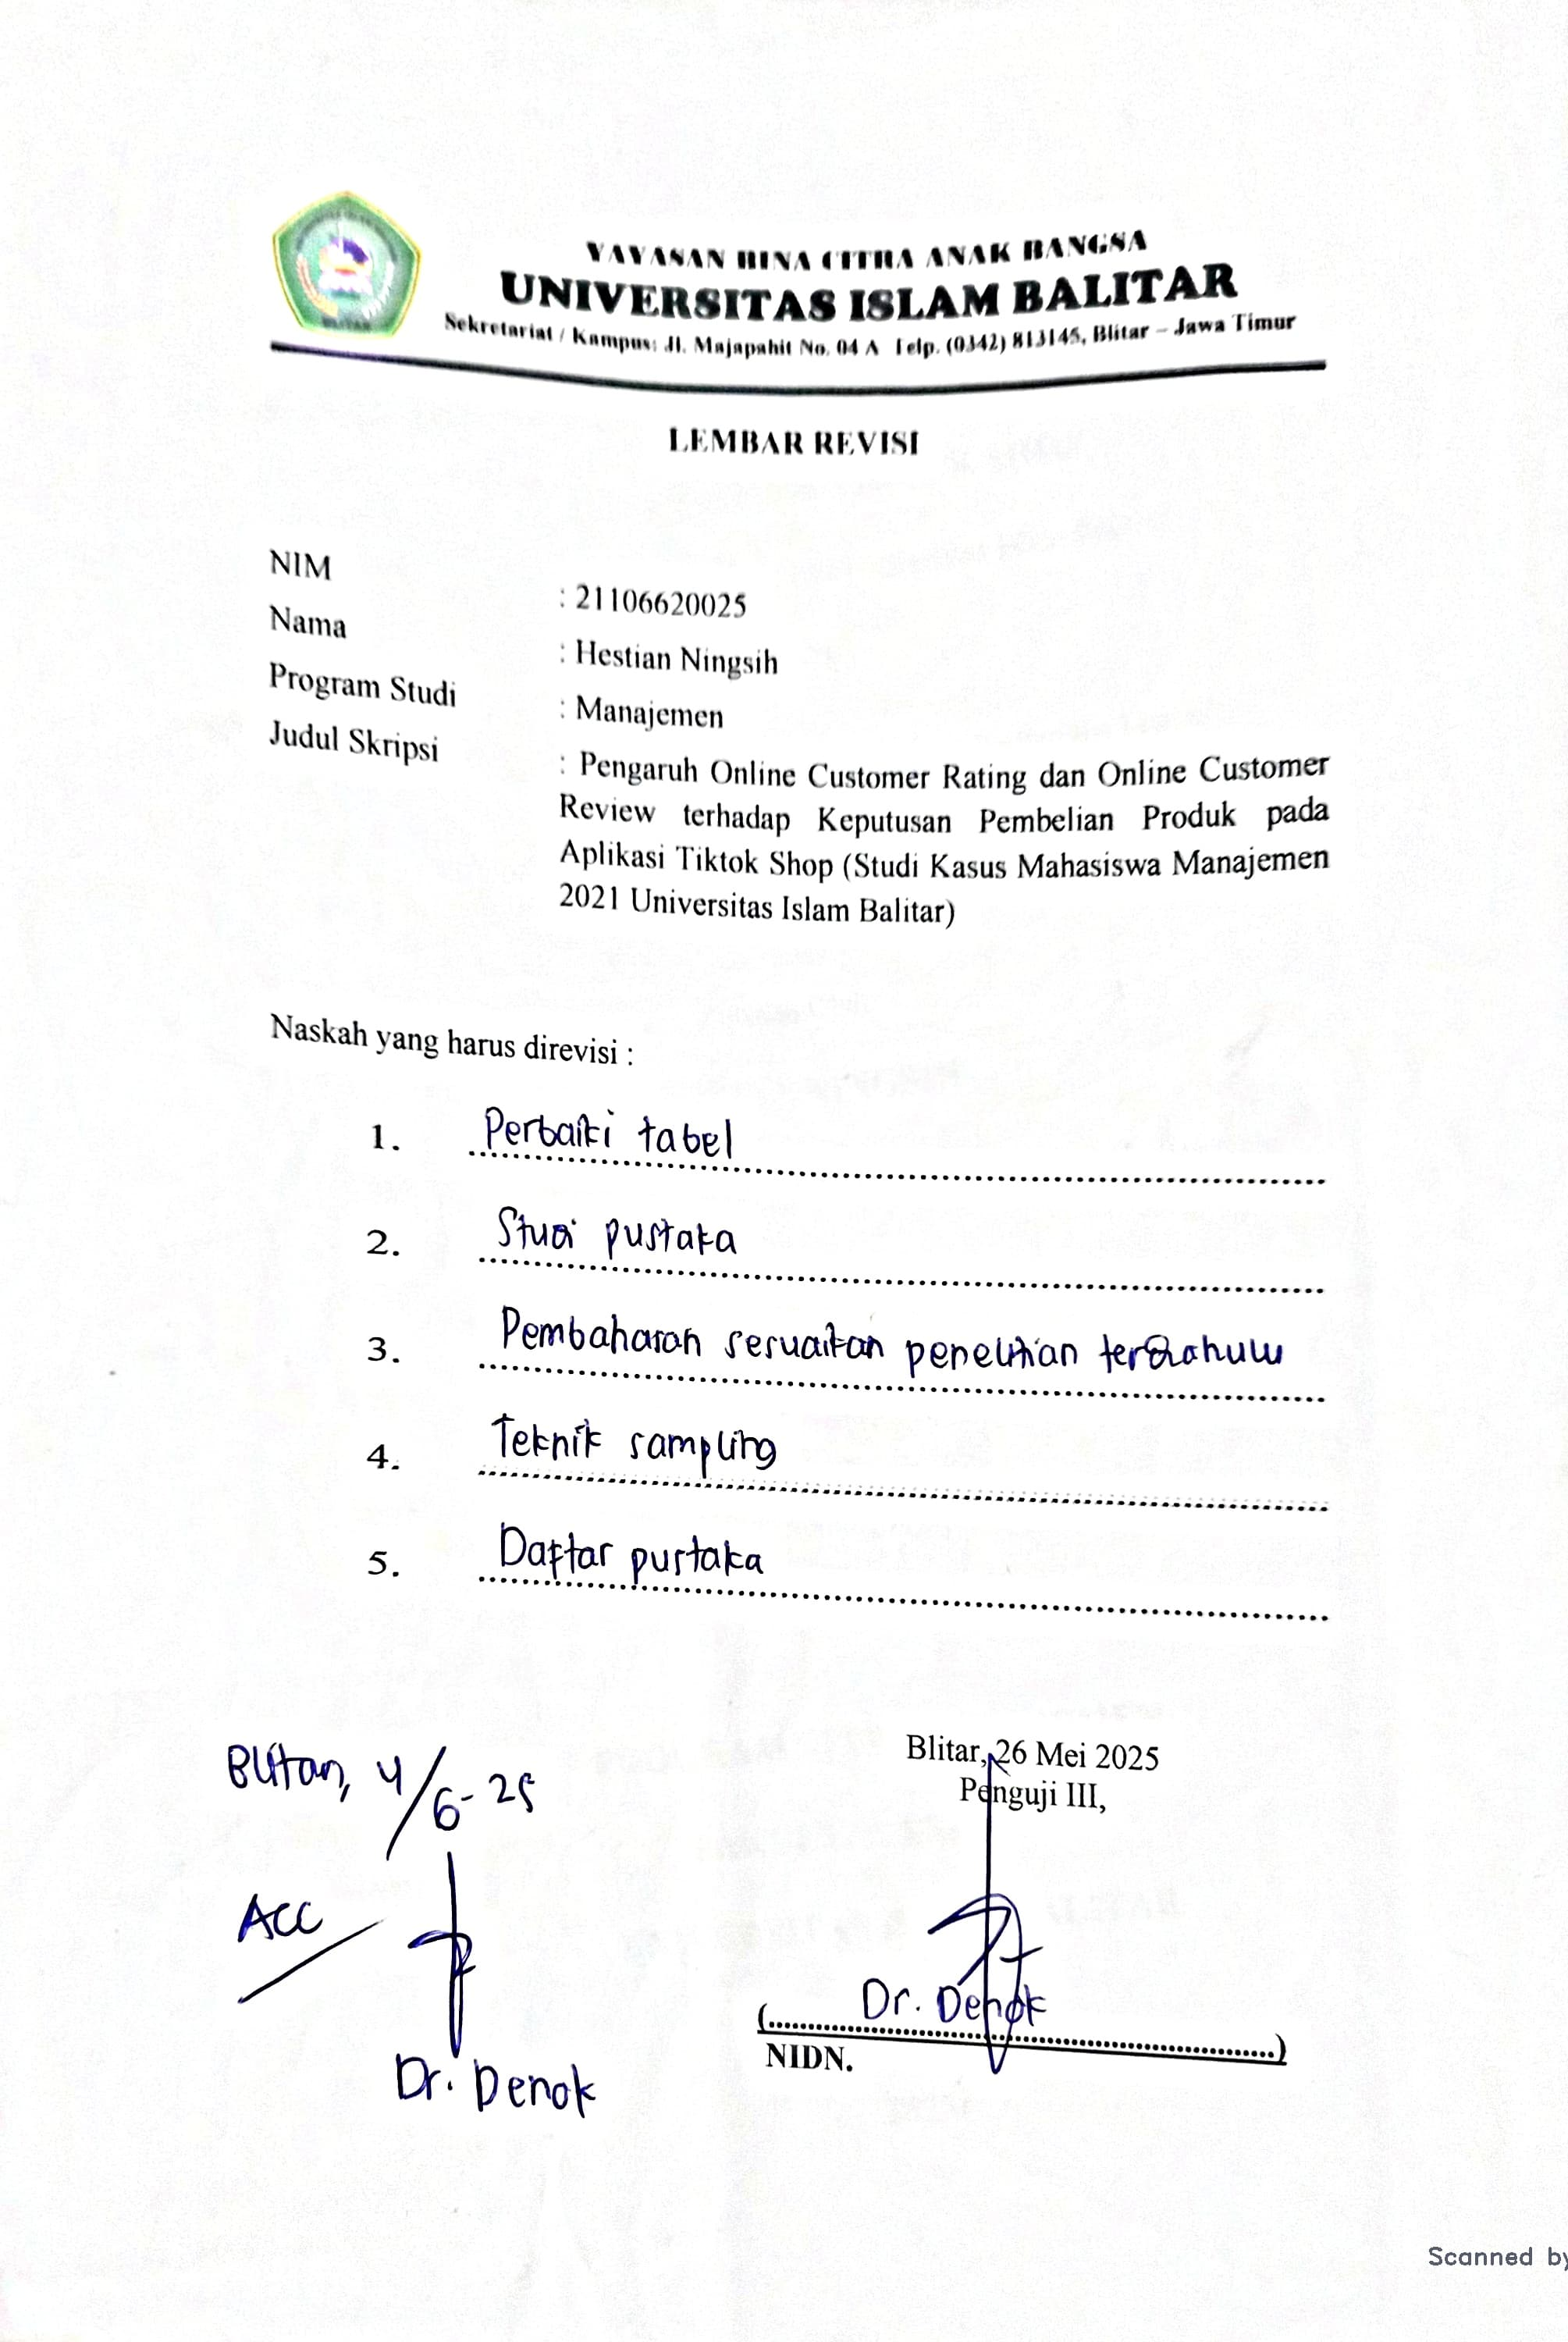

Lampiran 10 Lembar Revisi
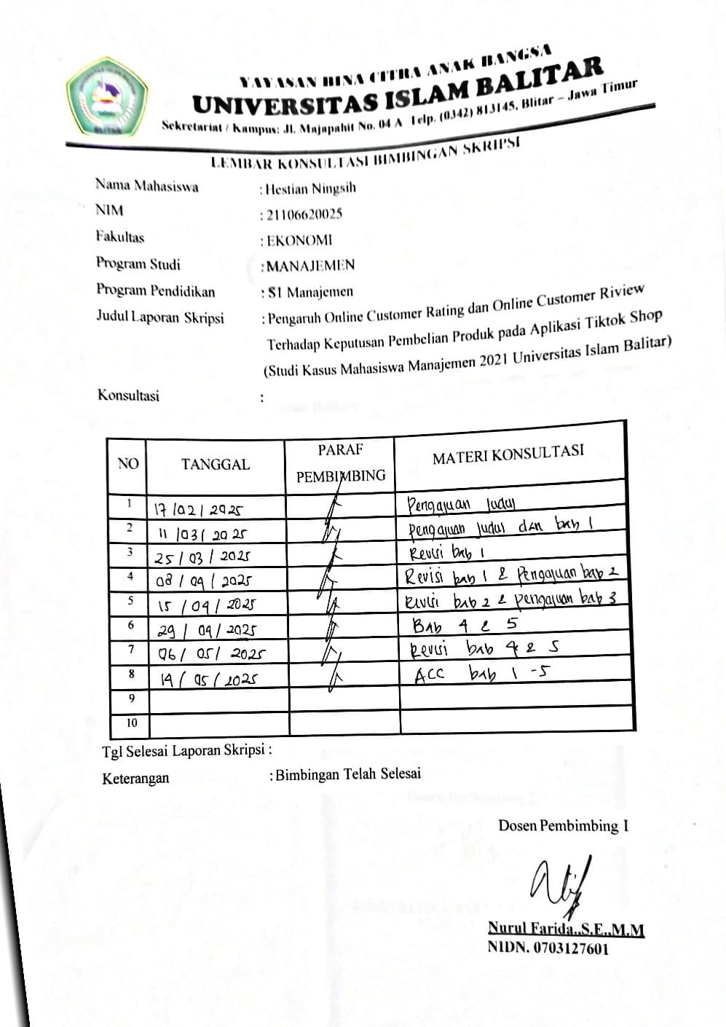

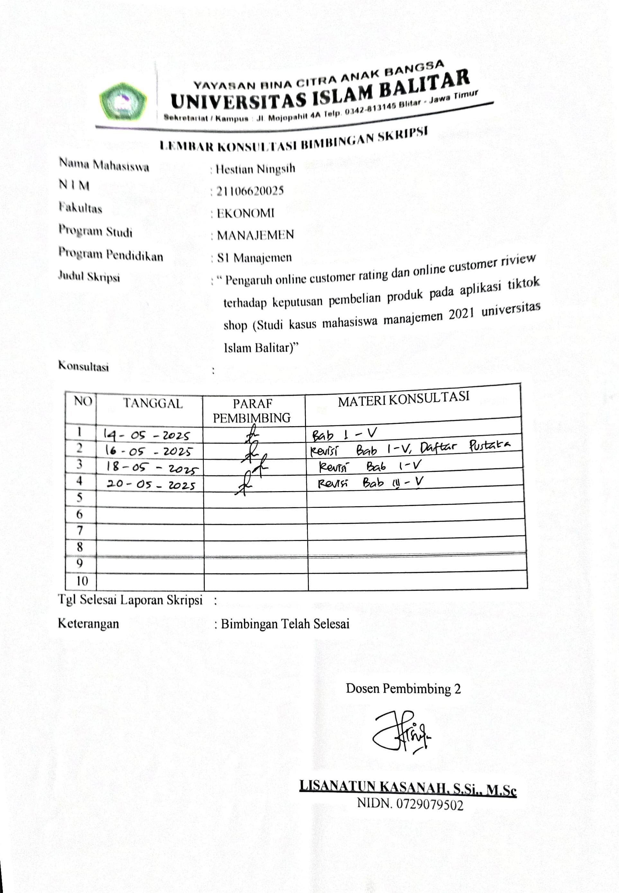
Berita Acara

